55341 Global Knowledge

Top of Form

Bottom of Form

Module 5: Installing and configuring Hyper-V and virtual machines

Lab: Installing and configuring Hyper-V

Scenario

IT management at Adatum Corporation is concerned about the low utilization of many of the physical servers that are deployed in the London datacenter. Adatum also is exploring options for expanding into multiple branch offices and deploying servers in public and private clouds. For this purpose, the organization is exploring the use of virtual machines.

You will deploy the Hyper-V server role, configure virtual machine storage and networking, and deploy the virtual machines.

Exercise 1: Verifying installation of the Hyper-V server role

Scenario

The first step in migrating to a virtualized environment is to install the Hyper-V server role on a new server. Because this role is installed already, you need to verify the presence of the Hyper-V role.

The main task for this exercise is as follows:

* Verify the presence of the Microsoft Hyper-V server role.

Task 1: Verify the presence of the Microsoft Hyper-V server role

1. Switch to [**LON-HV1**](urn:gd:lg:a:select-vm).
2. Send the [**CTRL+ALT+DEL**](urn:gd:lg:a:send-vm-key-combo) command and login on as **[Adatum\AdatumAdmin](urn:gd:lg:a:send-vm-keys" \o "Paste text into VM)** with the password [**Pa55w.rd**](urn:gd:lg:a:send-vm-keys)

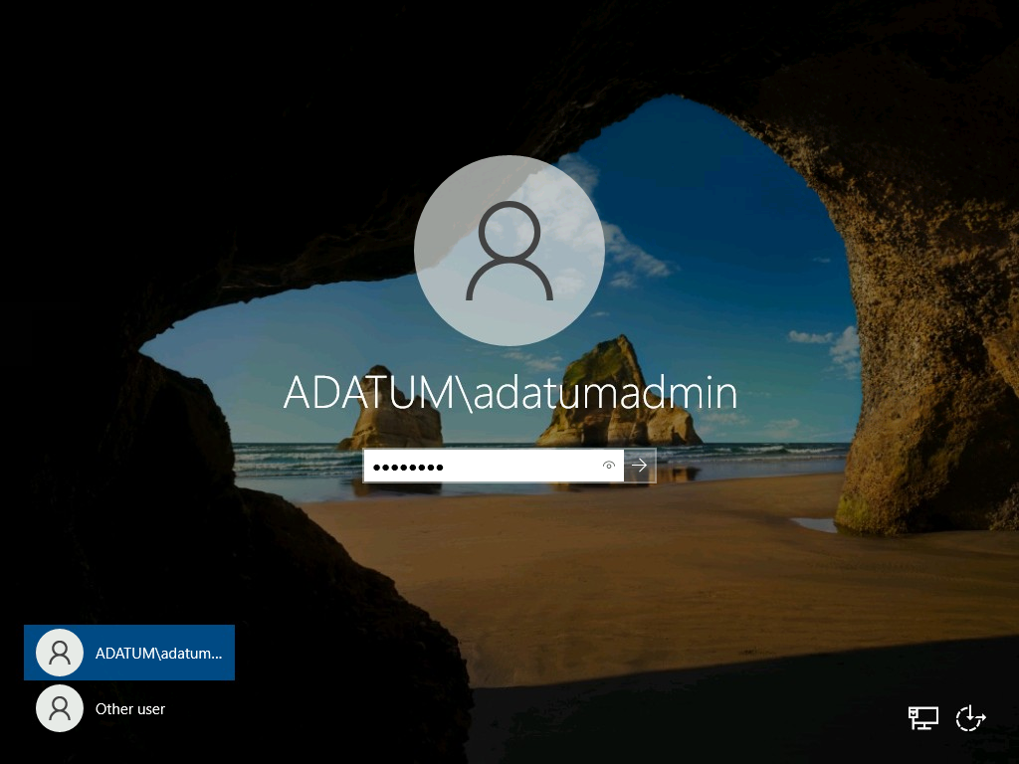

1. Click **Start**, and then click **Server Manager**.

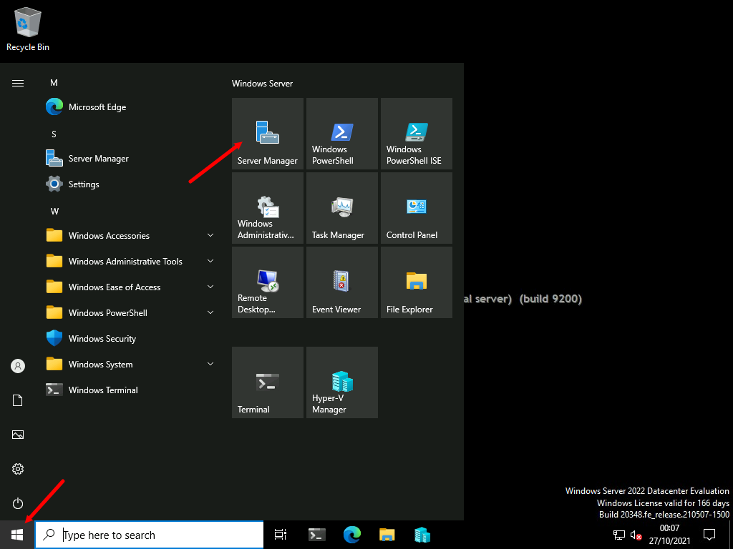

1. In Server Manager, click **Tools**, and then click **Hyper-V Manager**.

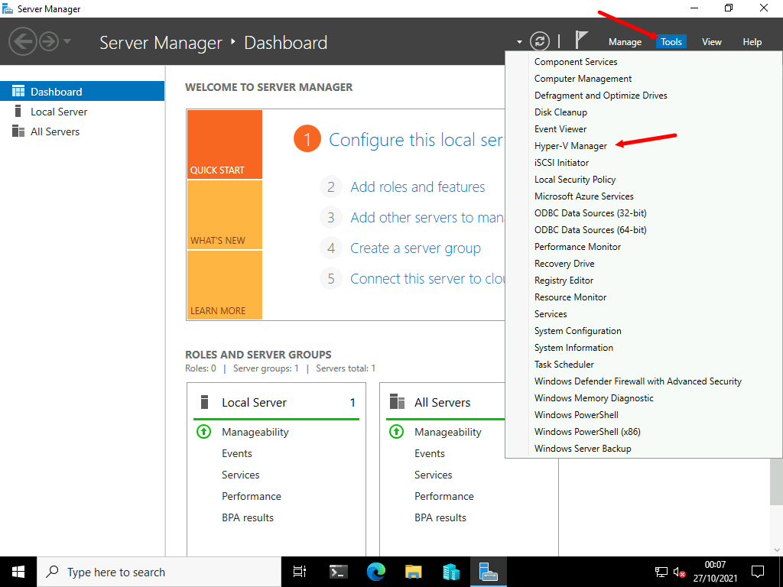

1. In **Hyper-V Manager**, click **LON-HV1**, and then click **Hyper-V Settings**.

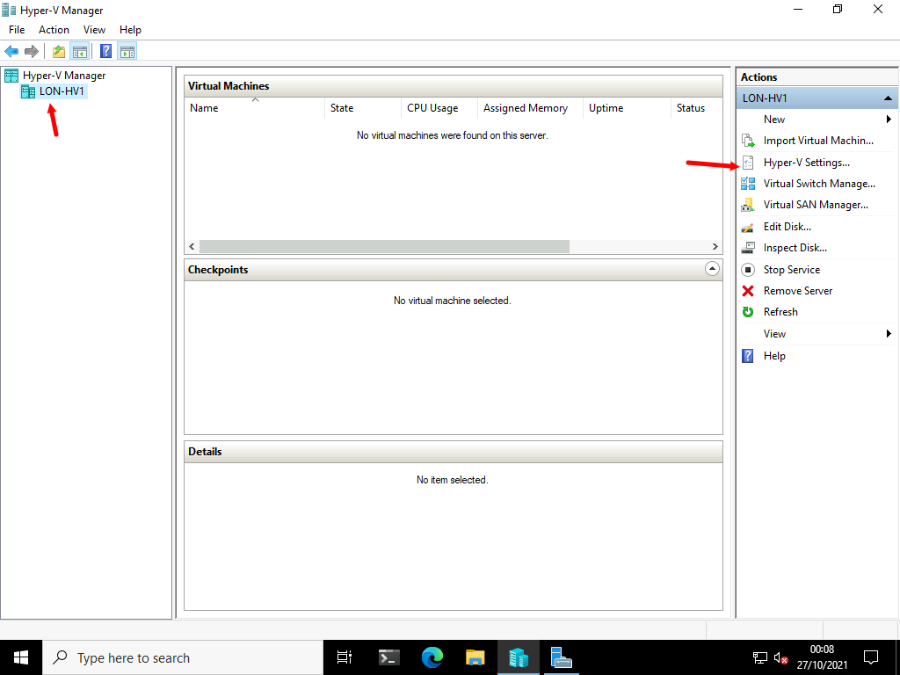

1. In the **Hyper-V Settings for** **LON-HV1** window, click each of the available options in the left pane, and review the description.

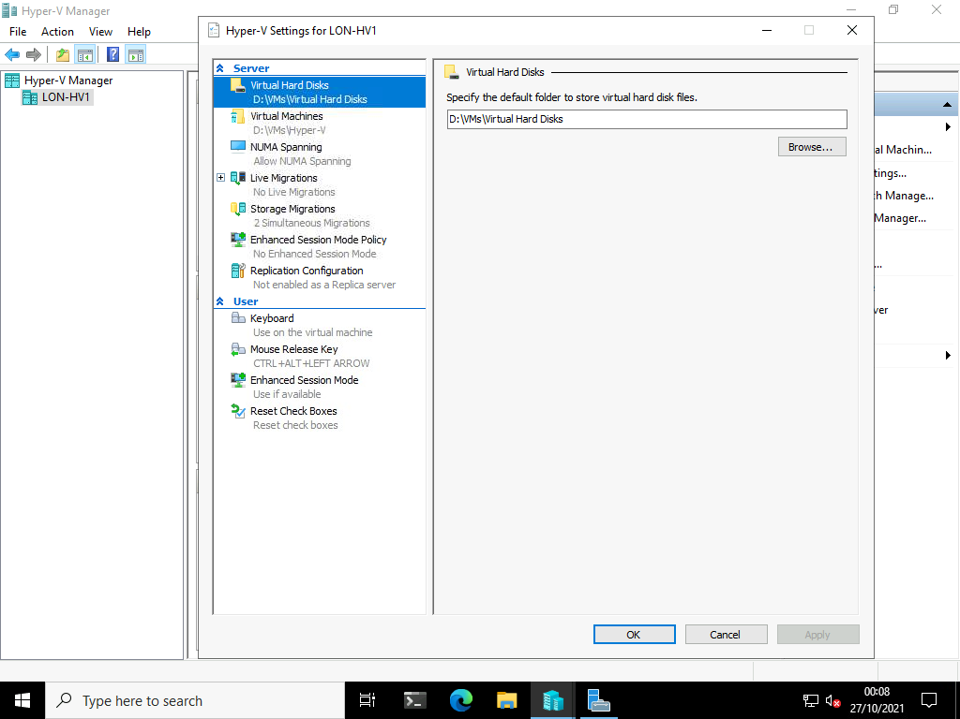

1. Click **Cancel**.

**Results** : After completing this exercise, you should have successfully verified the presence and configuration of the Hyper-V server role on a physical server.

Exercise 2: Configuring Hyper-V networks

Scenario

After installing the Hyper-V server role on the new server, you must configure the virtual networks. To see the differences between the different network types, you must create an external, internal, and private network.

The main tasks for this exercise are as follows:

* Create an external network.
* Create a private network.
* Create an internal network.

Task 1: Create an external network

**Note:** To perform this task, your computer must have physical network card (wired or wireless) and be connected to a network.

1. In **Hyper-V Manager**, click **LON-HV1**, and then in the **Actions** pane, click **Virtual Switch Manager**.

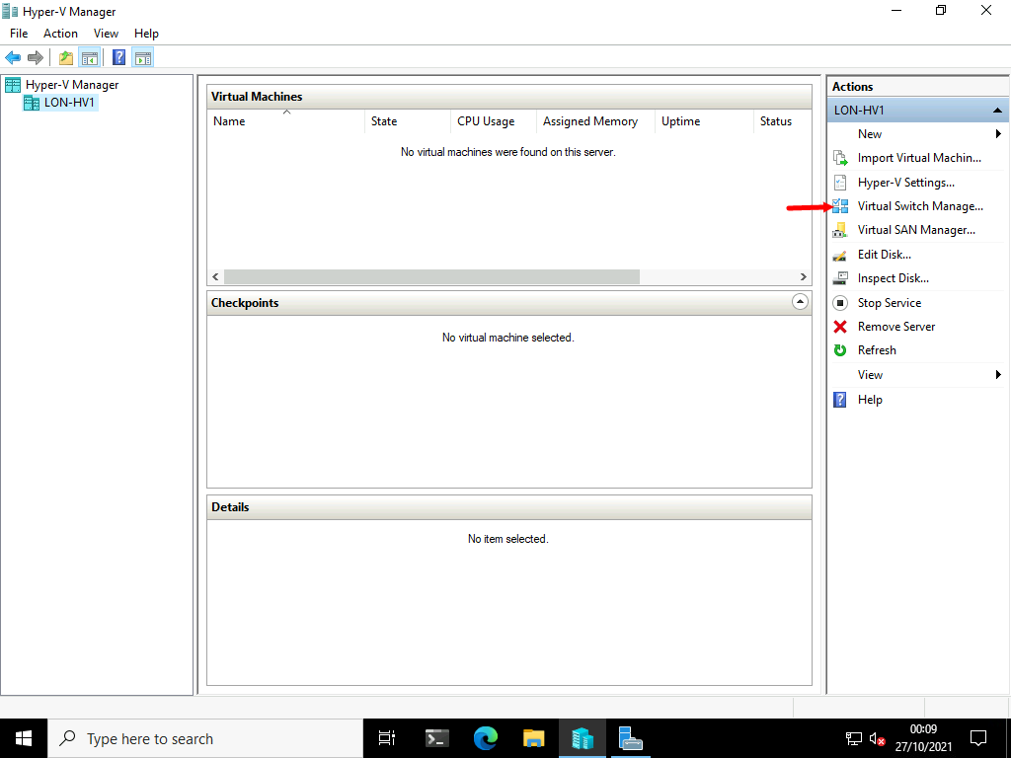

1. In the **Virtual Switch Manager for LON-HV1** window, in the left pane, click **New virtual network switch**.

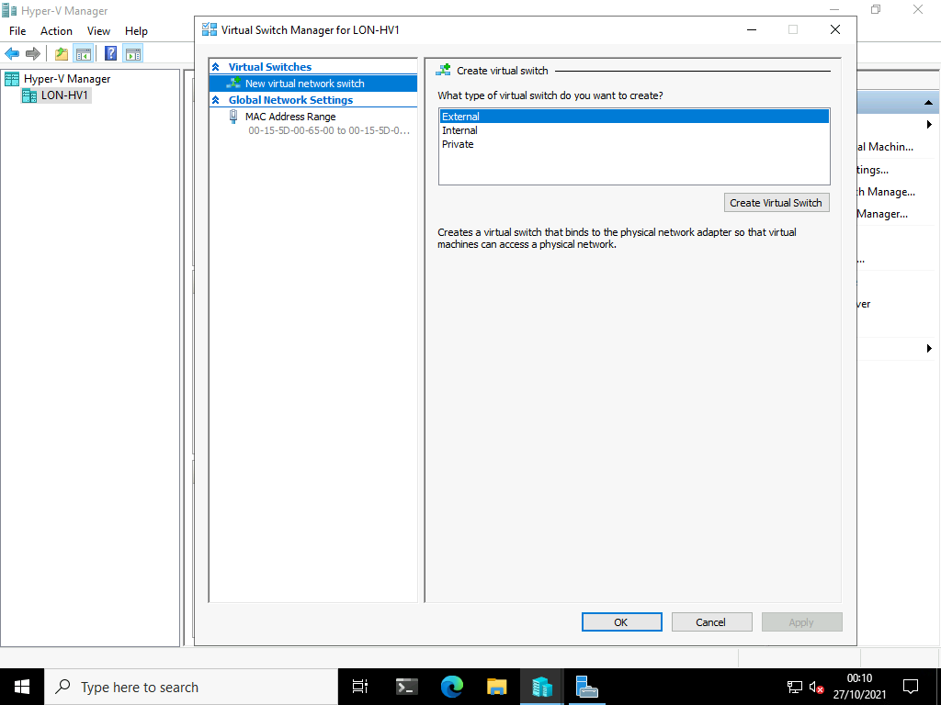

1. In the **Create virtual switch** pane, click **External**, and then click **Create Virtual Switch**.

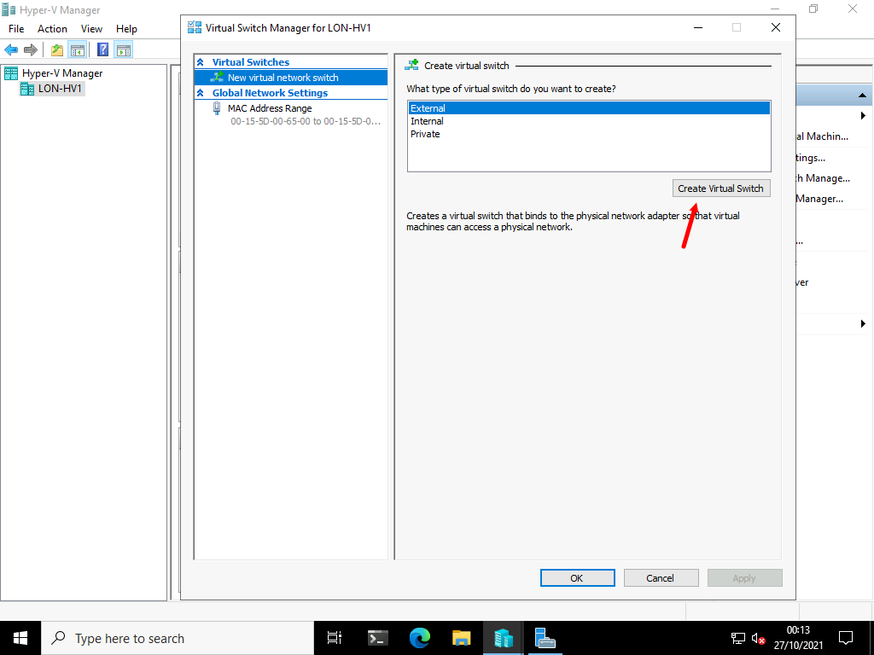

1. In the **Virtual switch properties** pane, in the **Name** text box, type [**Physical Network**](urn:gd:lg:a:send-vm-keys).

**Note:** It is important to ensure the name of the Virtual Switch is correct as other parts of this lab will not work. It is case sensative!

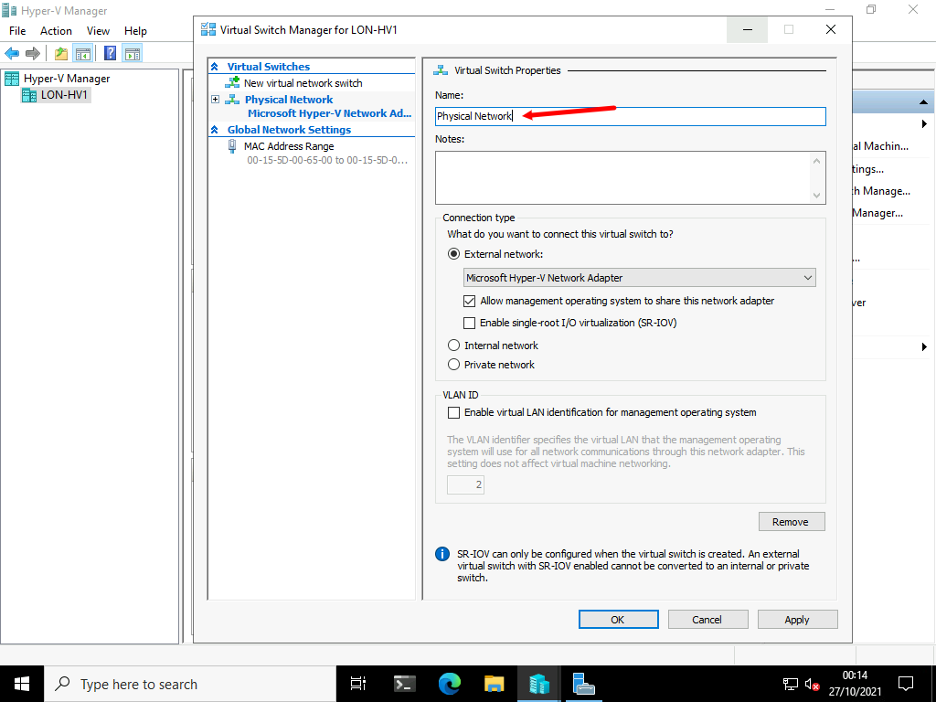

1. In the **Connection type** area, click **External network**. Select the **Allow management operating system to share this network adapter** check box, and then click **OK**.

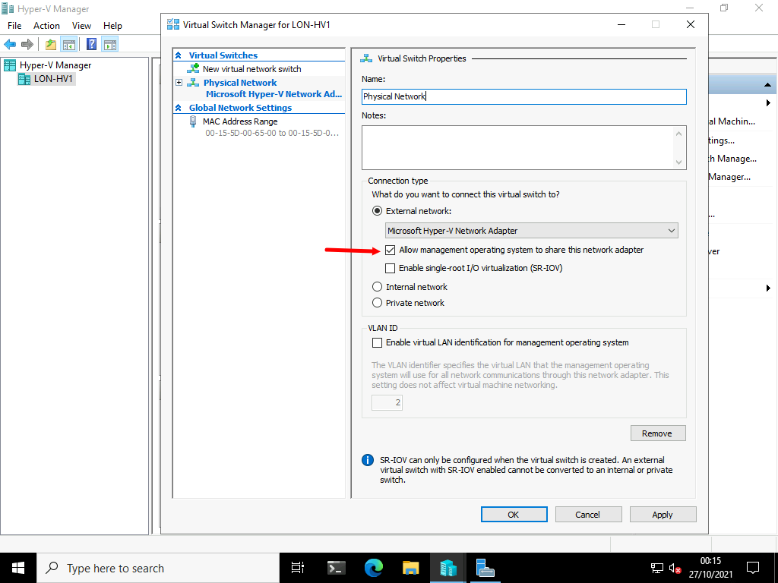

1. In the **Apply Networking Changes** dialog box, read the warning that displays, and then click **Yes**.

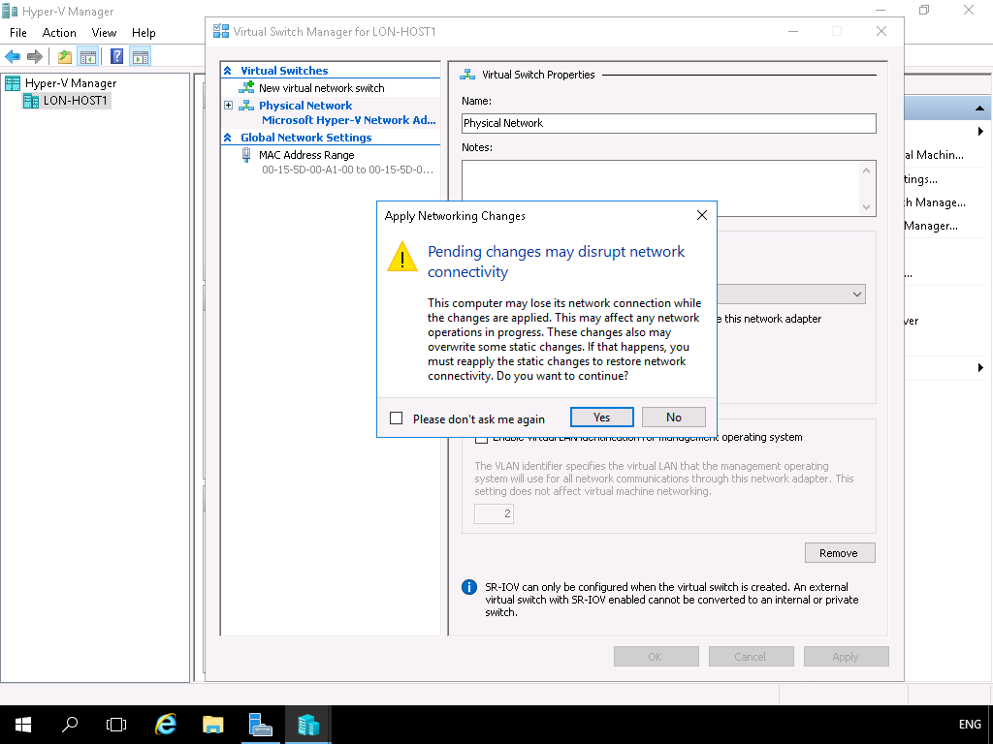

1. In **Server Manager**, click **Local Server**, and then verify that the name of the network adapter has changed to **vEthernet (Physical Network)**.

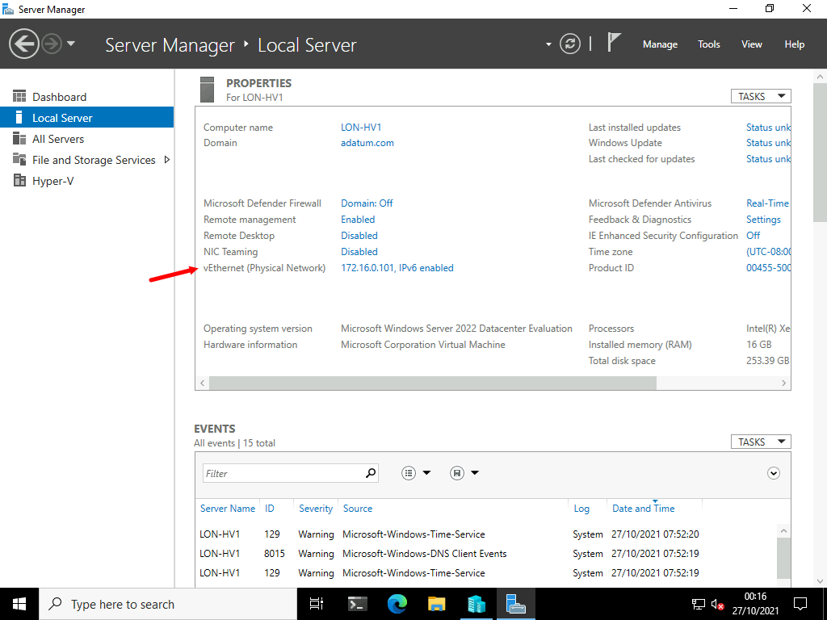

Task 2: Create a private network

1. On [**LON-HV1**](urn:gd:lg:a:select-vm), in **Hyper-V Manager**, in the **Actions** pane, click **Virtual Switch Manager**.

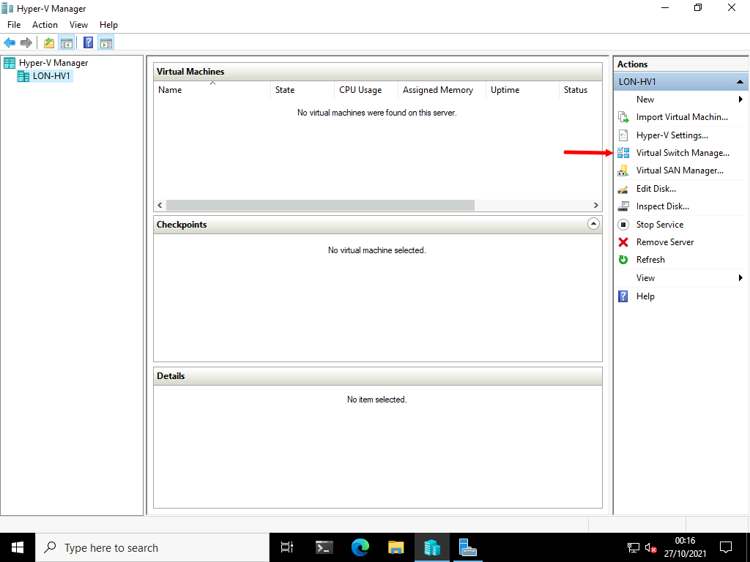

1. In the **Virtual Switch Manager for LON-HV1** window, in the left pane, click **New virtual network switch**.

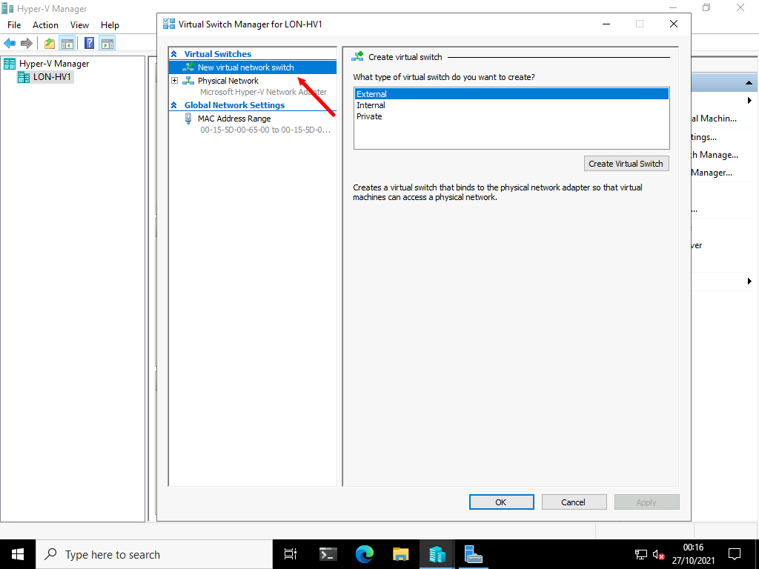

1. In the **Create virtual switch** pane, click **Private**, and then click **Create Virtual Switch**.

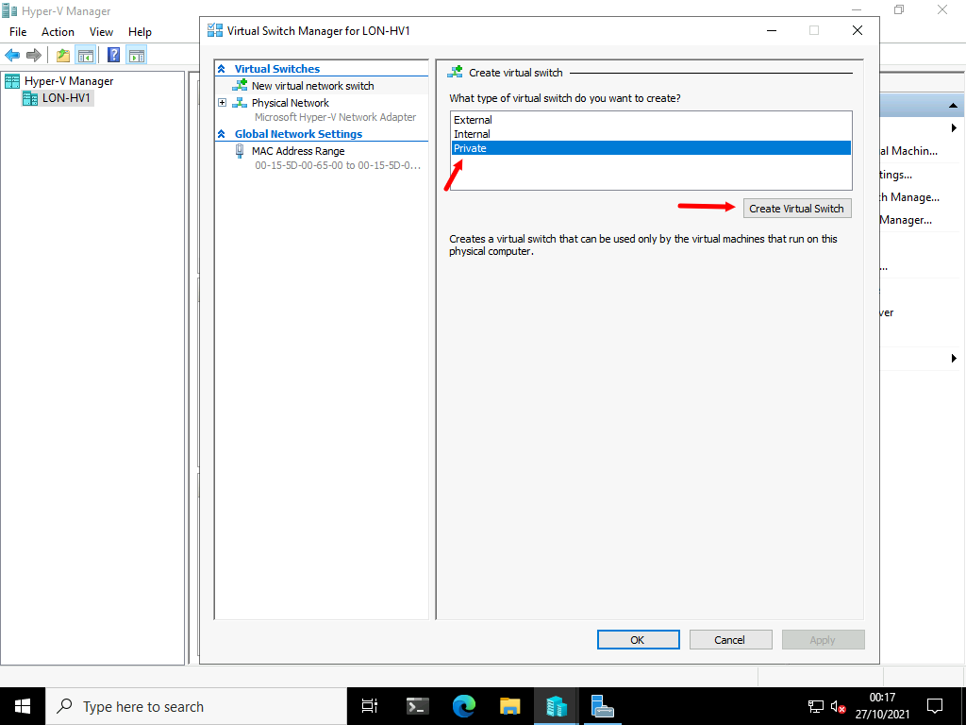

1. In the **Virtual Switch Properties** pane, in the **Name** text box, type [**Isolated Network**](urn:gd:lg:a:send-vm-keys).

**Note:** It is important to ensure the name of the Virtual Switch is correct as other parts of this lab will not work. It is case sensative!

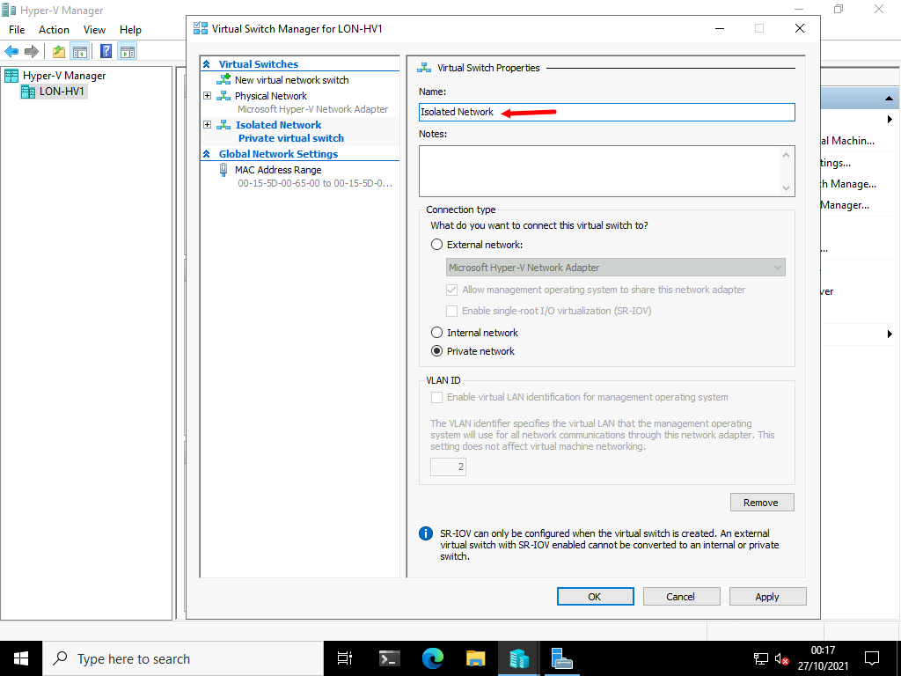

1. In the **Connection type** area, verify that **Private network** is selected, and then click **OK**.

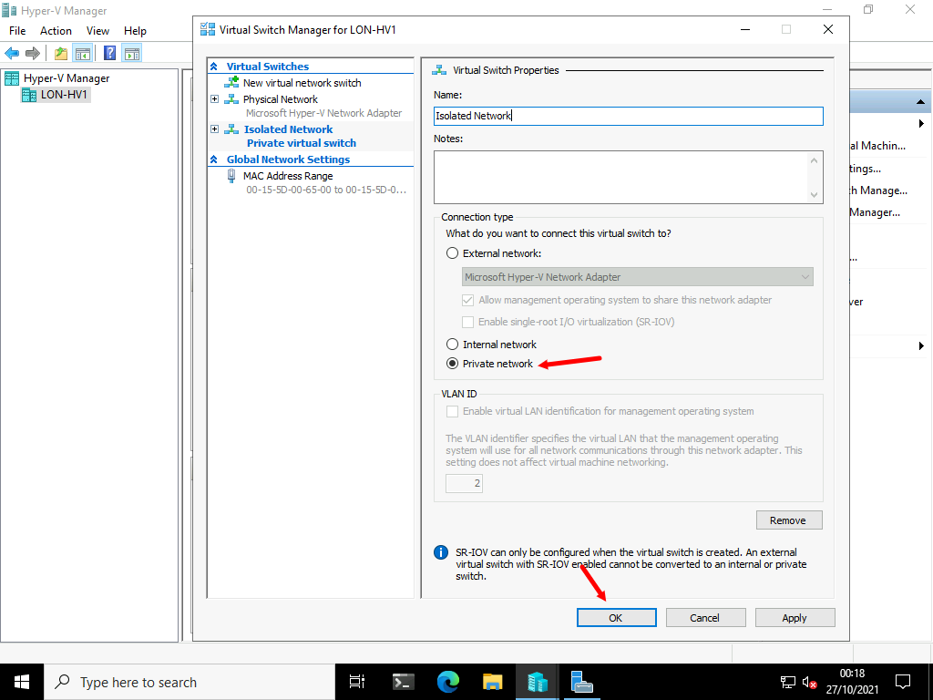

1. In **Server Manager**, verify that no new network adapters are visible.

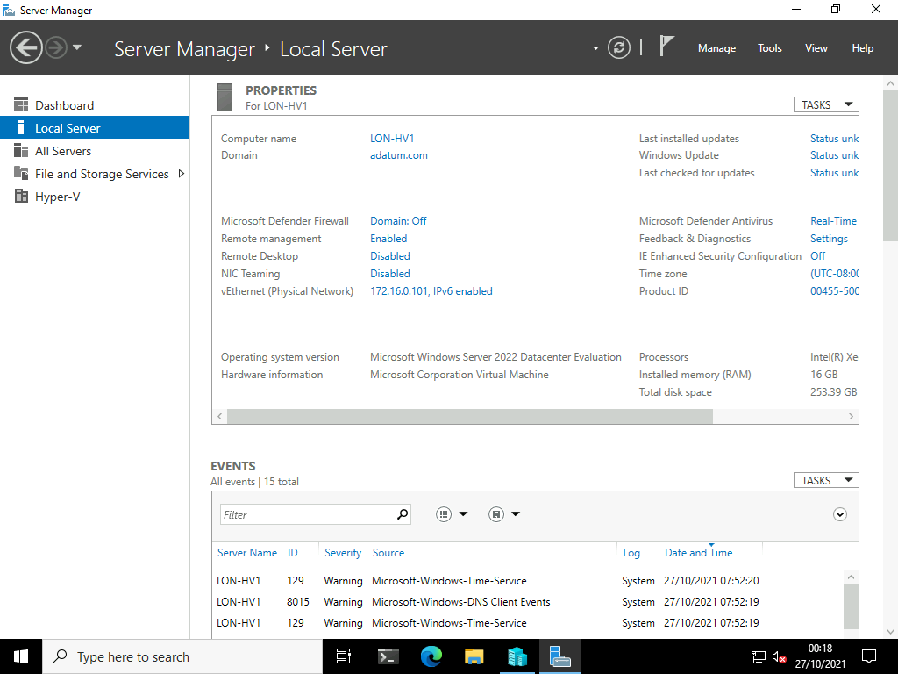

Task 3: Create an internal network

1. On [**LON-HV1**](urn:gd:lg:a:select-vm), in **Hyper-V Manager**, in the **Actions** pane, click **Virtual Switch Manager**.

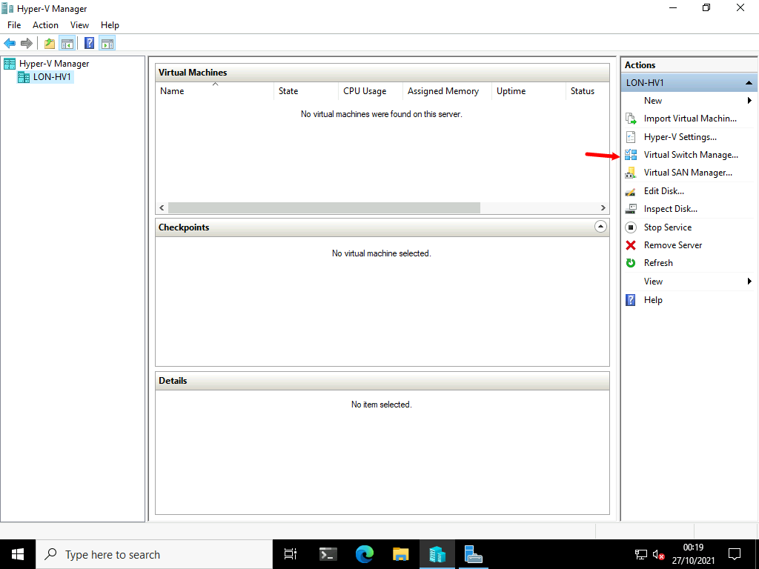

1. In the **Virtual Switch Manager for LON-HV1** window, in the left pane, click **New virtual network switch**.
2. In the **Create virtual switch** pane, click **Internal**, and then click **Create Virtual Switch**.

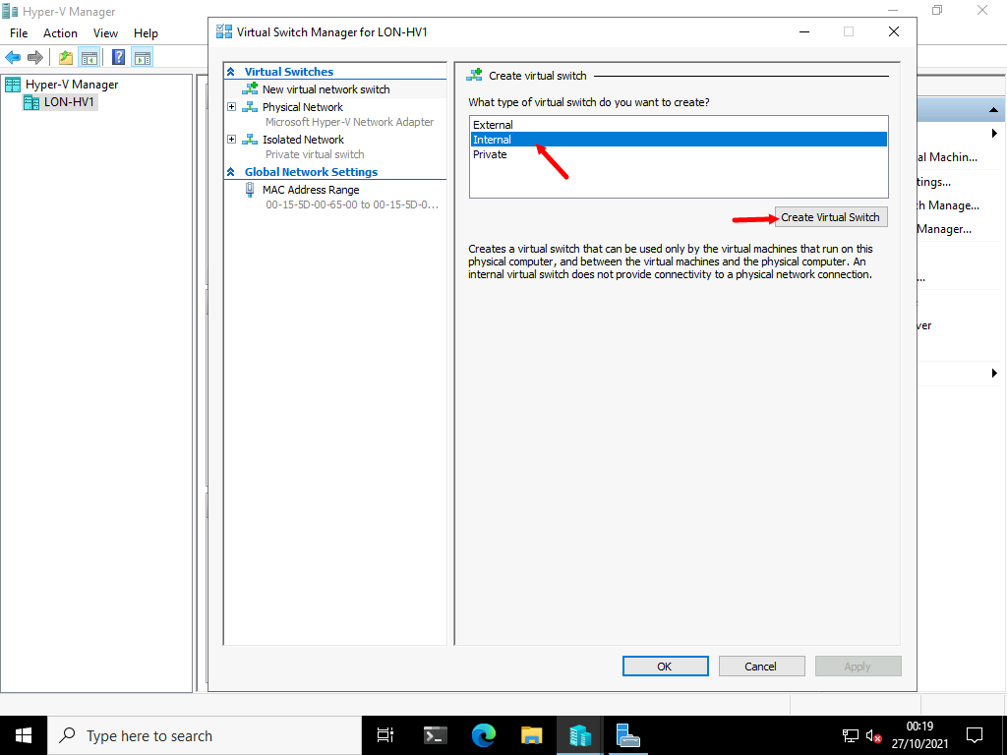

1. In the **Virtual Switch Properties** pane, in the **Name** text box, type [**HV Internal Network**](urn:gd:lg:a:send-vm-keys).

**Note:** It is important to ensure the name of the Virtual Switch is correct as other parts of this lab will not work. It is case sensative!

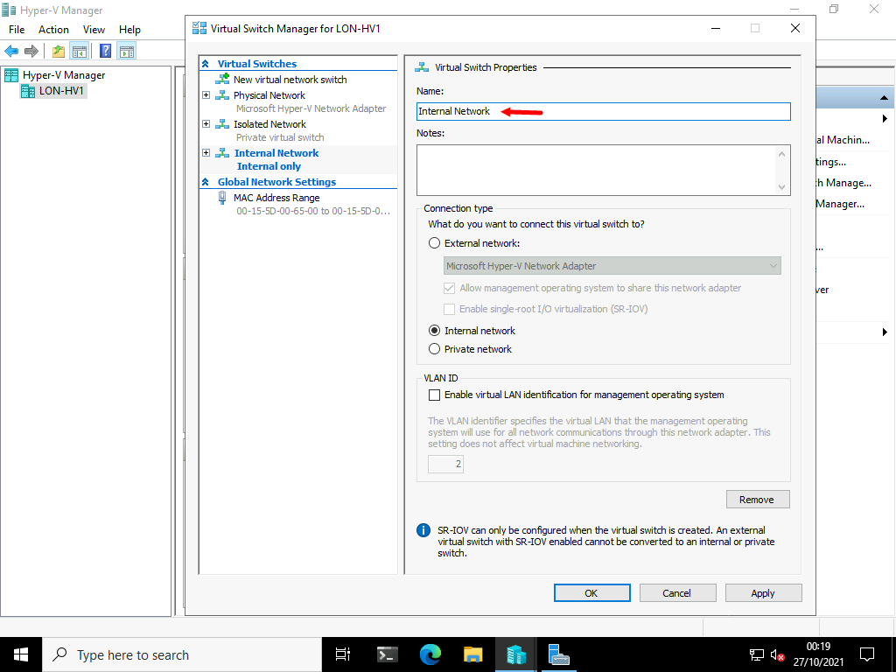

1. In the **Connection type** area, verify that **Internal network** is selected, and then click **OK**.

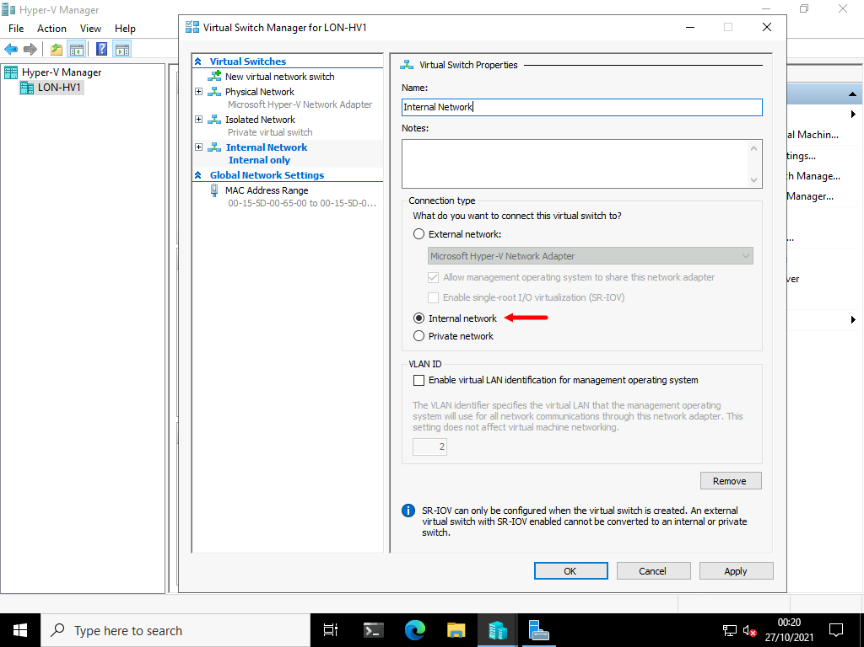

1. In **Server Manager**, click Refresh and verify that a new network adapter named **vEthernet (HV Internal Network)** has been created.

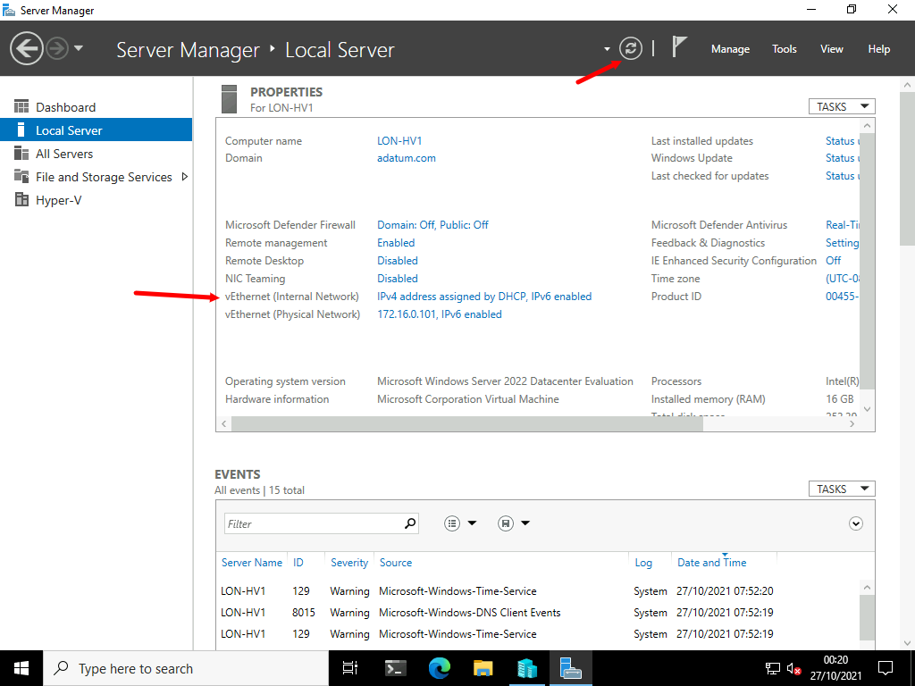

**Results** : After completing this exercise, you should have successfully configured an external, internal, and private network.

Exercise 3: Creating and configuring virtual machines

Scenario

To view the differences between Generation 1 and Generation 2 virtual machines, you will create two new virtual machines. You will install the Generation 2 virtual machine from Windows Server 2016 installation media. You will create the Generation 1 virtual machine by using a differencing disk and a base image created for an earlier project.

The main tasks for this exercise are as follows:

* Create a Generation 2 virtual machine.
* Create a Generation 1 virtual machine.
* Configure virtual machines.
* Create checkpoints.
* Enable HV resource protection.
* Export a virtual machine.

Task 1: Create a Generation 2 virtual machine

1. On [**LON-HV1**](urn:gd:lg:a:select-vm), on the taskbar, click **File Explorer**.

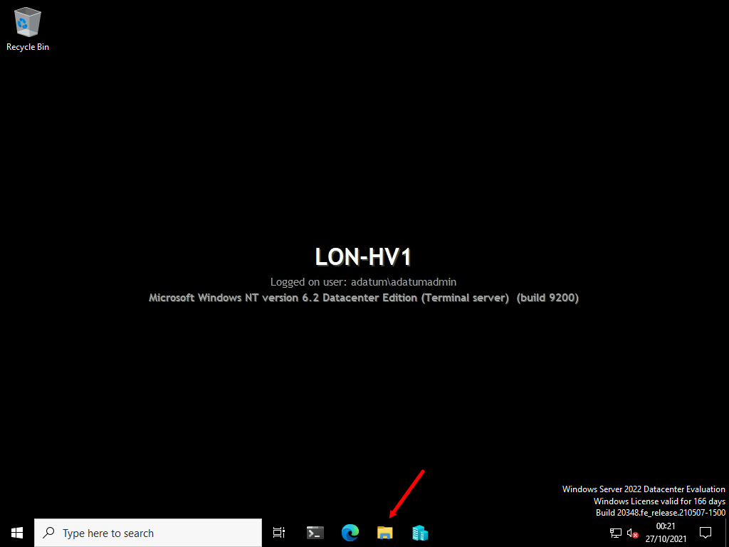

1. In File Explorer, go to [**D:\VMs**](urn:gd:lg:a:send-vm-keys).

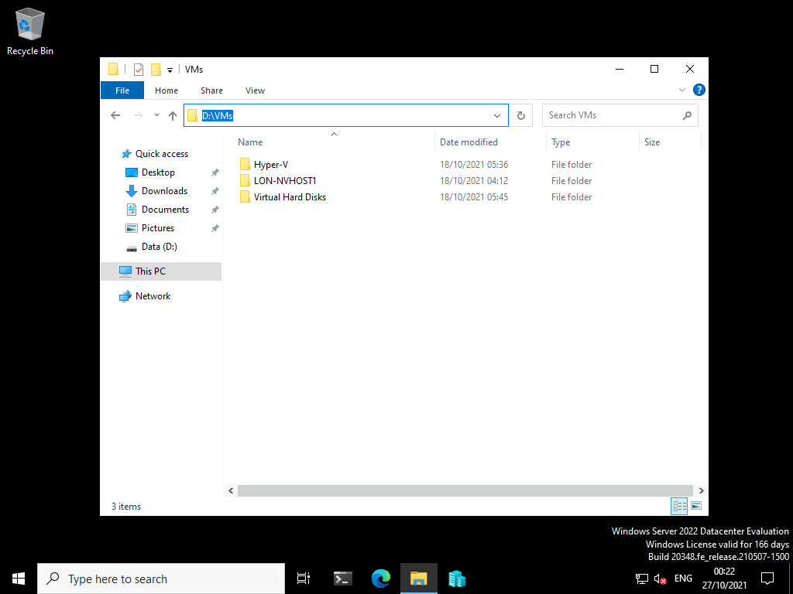

1. In File Explorer, click the **Home** tab, and then click the **New Folder** icon twice to create two new folders. Right-click each folder, and rename them:
   * [**LON-GUEST1**](urn:gd:lg:a:send-vm-keys)
   * [**LON-GUEST2**](urn:gd:lg:a:send-vm-keys)

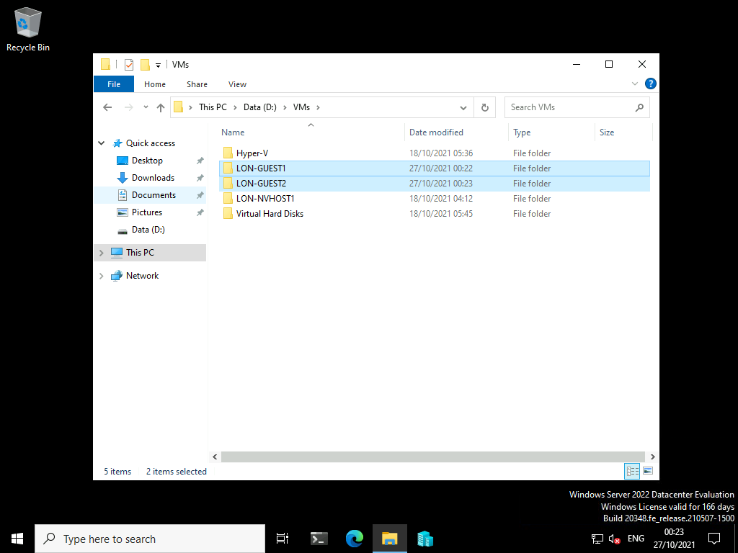

1. Close File Explorer.
2. In **Hyper-V Manager**, in the **Actions** pane, click **New**, and then click **Virtual Machine**.

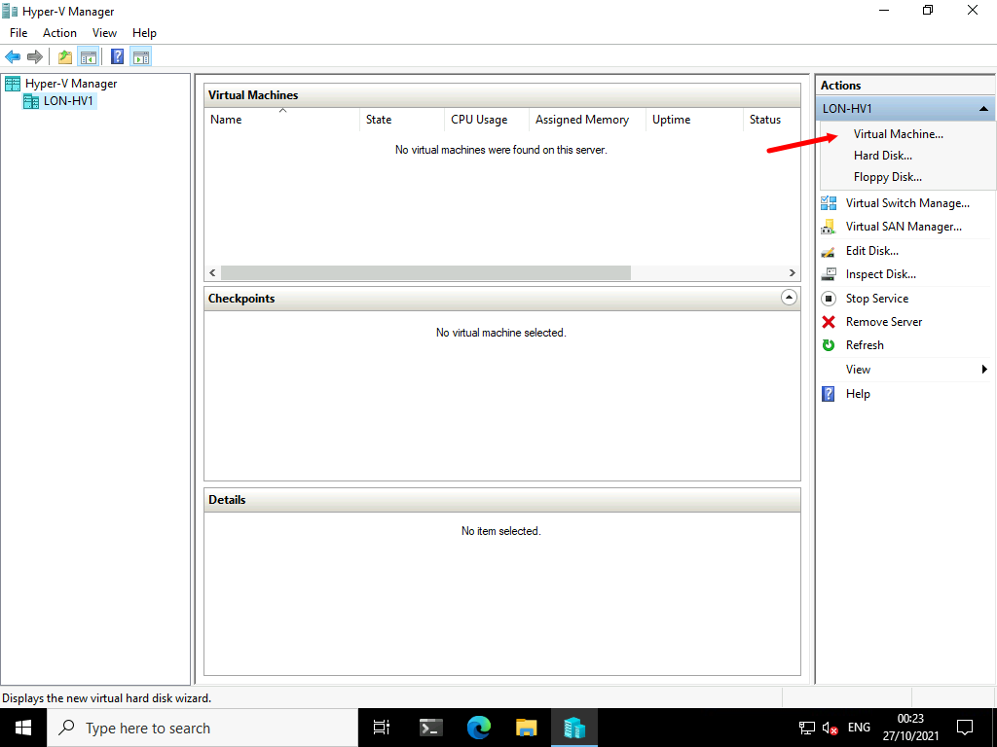

1. In the **New Virtual Machine Wizard**, on the **Before You Begin** page, click **Next**.

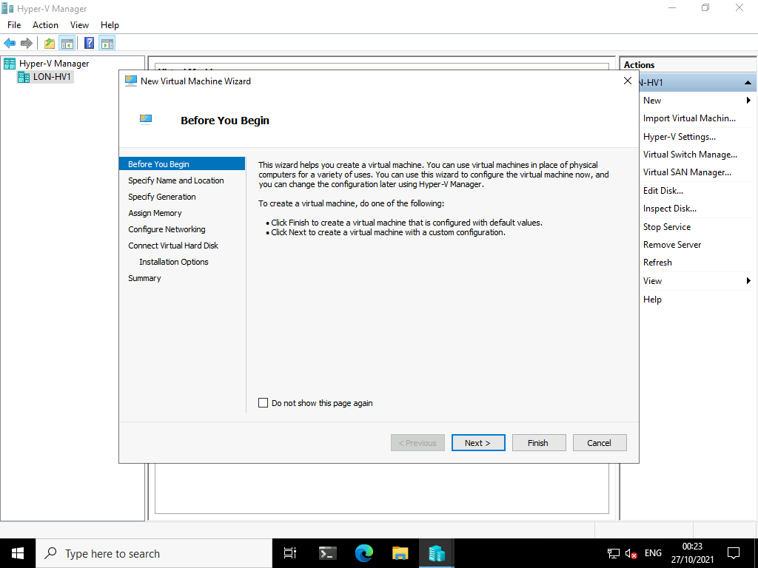

1. On the **Specify Name and Location** page, select **Store the virtual machine in a different location**, enter the following values, and then click **Next**:
   * Name: [**LON-GUEST2**](urn:gd:lg:a:send-vm-keys)
   * Location: [**D:\VMs\LON-GUEST2\**](urn:gd:lg:a:send-vm-keys)

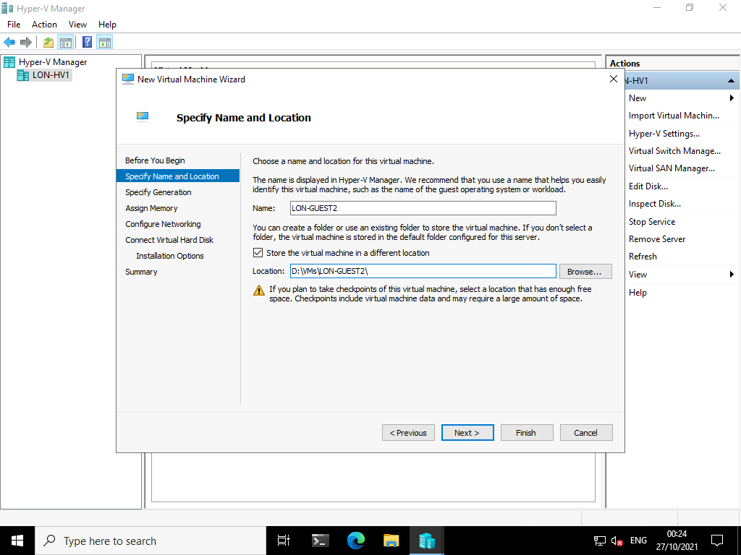

1. On the **Specify Generation** page, click **Generation 2**, and then click **Next**.

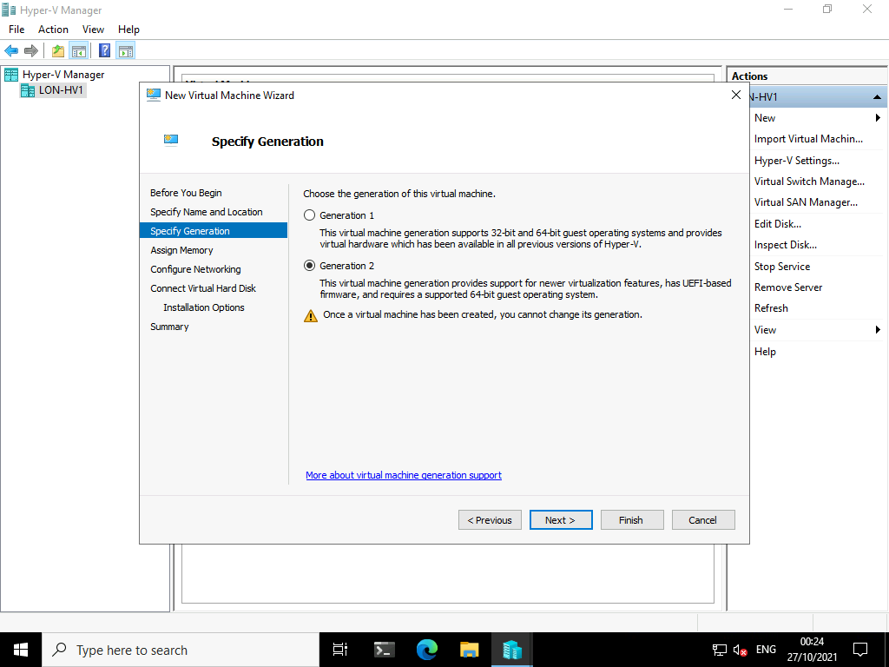

1. On the **Assign Memory** page, in the **Startup memory** box, enter a value of [**4096**](urn:gd:lg:a:send-vm-keys) **MB**, and then click **Next**.

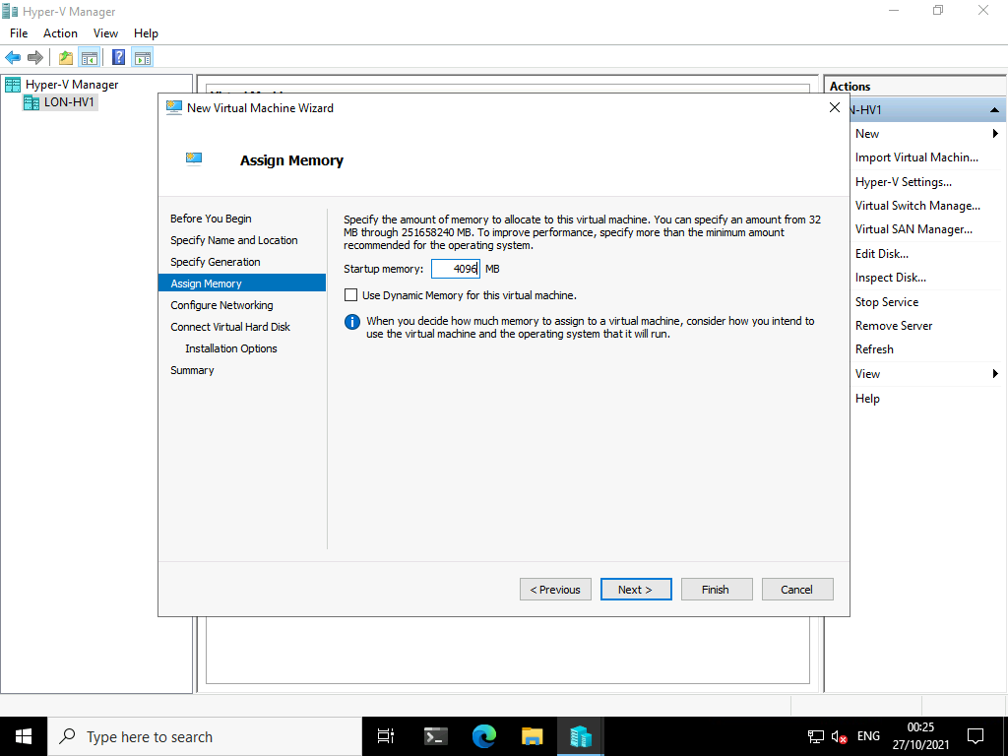

1. On the **Configure Networking** page, click **Isolated Network**, and then click **Next**.

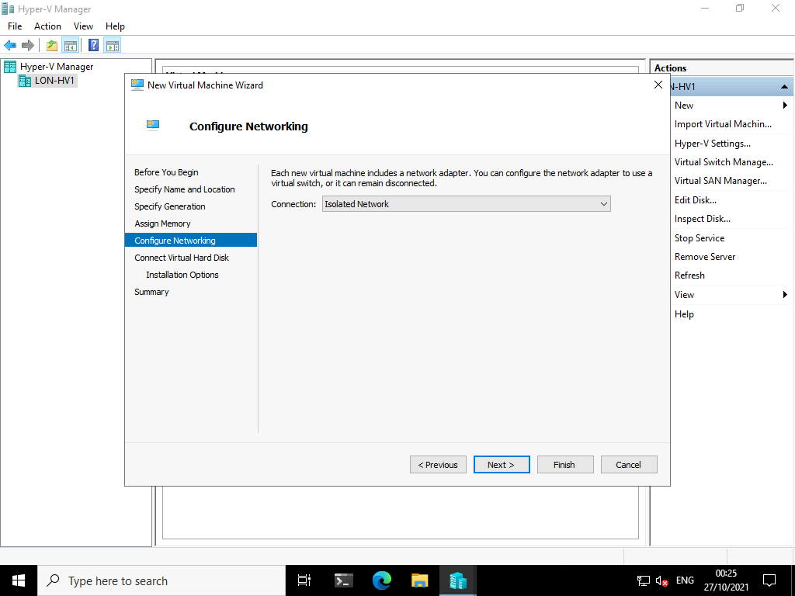

1. On the **Connect Virtual Hard Disk** page, ensure **Create a virtual hard disk** is selected and click **Finish**.

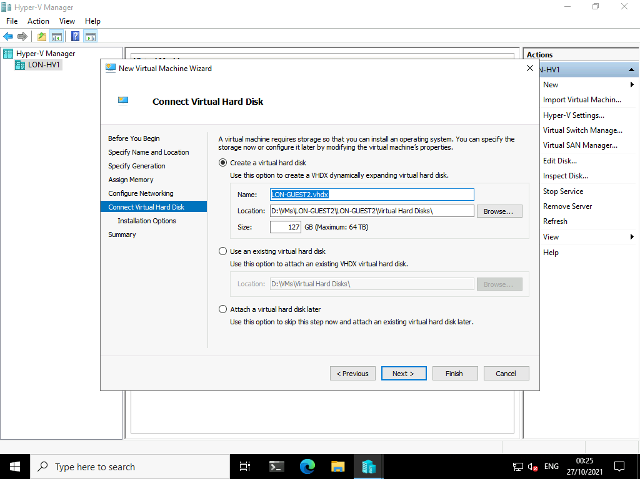

1. Right-click **LON-GUEST2**, and then click **Settings**.

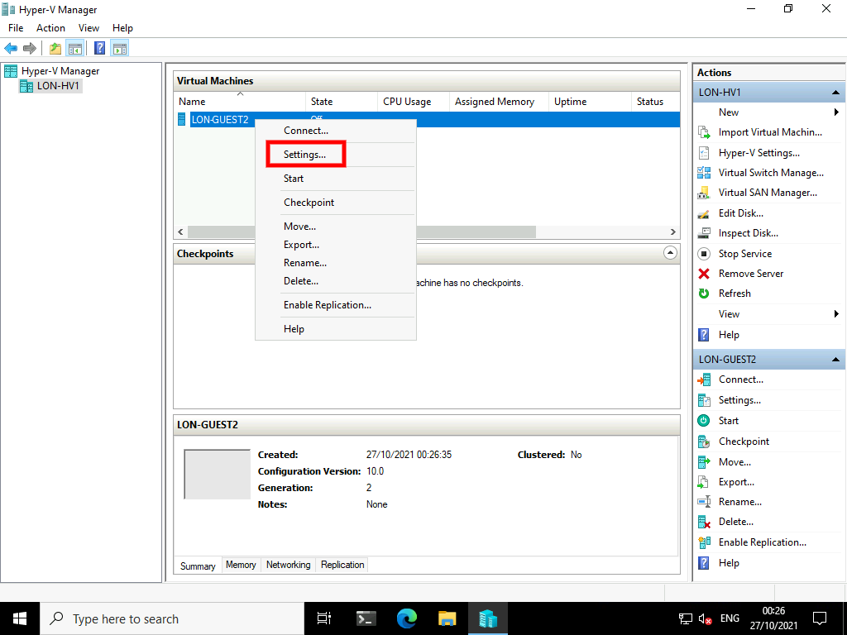

1. In the **Settings for LON-GUEST2 on LON-HV1** window, in the **Hardware** area, select **SCSI Controller** then select **Add**.

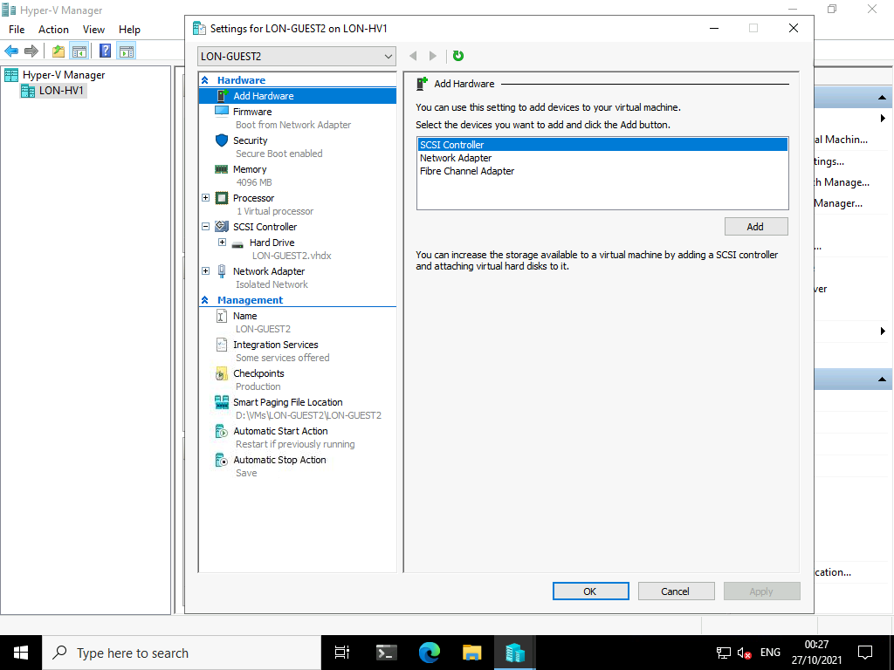

1. Select **SCSI Controller** again, click **DVD Drive**, then click **Add**.

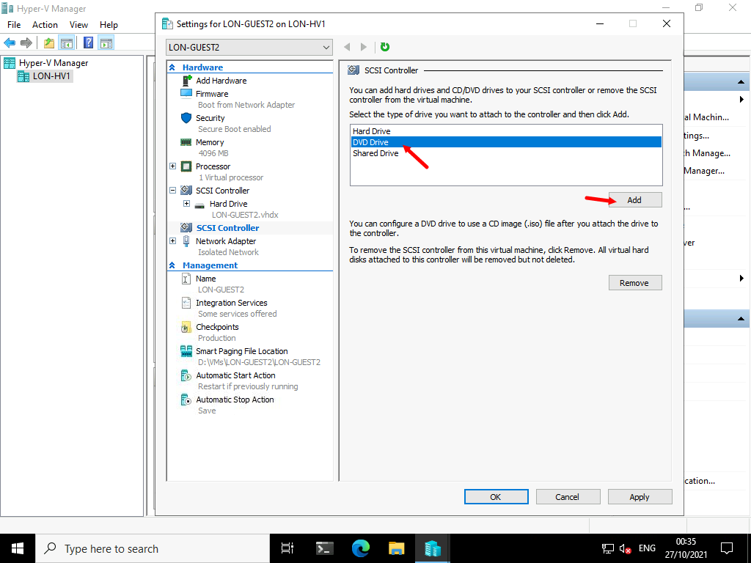

1. In the **DVD Drive** area, click **Image file**.

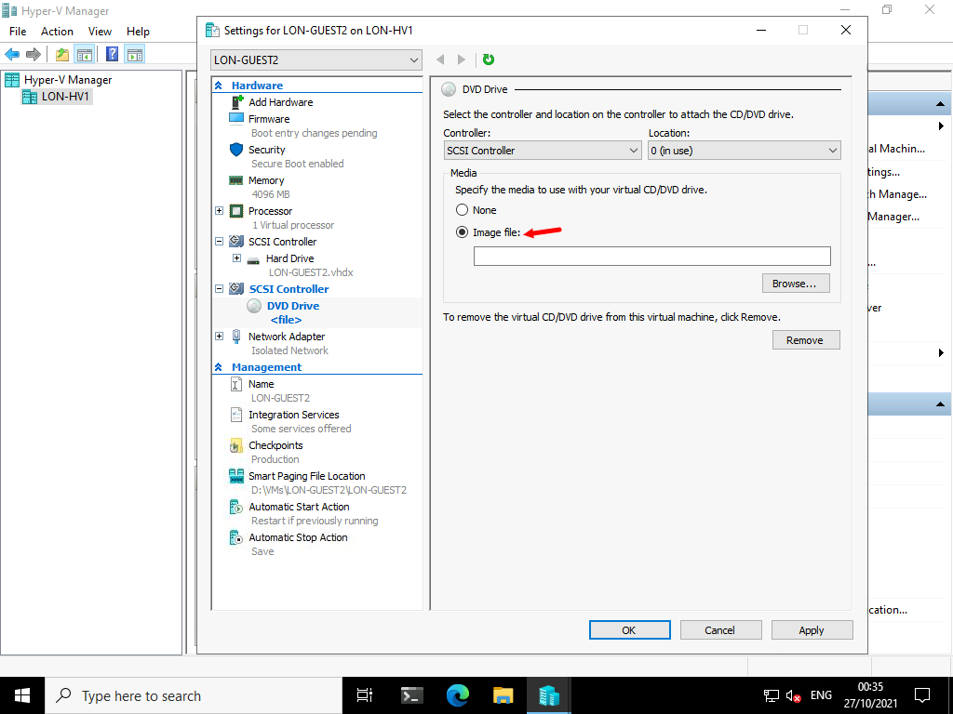

1. In the **Image file** text box, type [**D:\Server2022Eval.iso**](urn:gd:lg:a:send-vm-keys), and then click **Apply**.

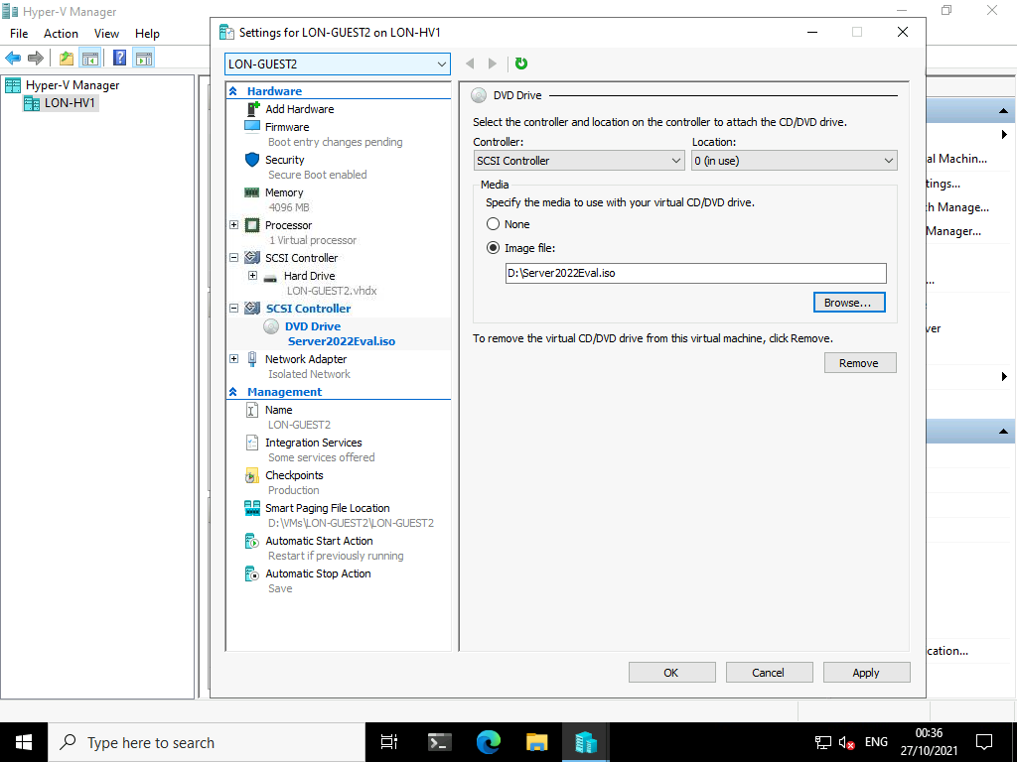

1. In the **Hardware** area, click **Firmware**.

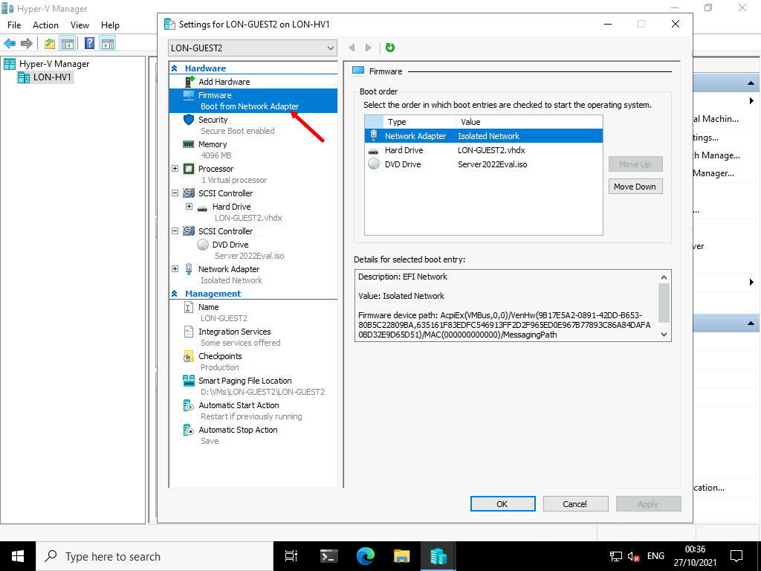

1. In the **Boot order** area, click **Network Adapter**, click **Move Down** twice, and then click **Apply**.

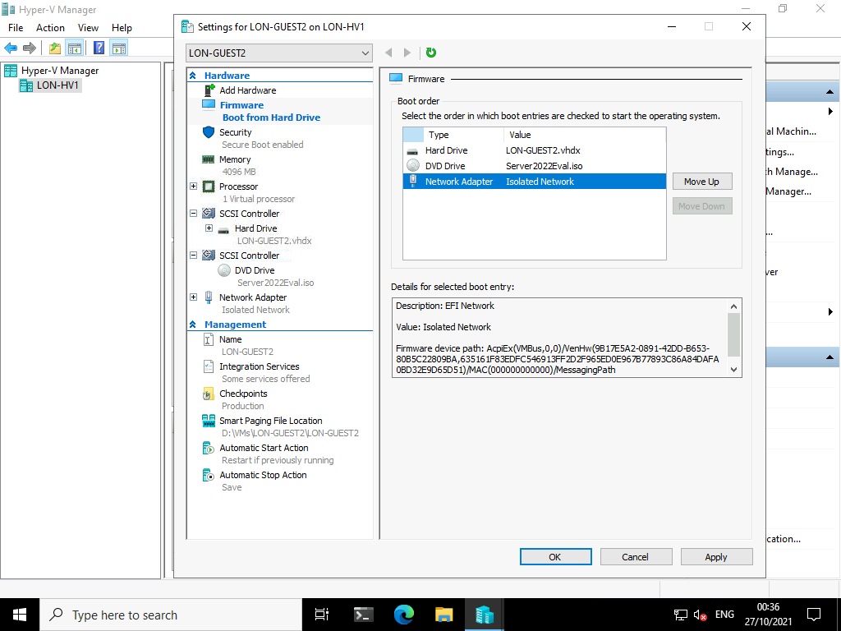

1. Select **Processor**. In the **Number of virtual processors** text box, type [**4**](urn:gd:lg:a:send-vm-keys).

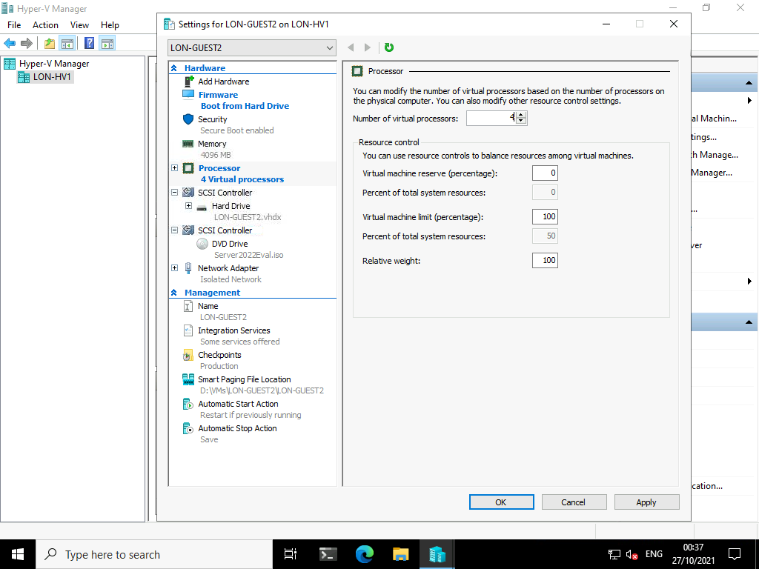

1. Right-click **LON-GUEST2**, and then click **Connect**.

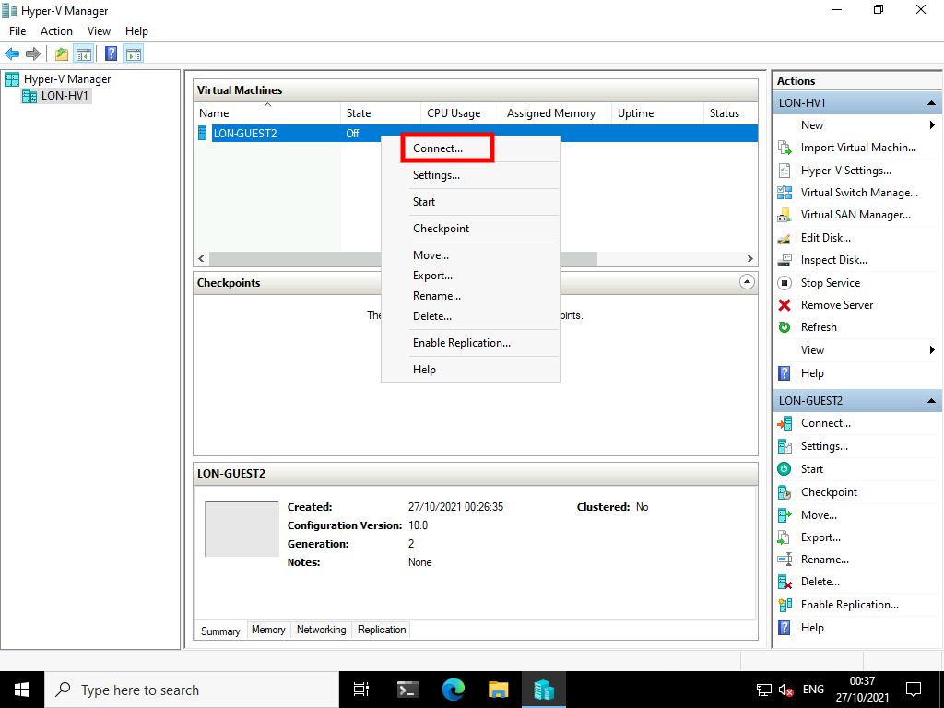

1. In the **LON-GUEST2 on LON-HV1 - Virtual Machine Connection** window, click **Start**.

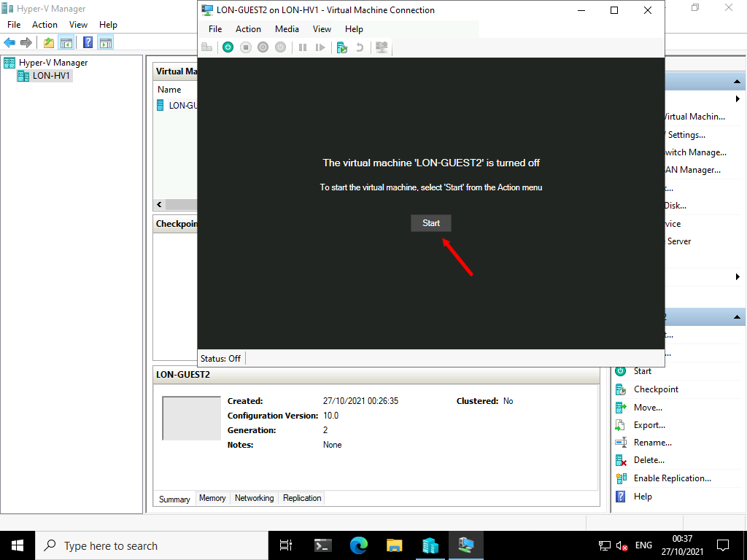

1. Press any key to boot from DVD.

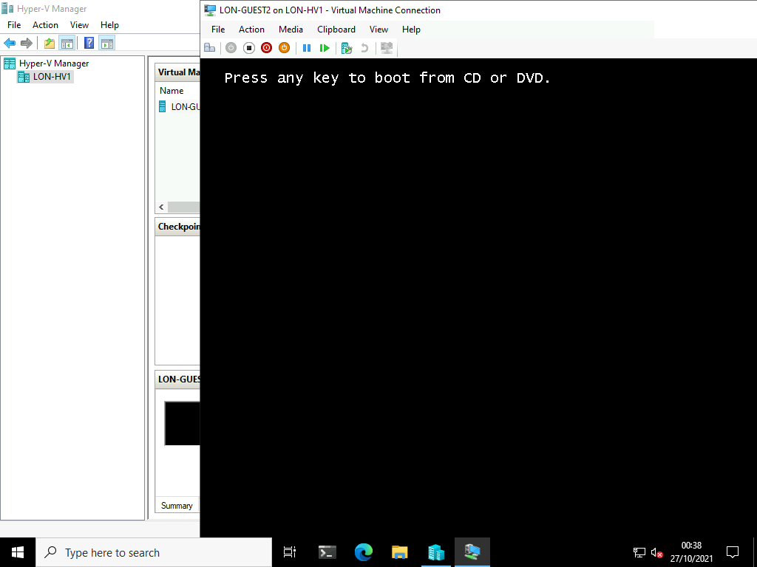

1. In the **Windows Setup** window, click **Next**, and then click **Install now**.

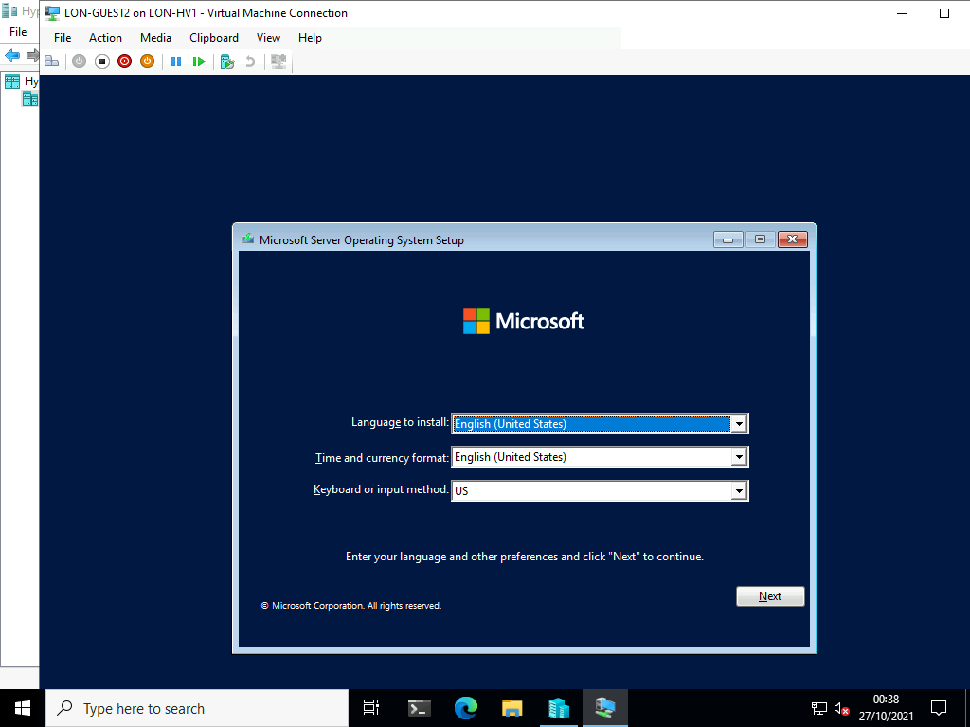

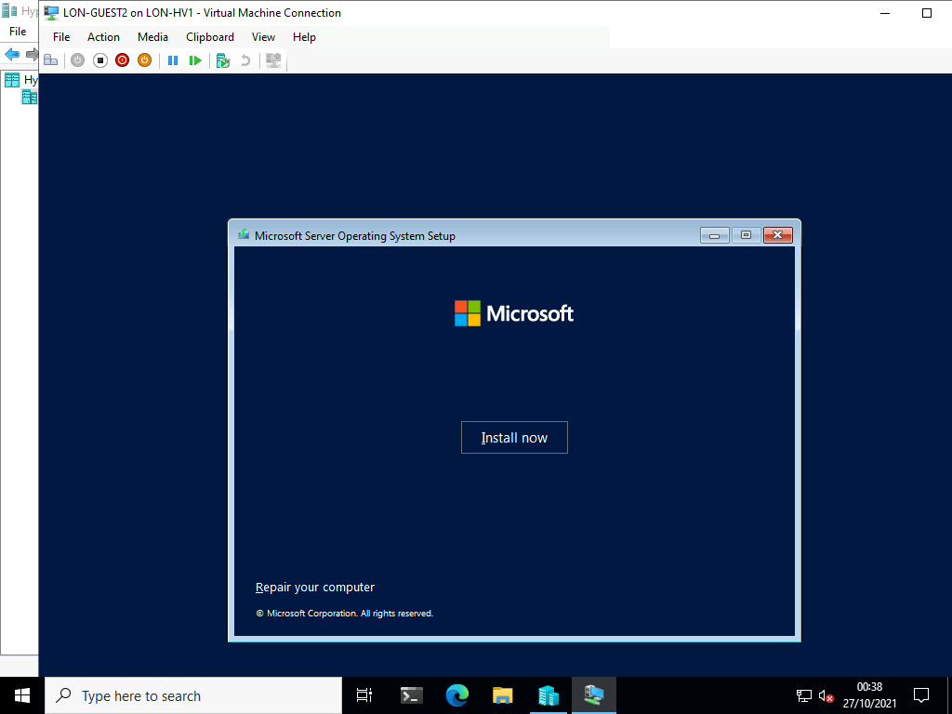

1. On the **Select the operating system you want to install** page, click **Windows Server 2022 Datacenter Evaluation (Desktop Experience)**, and then click **Next**.

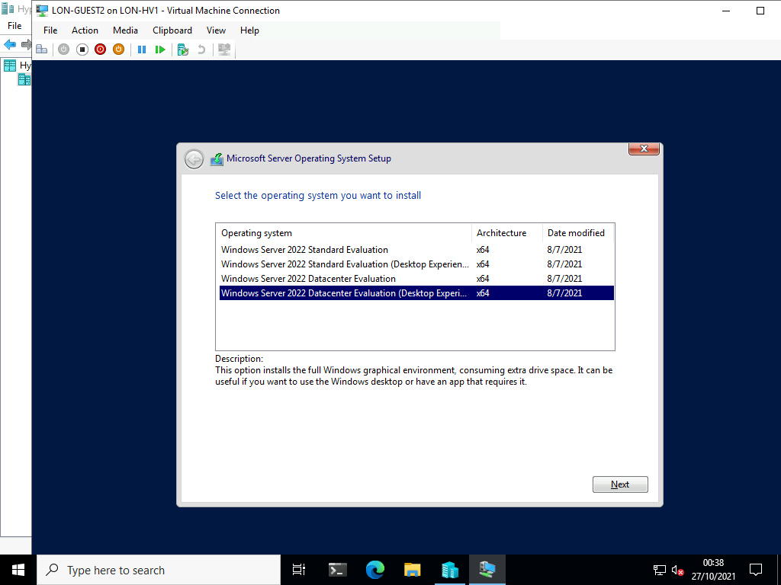

1. On the **Applicable notices and license terms** page, select the **I accept the license terms** check box, and then click **Next**.

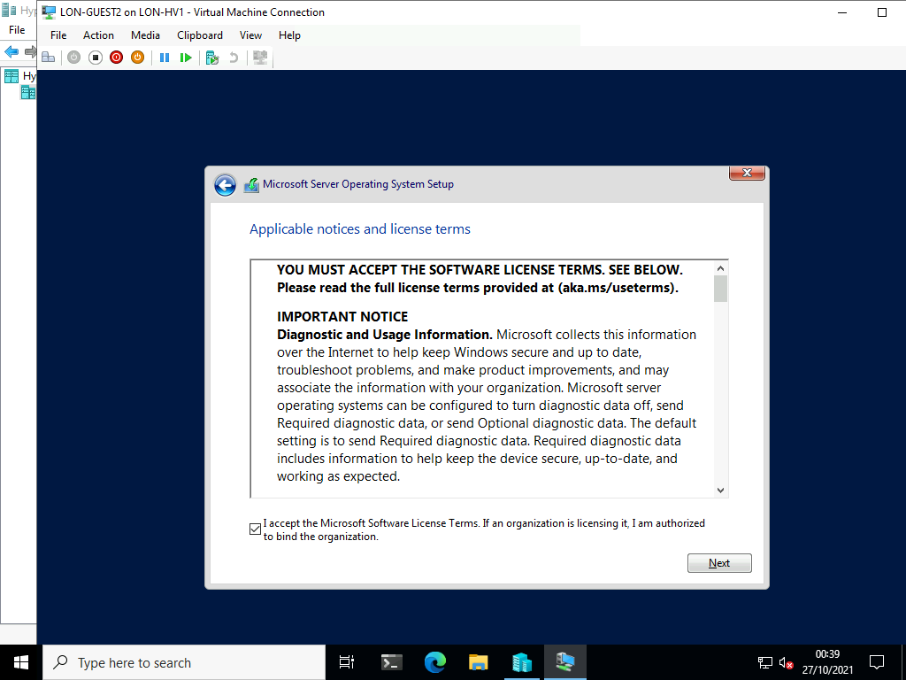

1. On the **Which type of installation do you want** page, click **Custom: Install Windows only (advanced)**.

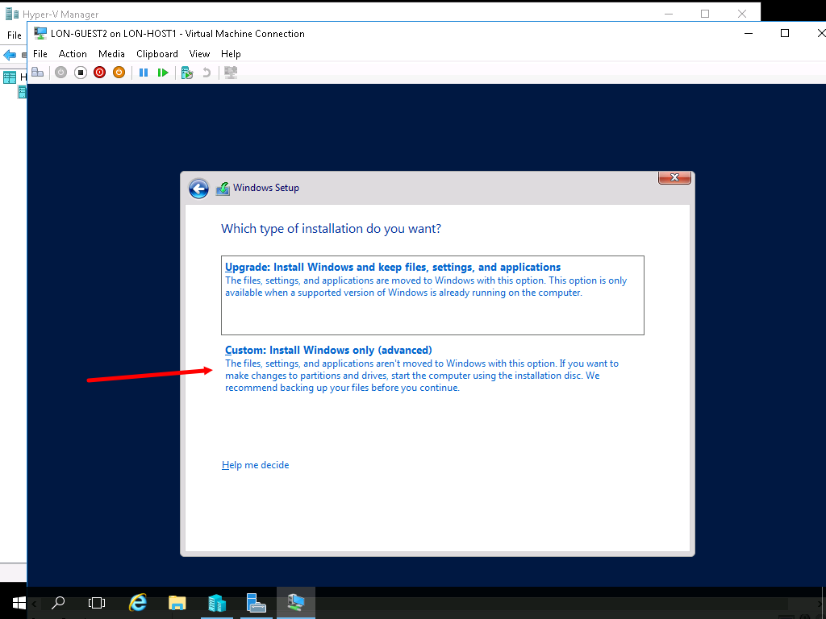

1. On the **Where do you want to install Windows** page, click **Drive 0 Unallocated Space**, and then click **Next**.

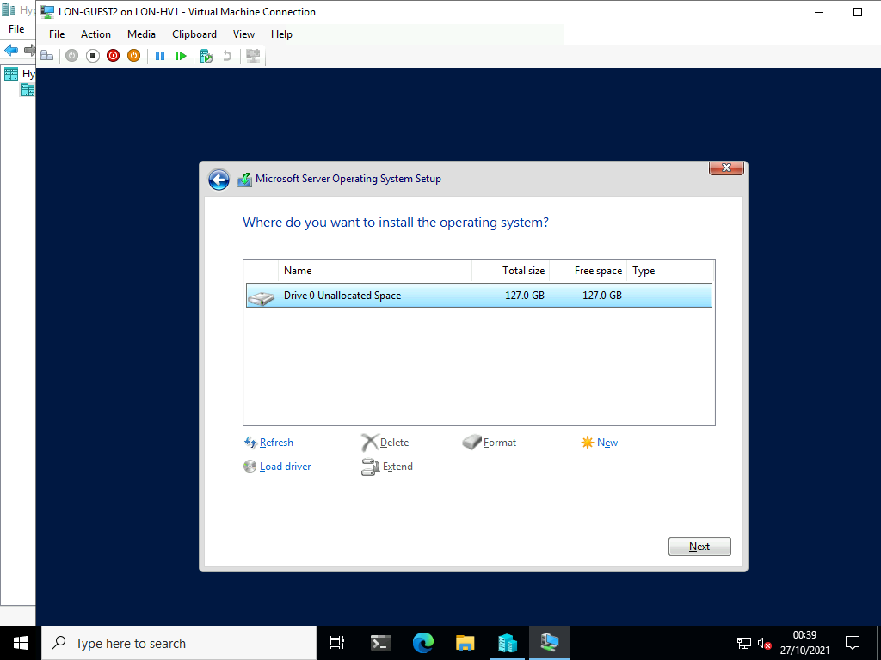

**Note:** The Windows Server operating system installation requires an extended amount of time. You can work on the next task while waiting for the installation to complete. It should take around 15 Minutes to complete.

1. On the **Customize settings** page, in the **Password** and **Reenter password** text boxes, type [**Pa55w.rd**](urn:gd:lg:a:send-vm-keys), and then click **Finish**.

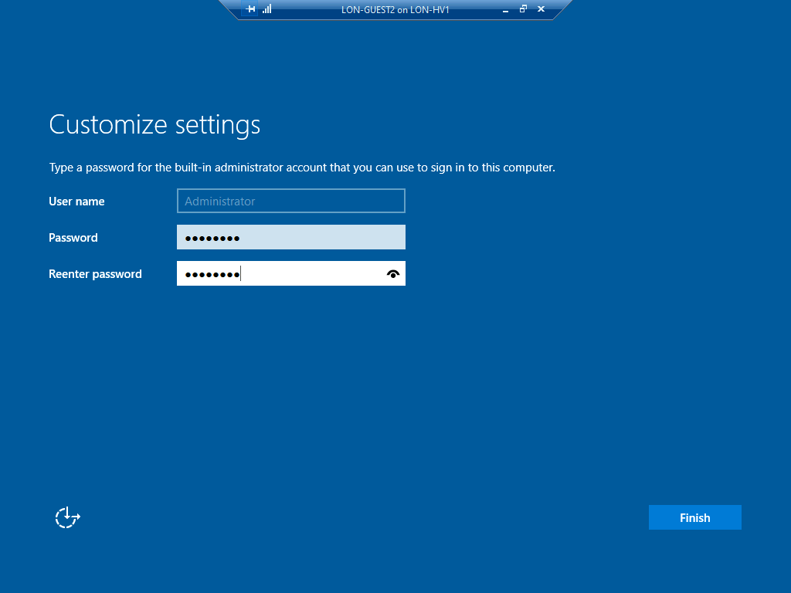

1. After the installation is complete, in the **LON-GUEST2 on LON-HV1 - Virtual Machine Connection** window, click **Action**, then click **Shut Down**. Click **Shut Down** again to confirm.

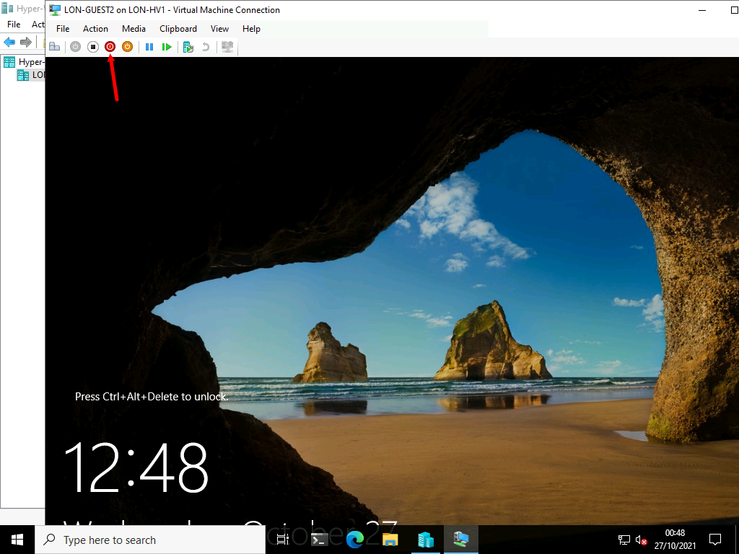

1. Close the connection window to LON-GUEST2.

Task 2: Create a Generation 1 virtual machine

1. In **Hyper-V Manager**, in the **Actions** pane, click **New**, and then click **Hard Disk**.

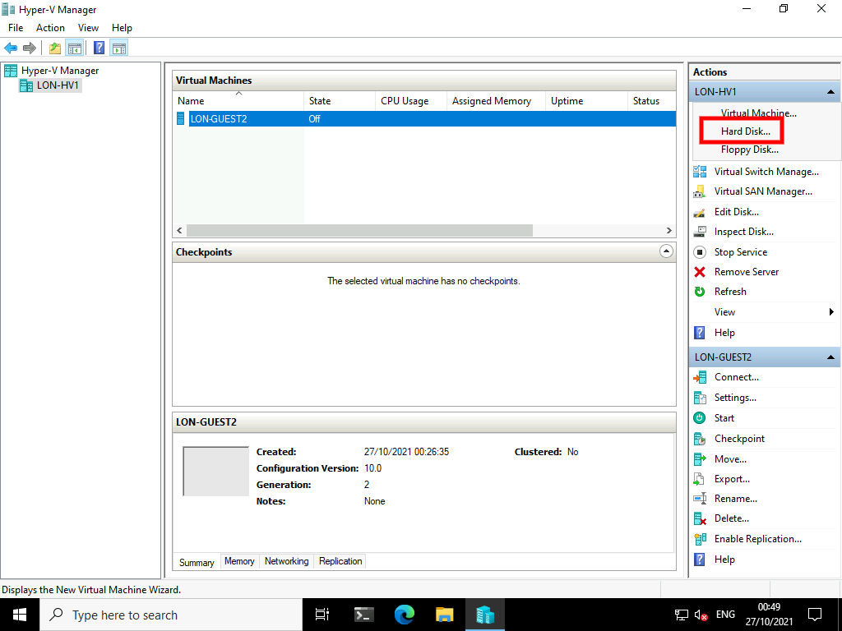

1. In the **New Virtual Hard Disk Wizard**, on the **Before You Begin** page, click **Next**.

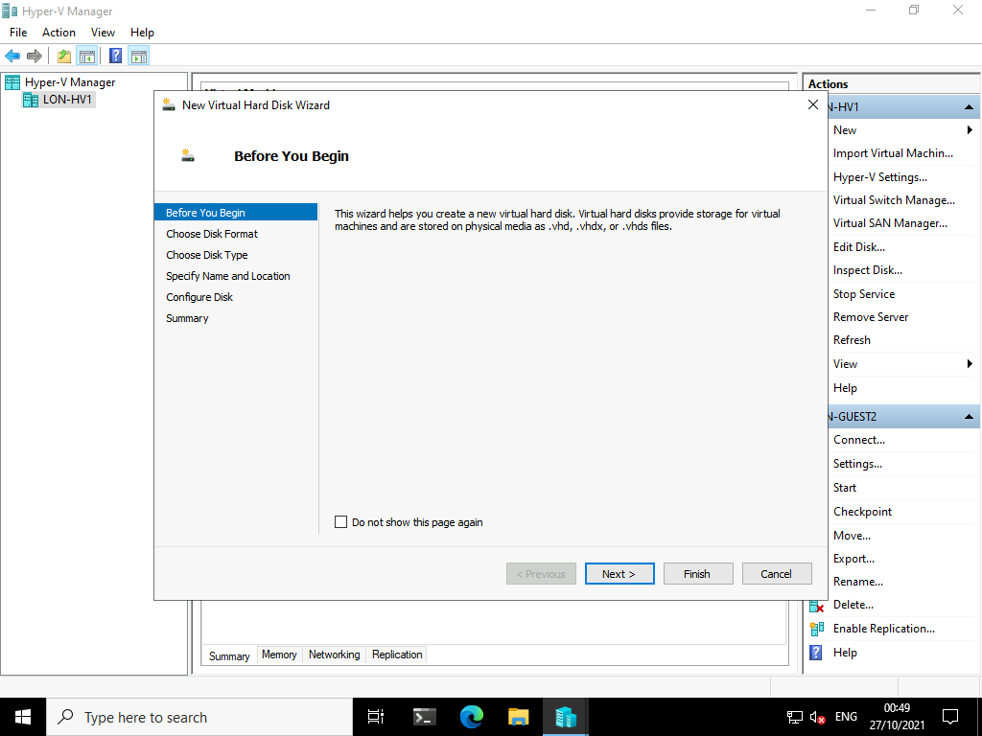

1. On the **Choose Disk Format** page, click **VHD**, and then click **Next**.

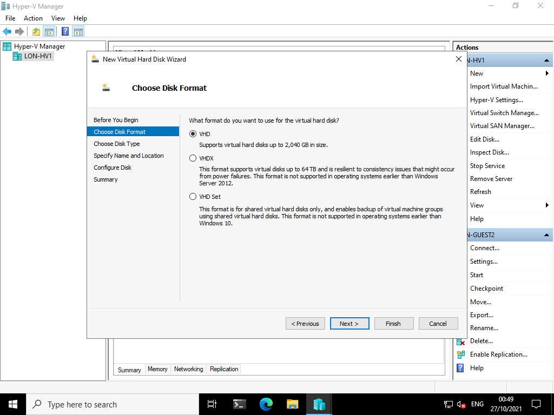

1. On the **Choose Disk Type** page, select **Differencing**, and then click **Next**.

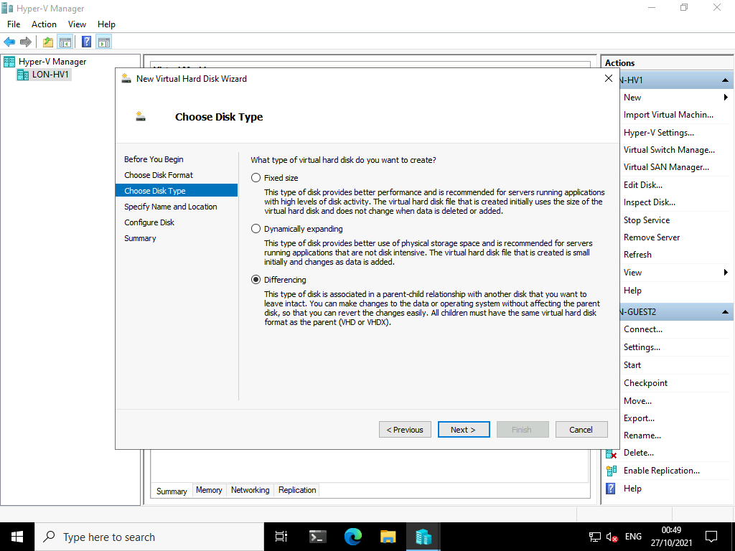

1. On the **Specify Name and Location** page, specify the following details, and then click **Next** :
   * Name: [**LON-GUEST1.vhd**](urn:gd:lg:a:send-vm-keys)
   * Location: [**D:\VMs\LON-GUEST1\**](urn:gd:lg:a:send-vm-keys)

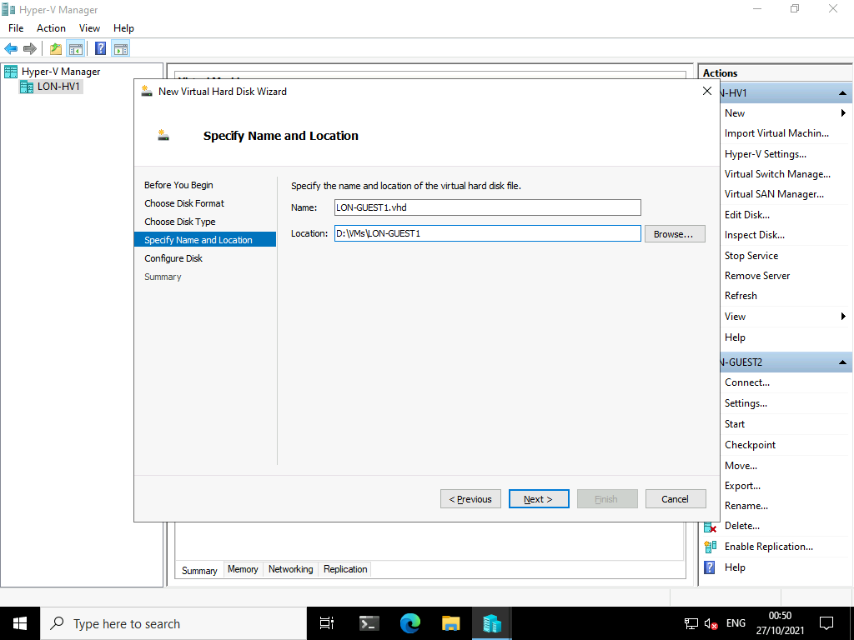

1. On the **Configure Disk** page, type [**D:\Server2022Base.vhd**](urn:gd:lg:a:send-vm-keys) as the location, and then click **Finish**.

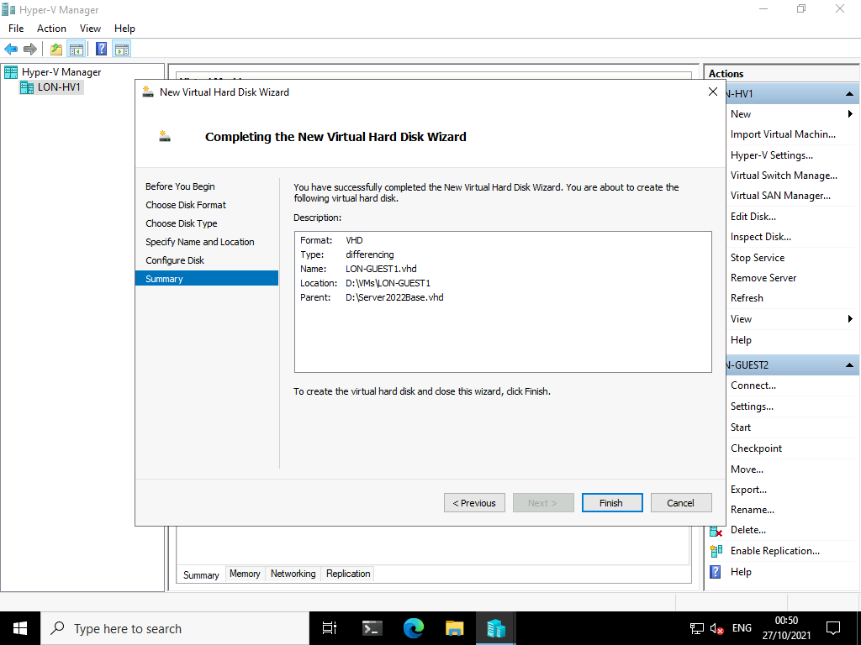

1. Right click **Start**, and then click the **Windows PowerShell (Admin)**.

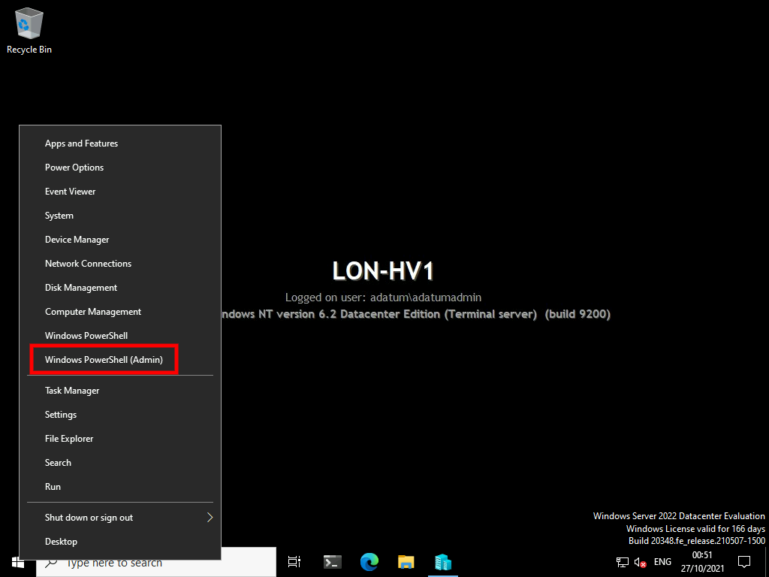

1. At the **Windows PowerShell** command prompt, type the following command to create a new virtual machine named **LON-GUEST1**, and then press Enter:
2. New-VM -Name LON-GUEST1 -MemoryStartupBytes 1024MB -VHDPath "D:\VMs\LON-GUEST1\LON-GUEST1.vhd" -SwitchName "Isolated Network"

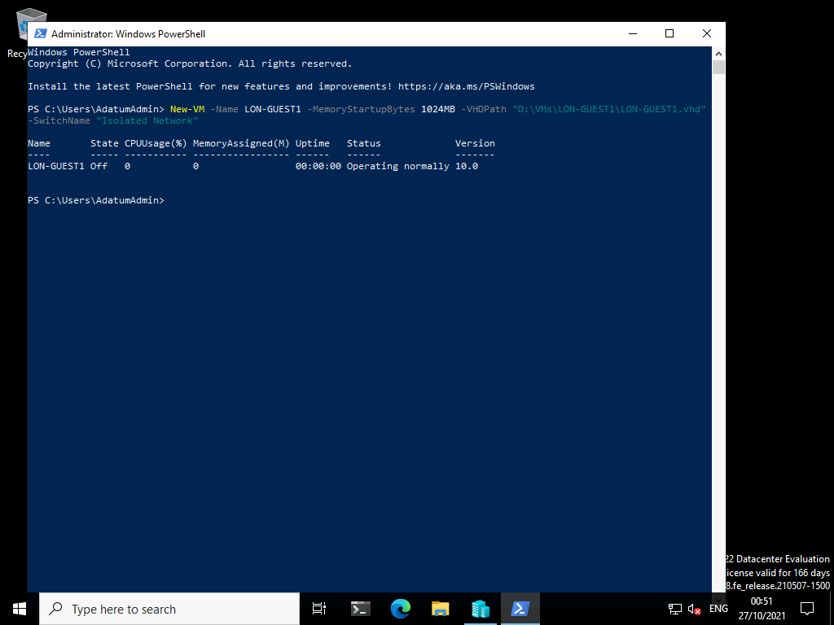

1. Close the **Windows PowerShell** window.

Task 3: Configure virtual machines

1. On [**LON-HV1**](urn:gd:lg:a:select-vm), in **Hyper-V Manager**, right-click **LON-GUEST1**, and then click **Settings**.

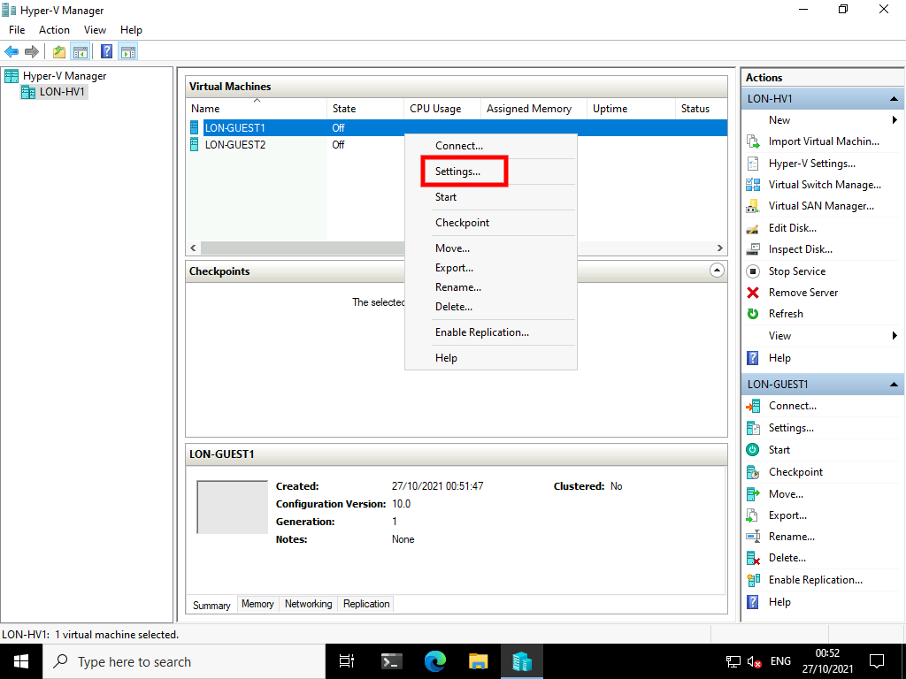

1. In the **Settings for LON-GUEST1 on LON-HV1** window, note the list of hardware for **LON-GUEST1**.

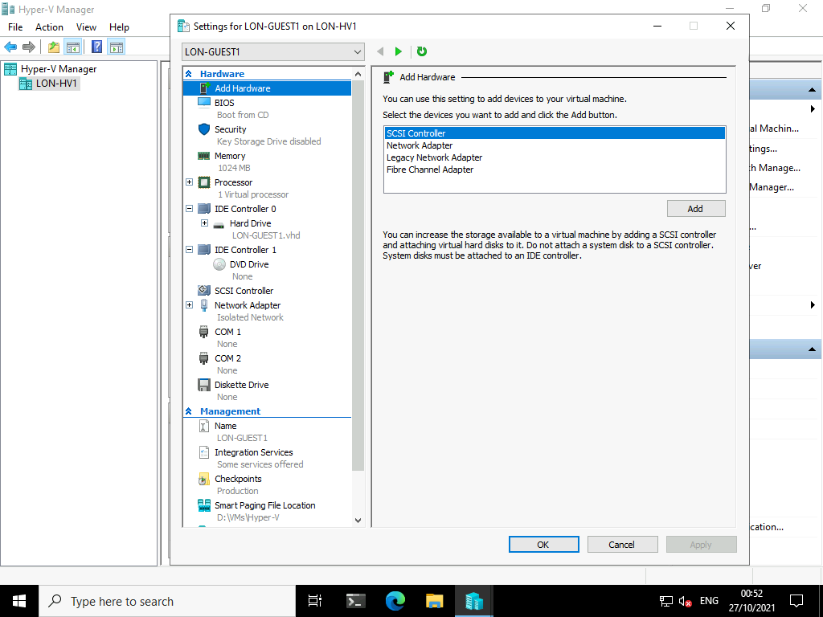

1. In the **Hardware** area, click **Memory**.

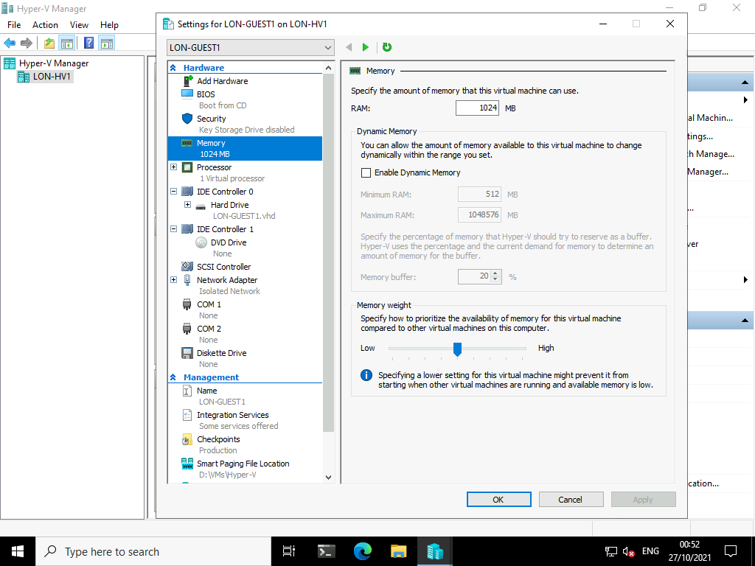

1. Select the **Enable Dynamic Memory** check box.

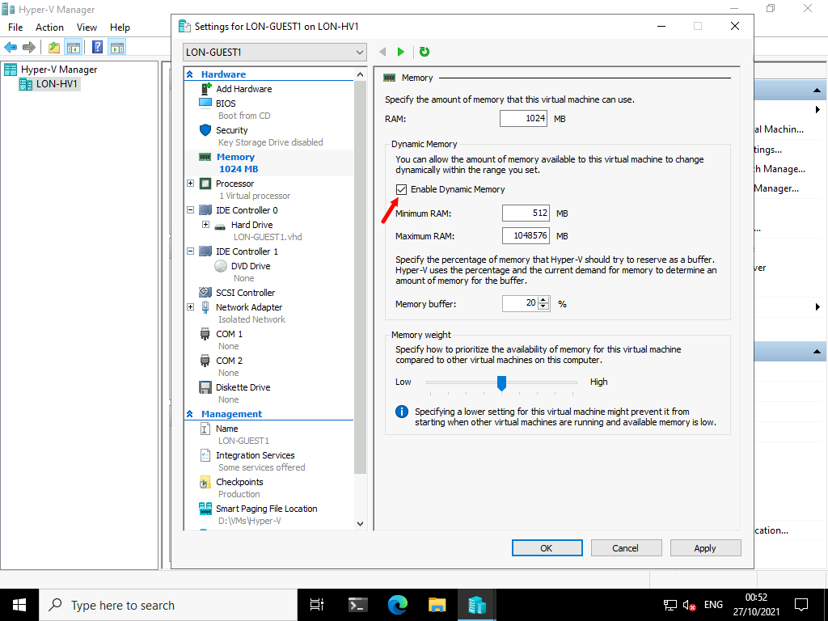

1. In the **Maximum RAM** box, type [**4096**](urn:gd:lg:a:send-vm-keys).

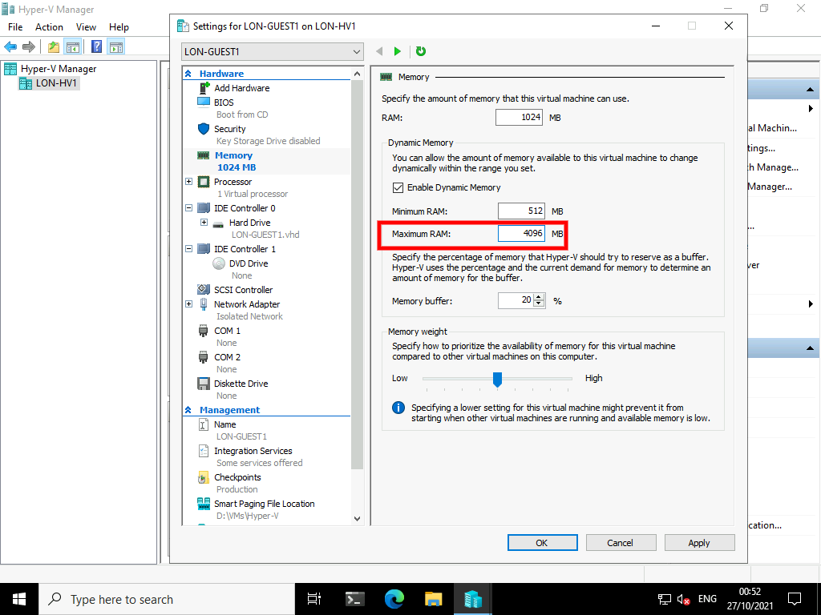

1. In the **Hardware** area, click **Processor**.

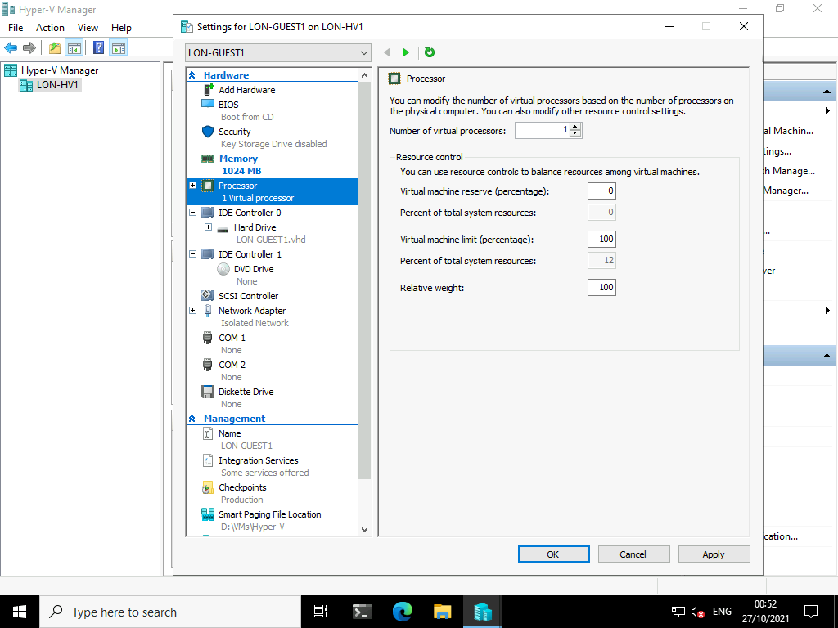

1. In the **Number of virtual processors** text box, type [**4**](urn:gd:lg:a:send-vm-keys).

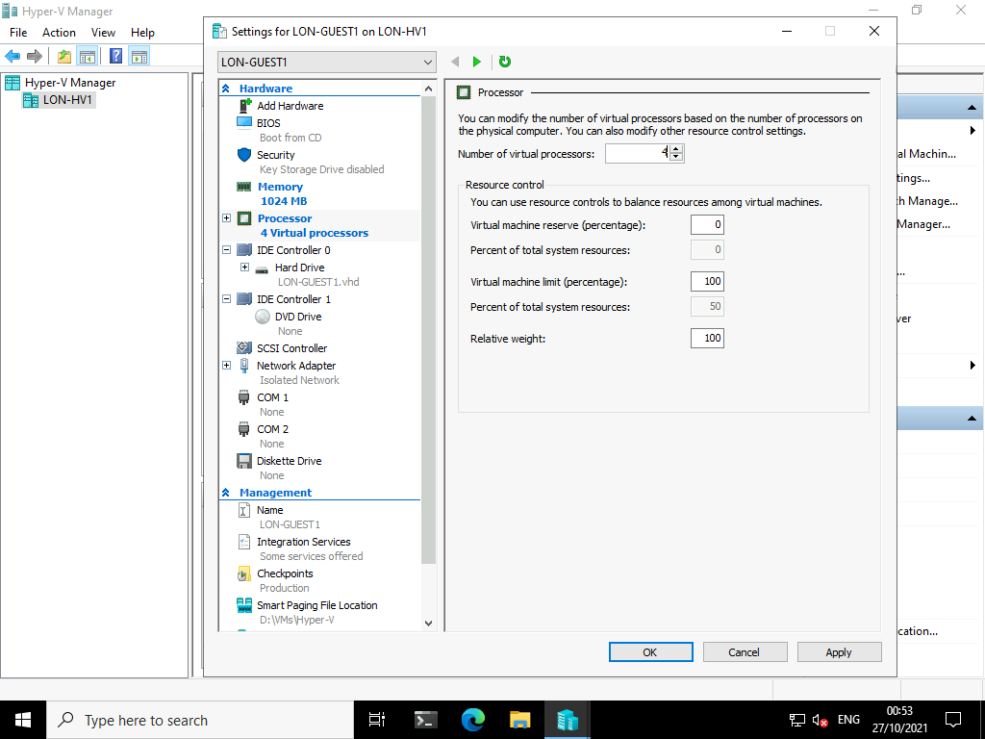

1. In the **Hardware** area, click **Network Adapter**.

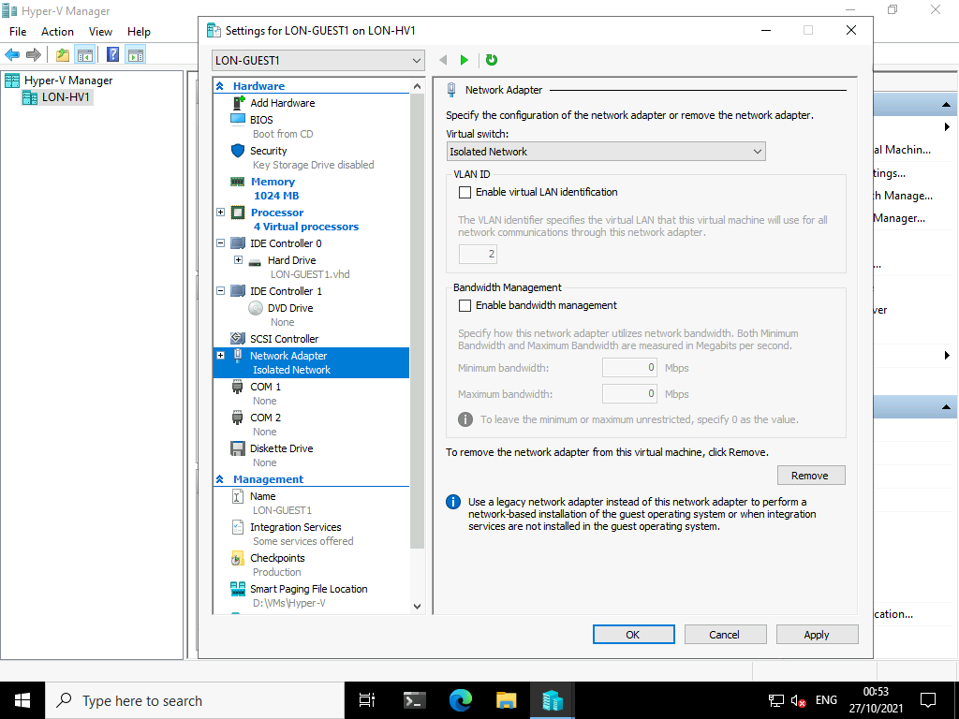

1. In the **Bandwidth Management** area, select the **Enable bandwidth management** check box.

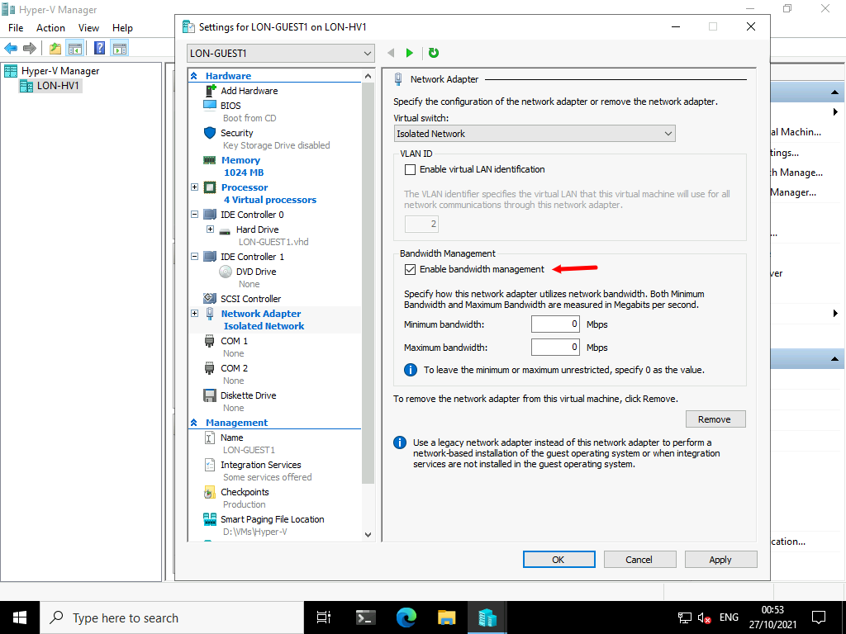

1. In the **Minimum bandwidth** textbox, type [**10**](urn:gd:lg:a:send-vm-keys).
2. In the **Maximum bandwidth** text box, type [**100**](urn:gd:lg:a:send-vm-keys).

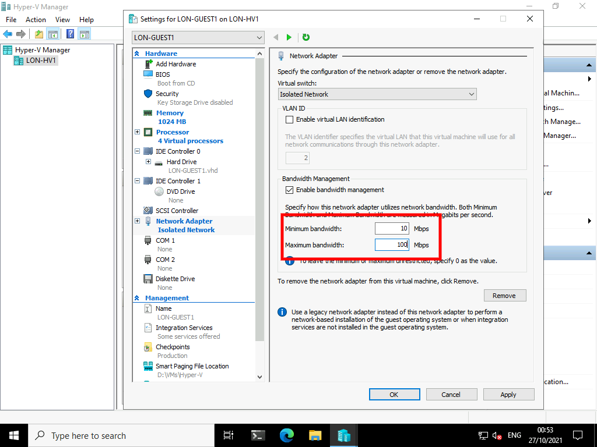

1. In the **Management** area, click **Integration Services**.

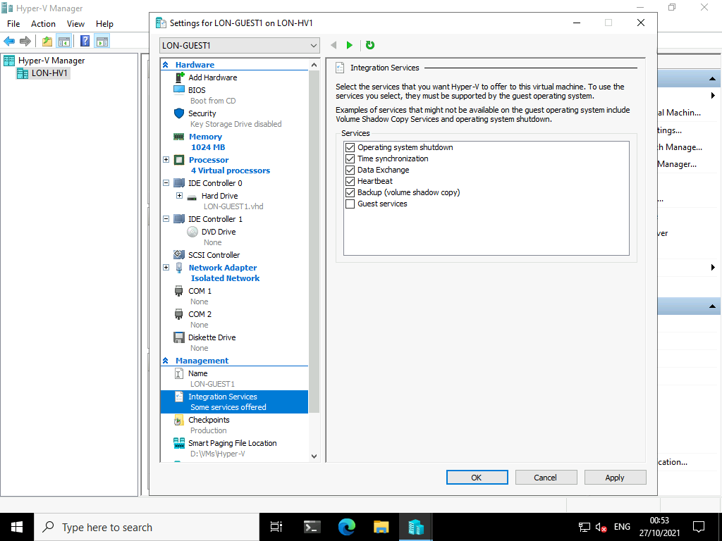

1. Select the **Guest services** check box, and then click **OK**.

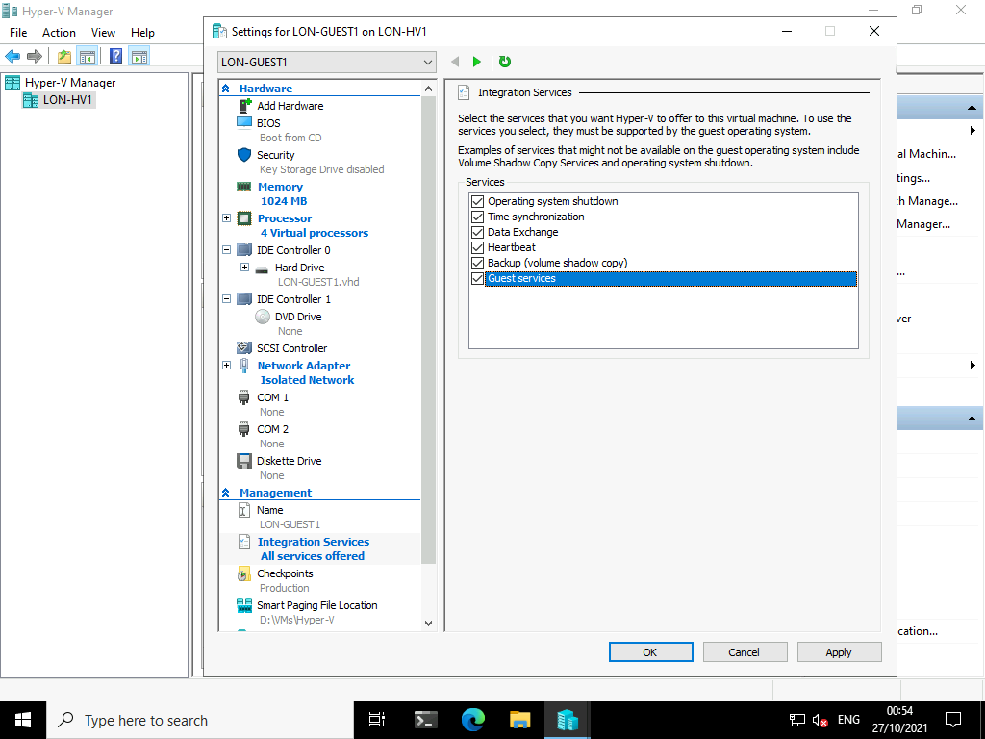

**Note:** You must have completed the previous tasks in this exercise before you can continue. This includes shutting down **LON-GUEST2**.

1. In **Hyper-V Manager**, right-click **LON-GUEST2**, and then click **Settings**.

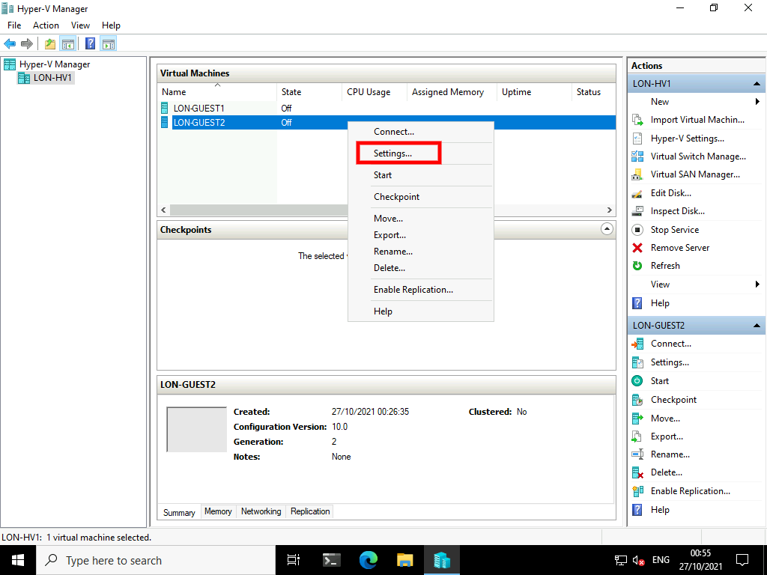

1. In the **Settings for LON-GUEST2 on LON-HV1** window, note the list of hardware for **LON-GUEST2**. Note the differences from **LON-GUEST1**.
2. In the **Hardware** area, click **Security**, and then read the settings that are available.

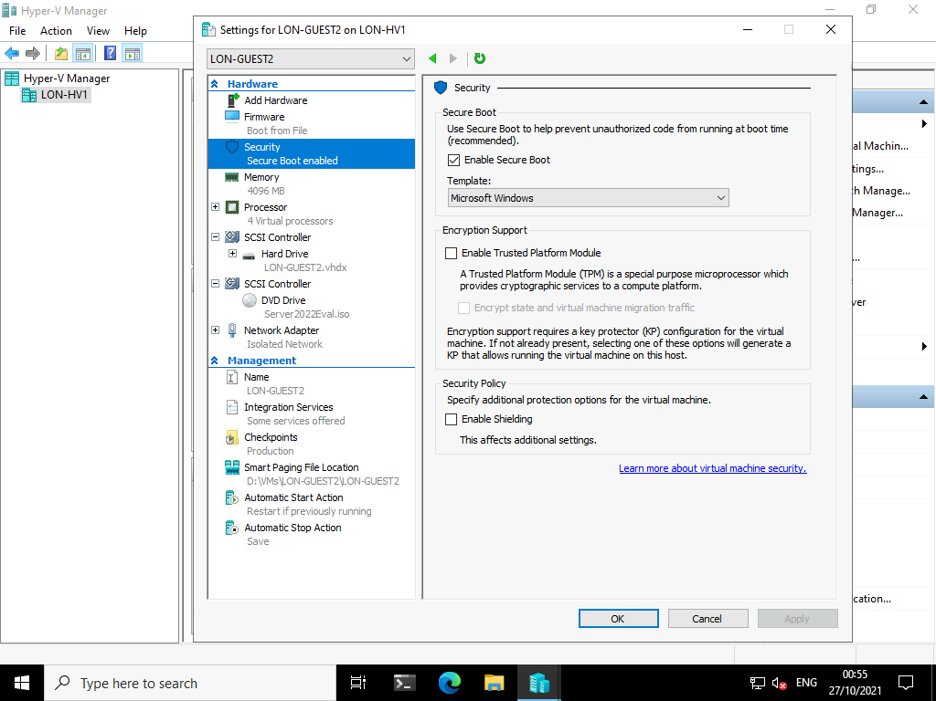

1. In the **Hardware** area, click **Memory**.

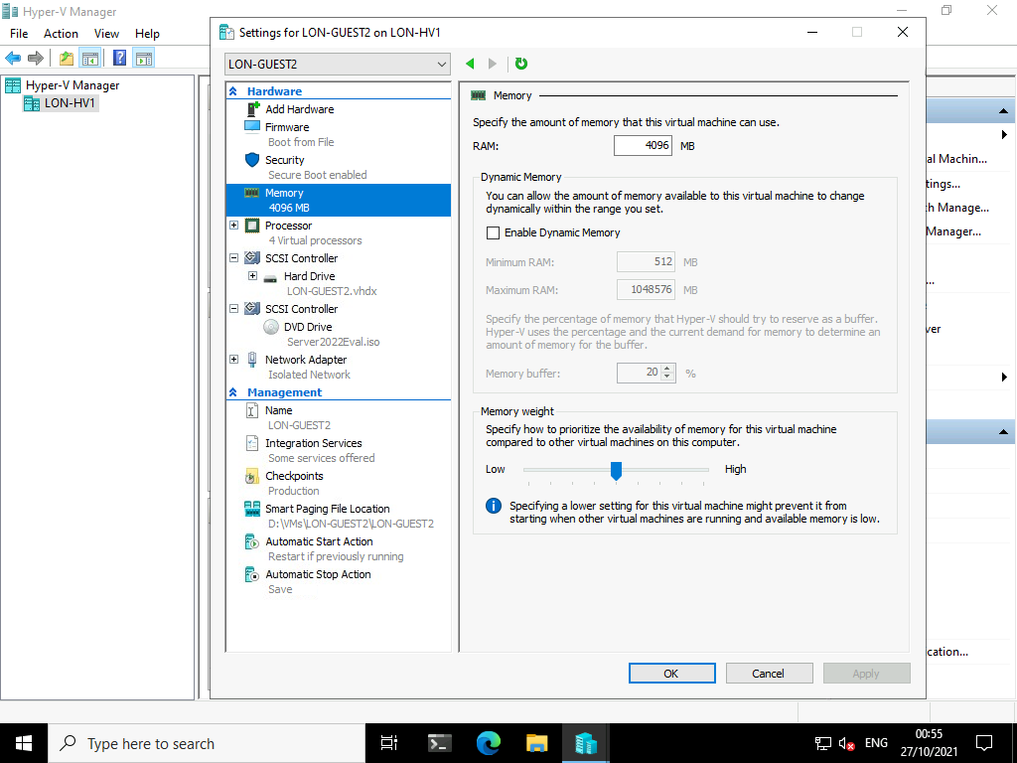

1. Verify that the **Enable dynamic memory** check box is not selected.

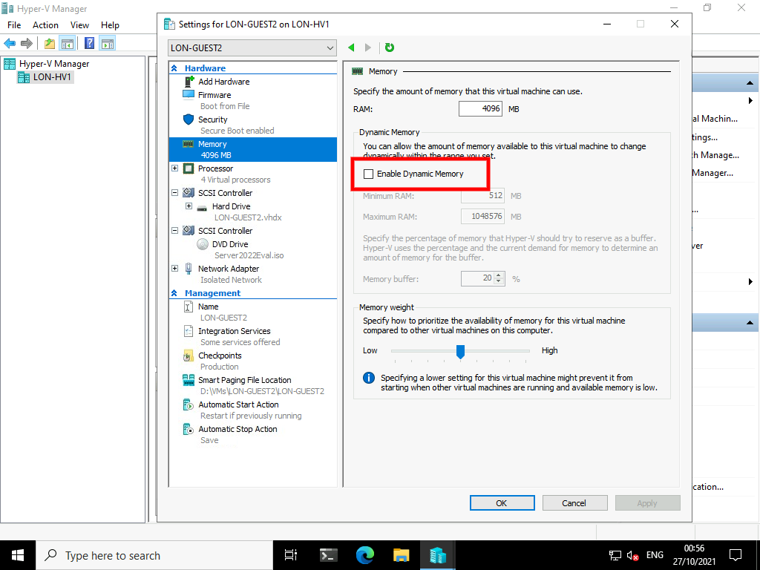

1. In the **Hardware** area, expand **Hard Drive**, and then click **Quality of Service**.

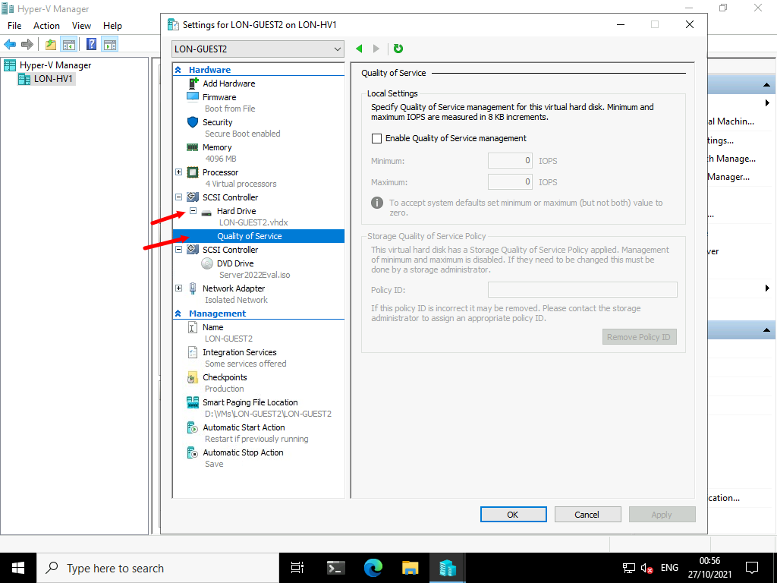

1. Select the **Enable Quality of Service management** check box.

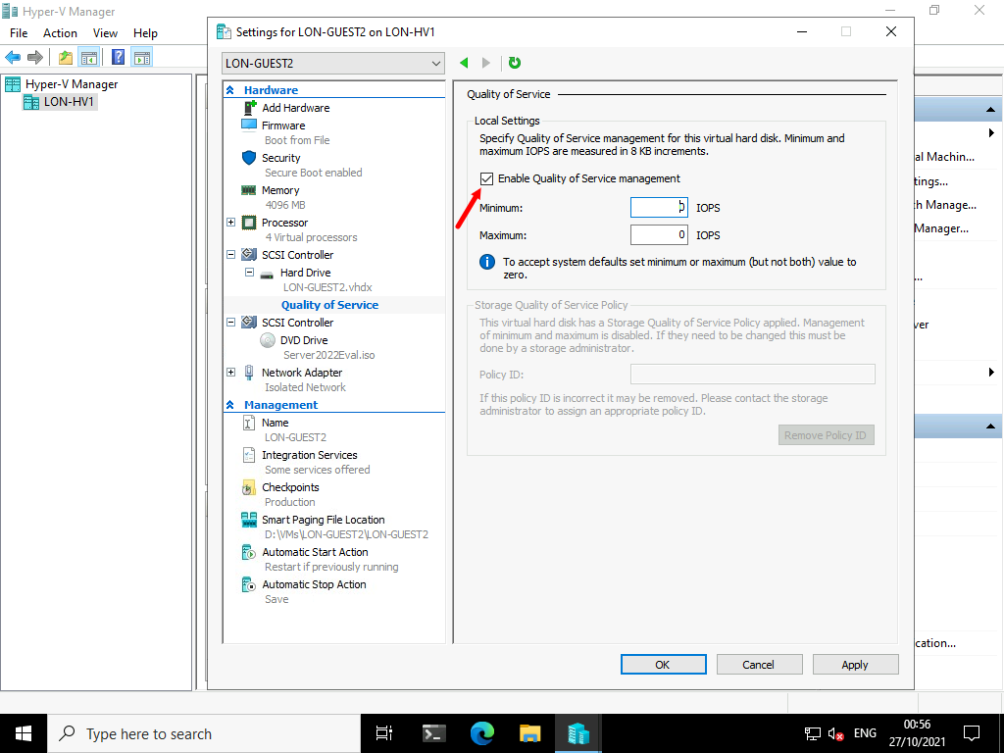

1. In the **Minimum** text box, type [**10**](urn:gd:lg:a:send-vm-keys).

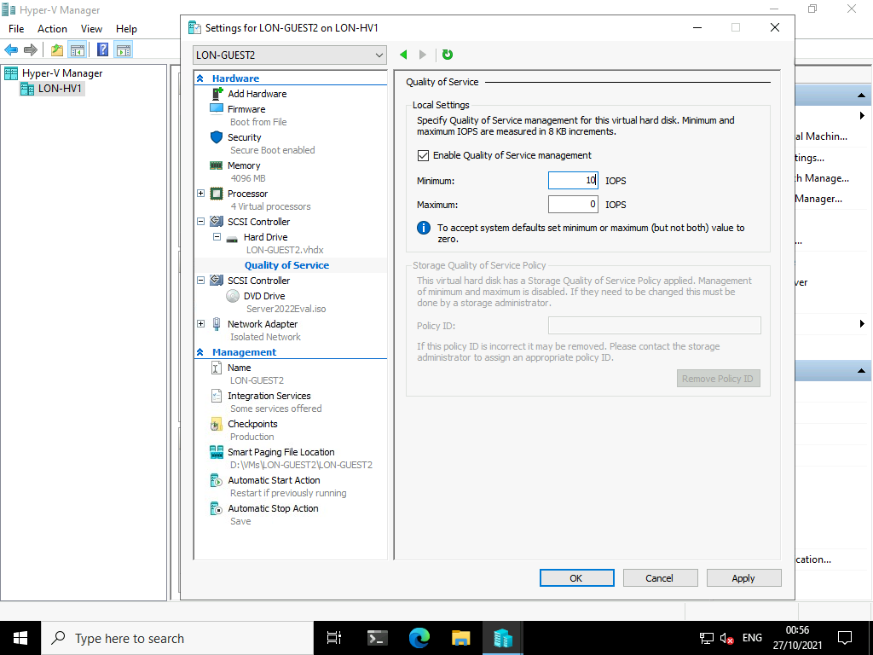

1. In the **Management** area, click **Integration Services**.

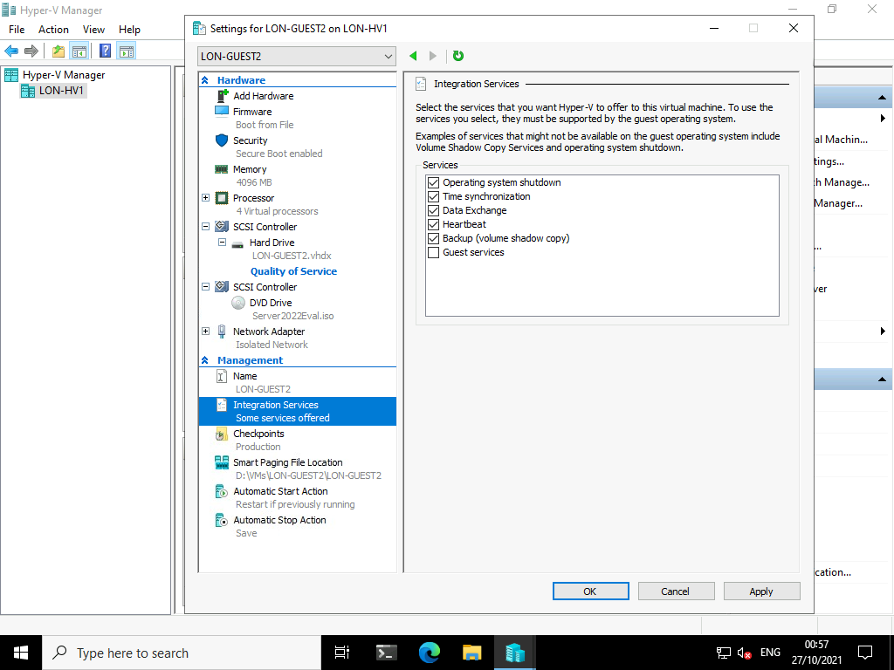

1. Select the **Guest services** check box, and then click **OK**.

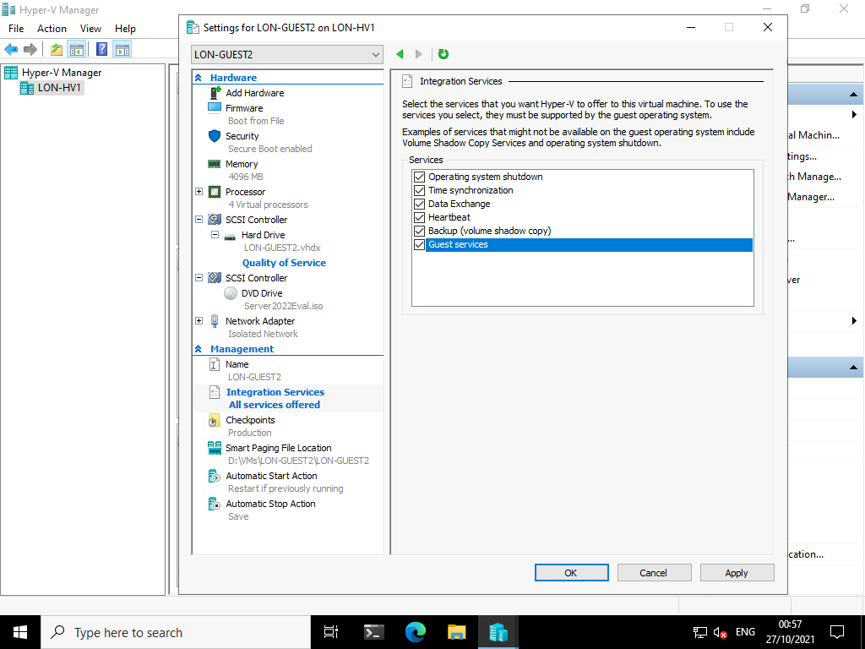

Task 4: Create checkpoints

1. On [**LON-HV1**](urn:gd:lg:a:select-vm), in **Hyper-V Manager**, right-click **LON-GUEST2**, and then click **Checkpoint**.

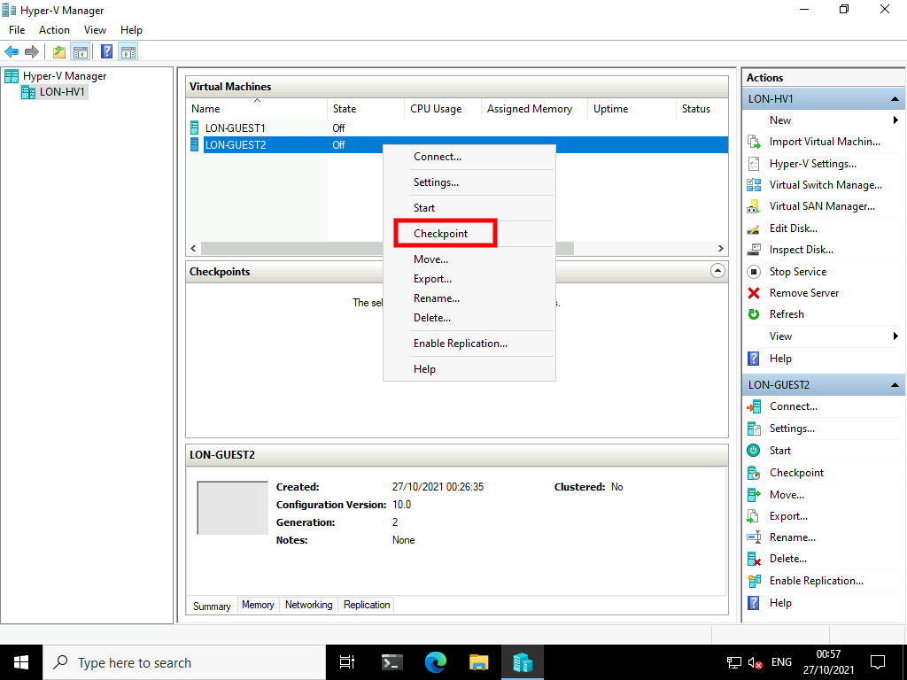

1. Right-click **LON-GUEST2**, and then click **Start**.

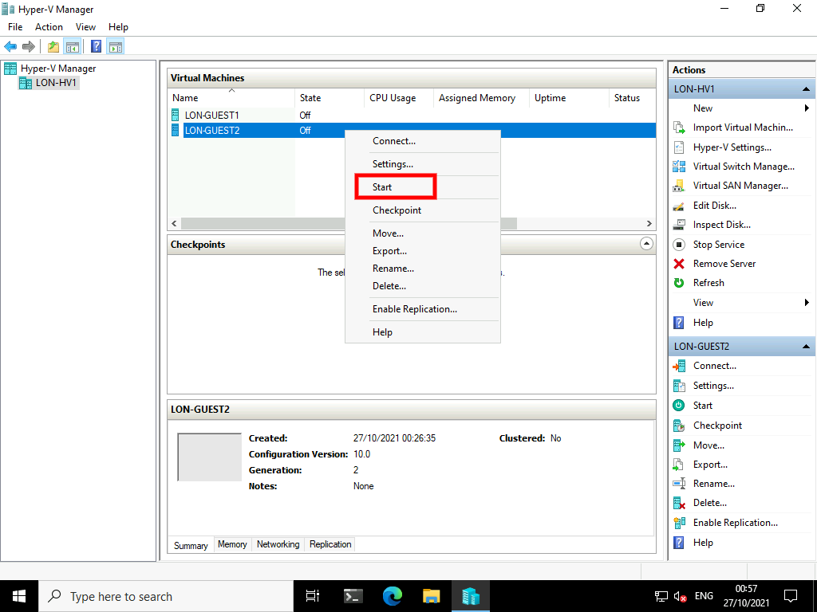

1. Right-click **LON-GUEST2**, and then click **Connect**.

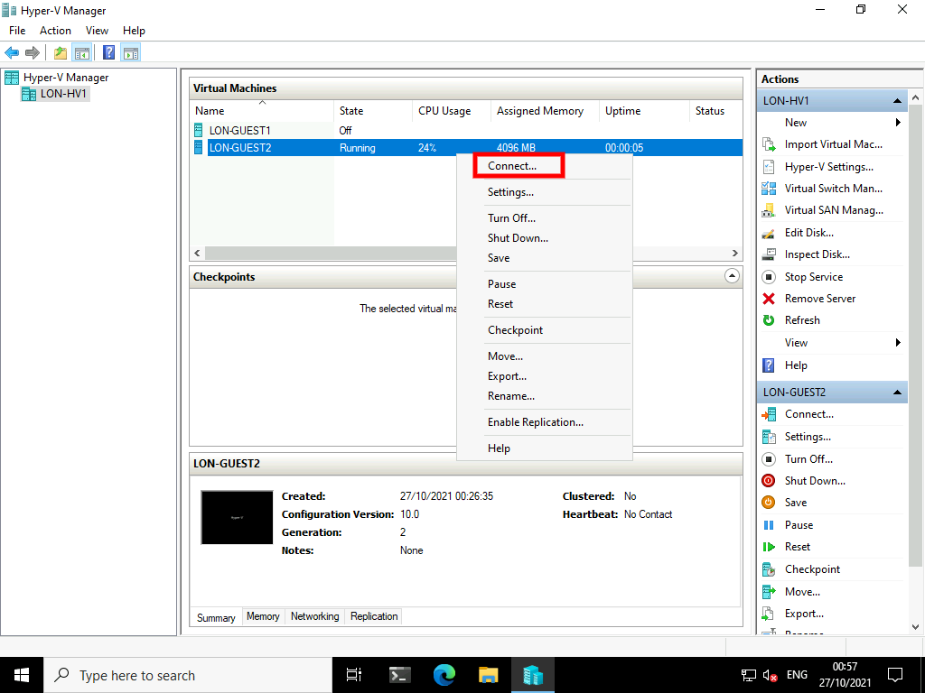

1. On **LON-GUEST2**, select the **Action** tab at the top of the display, then select **Ctrl+Alt+Delete**.

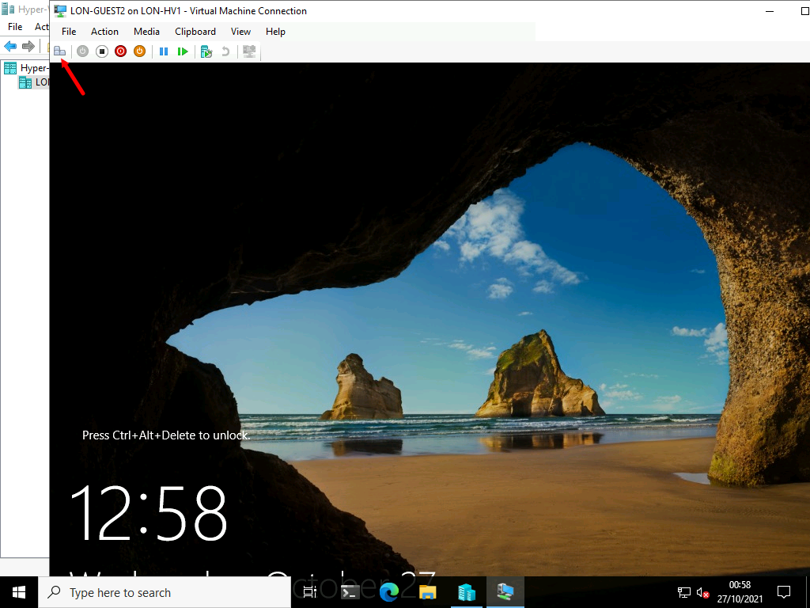

1. On **LON-GUEST2**, sign in as **Administrator** with the password [**Pa55w.rd**](urn:gd:lg:a:send-vm-keys).

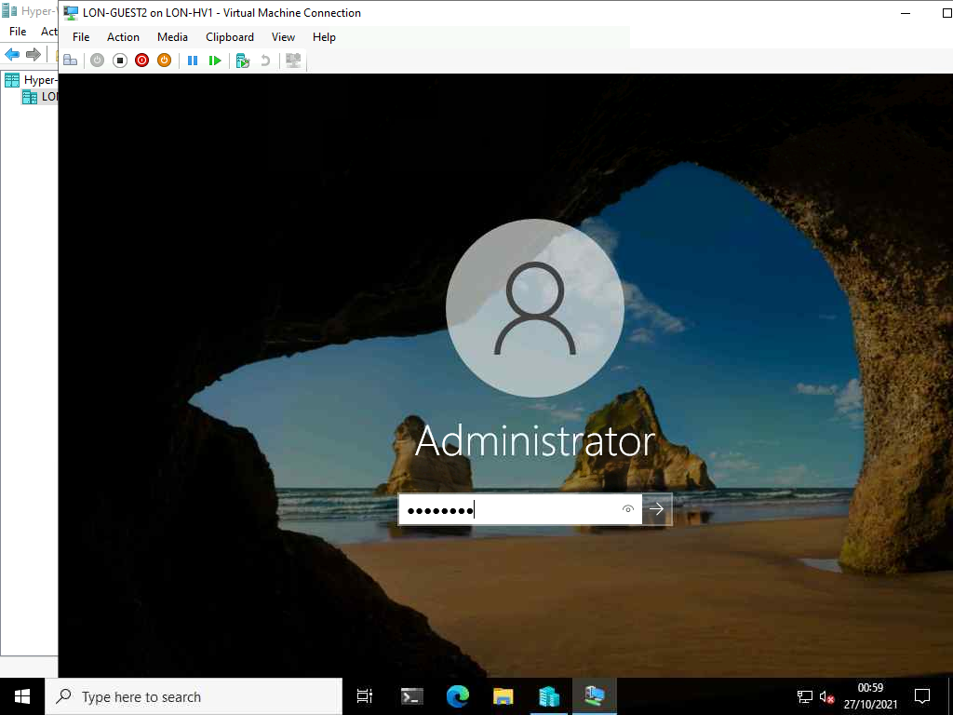

1. In **Server Manager**, click **Local Server**, and verify that there is only one network adapter.

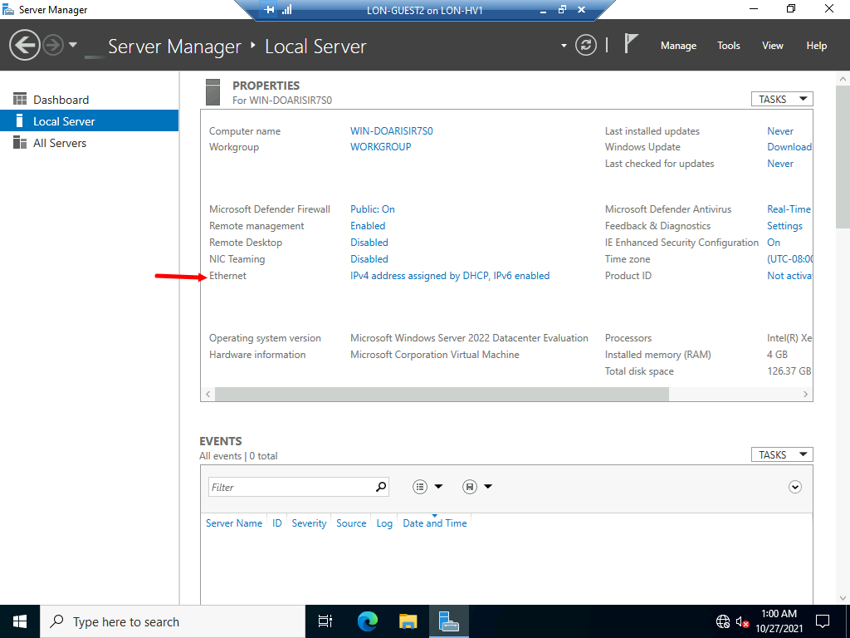

1. Minimize the **LON-GUEST2** virtual machine.
2. On [**LON-HV1**](urn:gd:lg:a:select-vm), in **Hyper-V Manager**, right-click **LON-GUEST2**, and then click **Settings**.

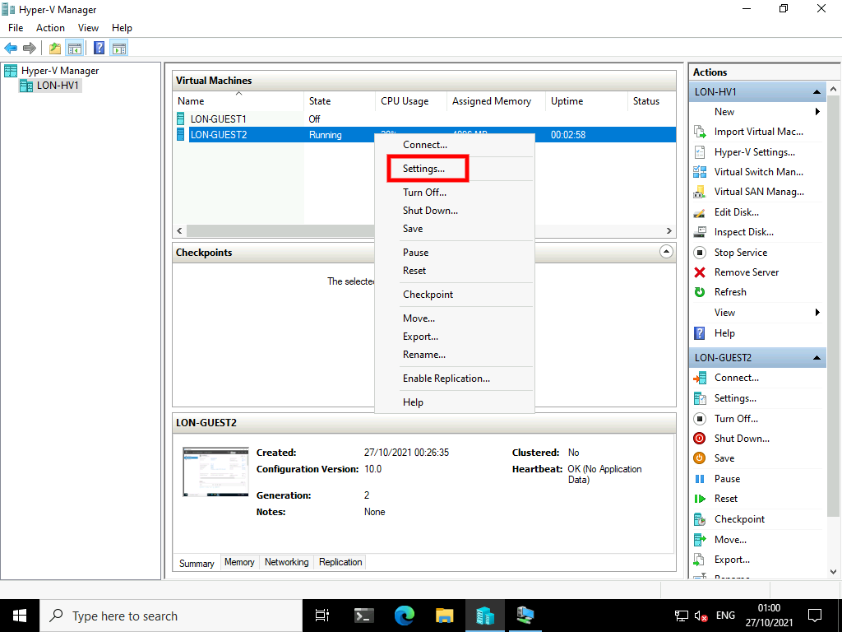

1. In the **Settings for LON-GUEST2 on LON-HV1** window, in the **Hardware** area, click **Add Hardware**.

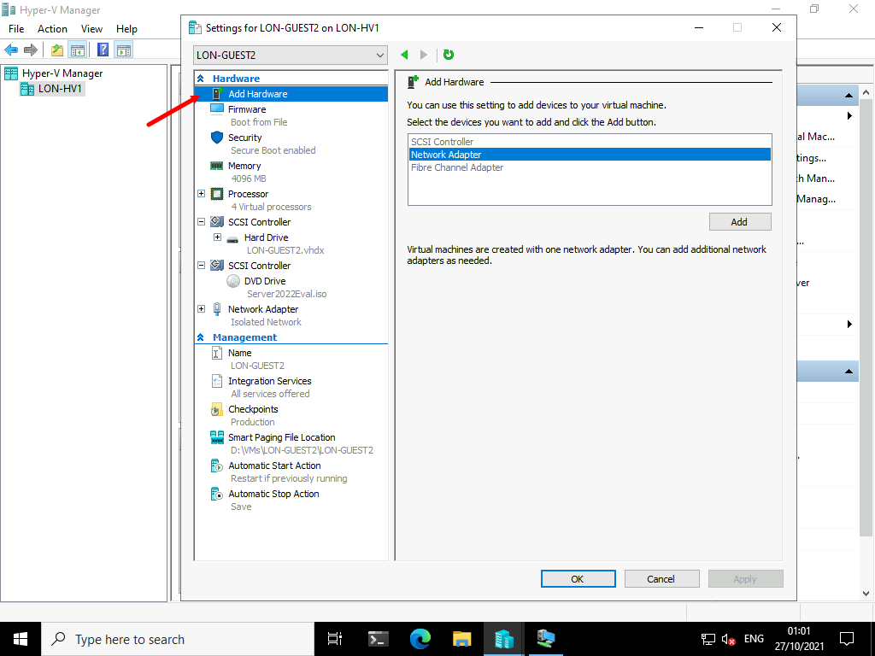

1. In the **Add Hardware** area, click **Network Adapter**, and then click **Add**.

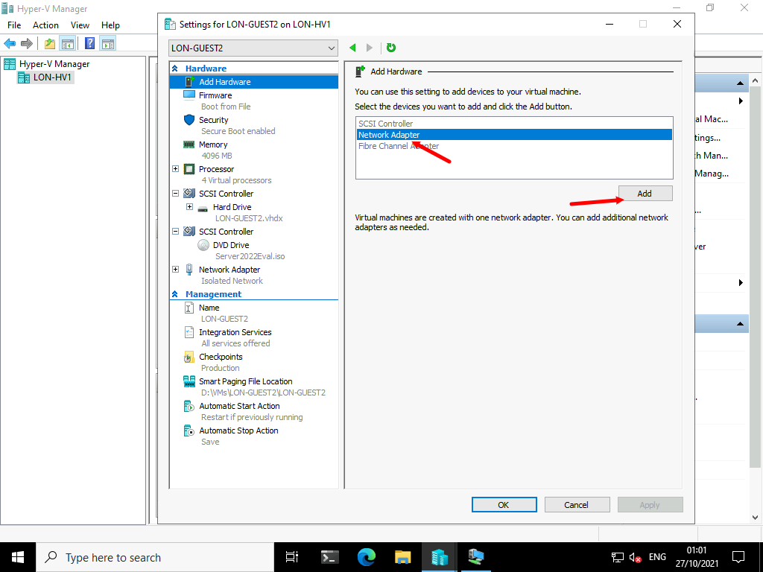

1. In the **Network adapter** area, in the **Virtual switch** box, select **HV Internal Network**, and then click **OK**.

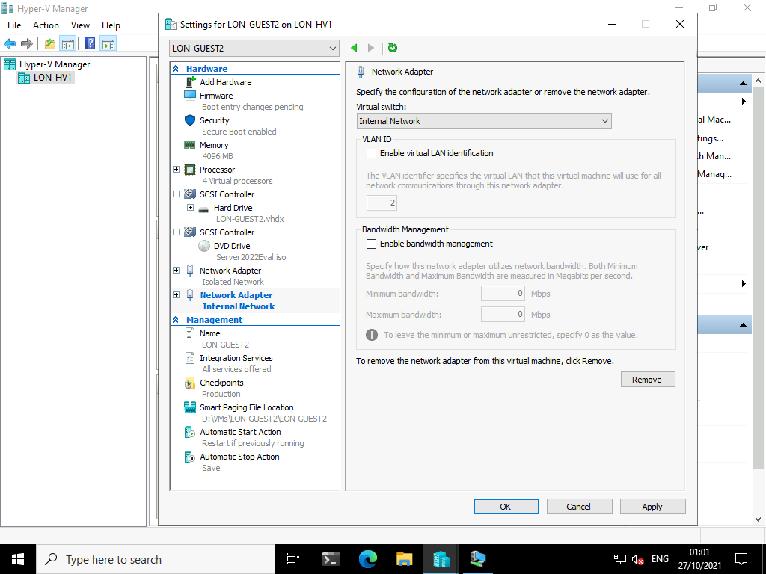

1. Switch to **LON-GUEST2**.

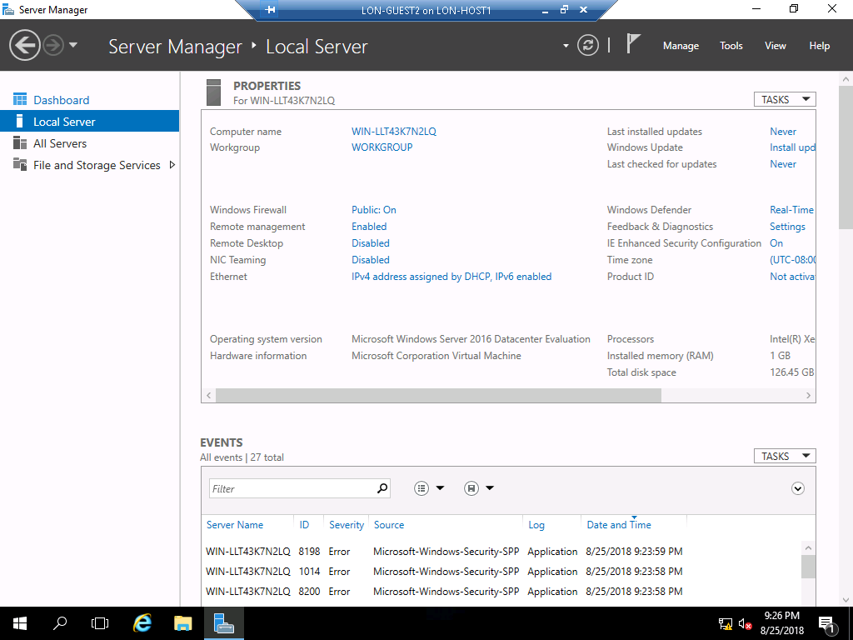

1. On **LON-GUEST2**, in **Server Manager**, refresh the view and verify that a second network adapter has been added.

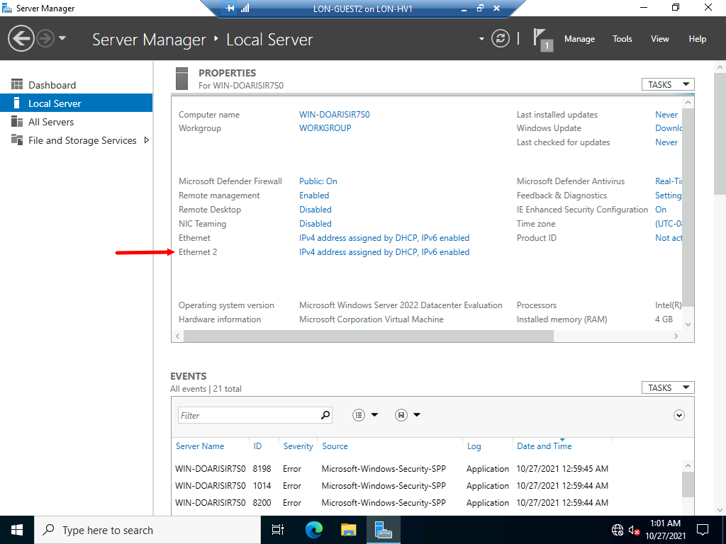

1. Minimize the LON-GUEST2 virtual machine.
2. On [**LON-HV1**](urn:gd:lg:a:select-vm), in **Hyper-V Manager**, right-click **LON-GUEST2**, and then click **Checkpoint**.

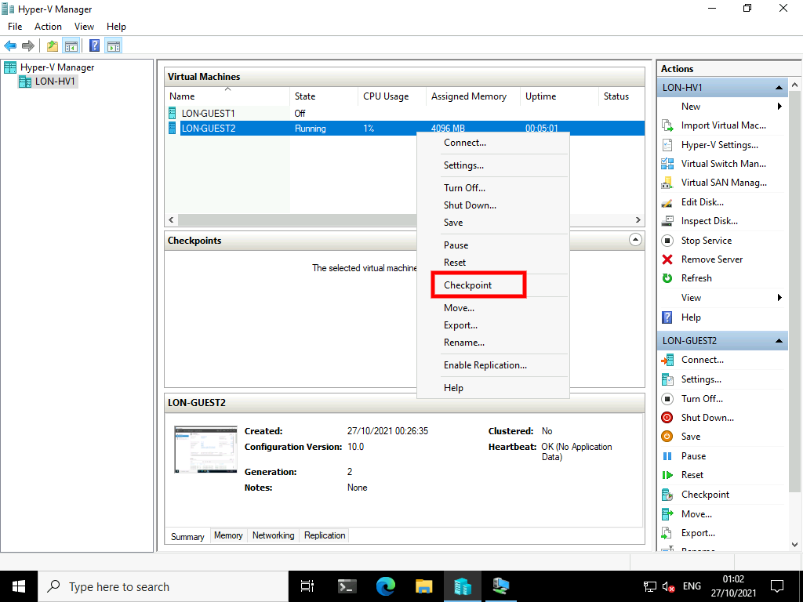

1. Read the information in the **Virtual Machine Checkpoint** window, and then click **OK**.

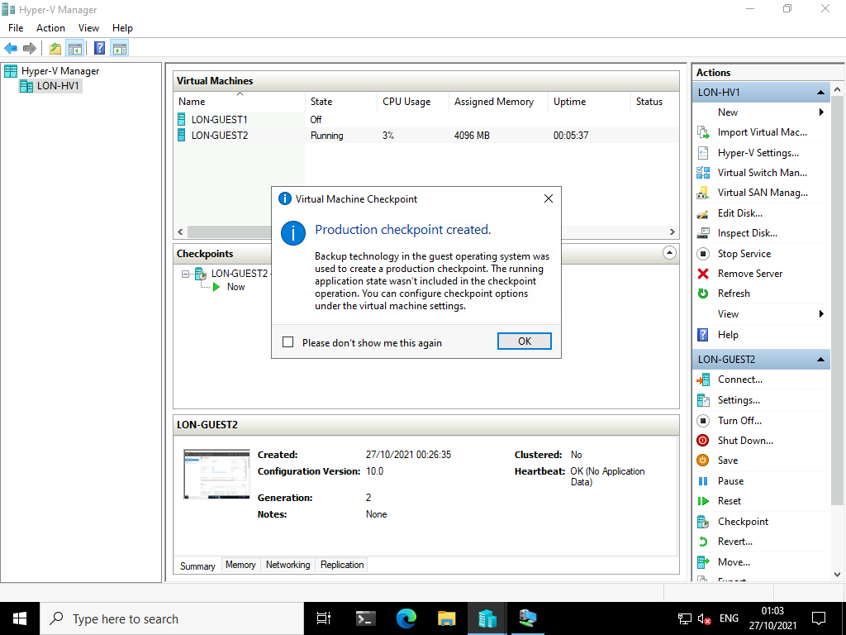

1. Right-click the most recent checkpoint, and then click **Apply**.

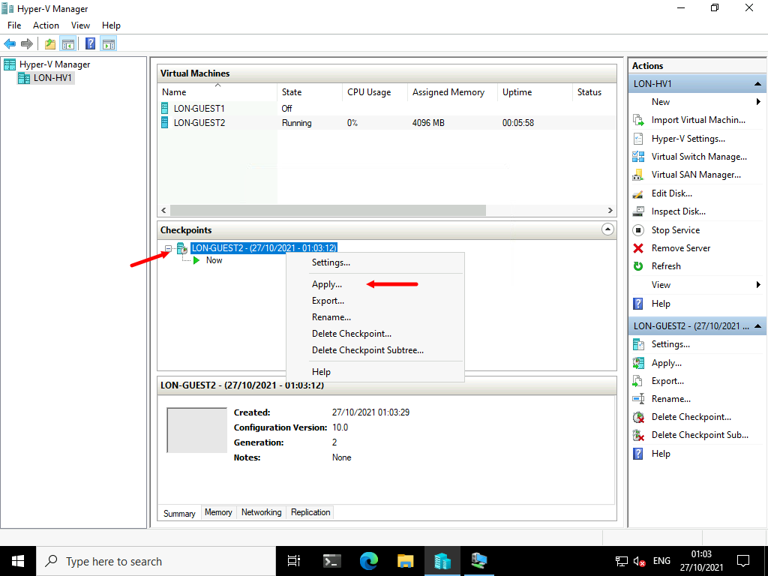

1. In the **Apply Checkpoint** dialog box, click **Apply**.

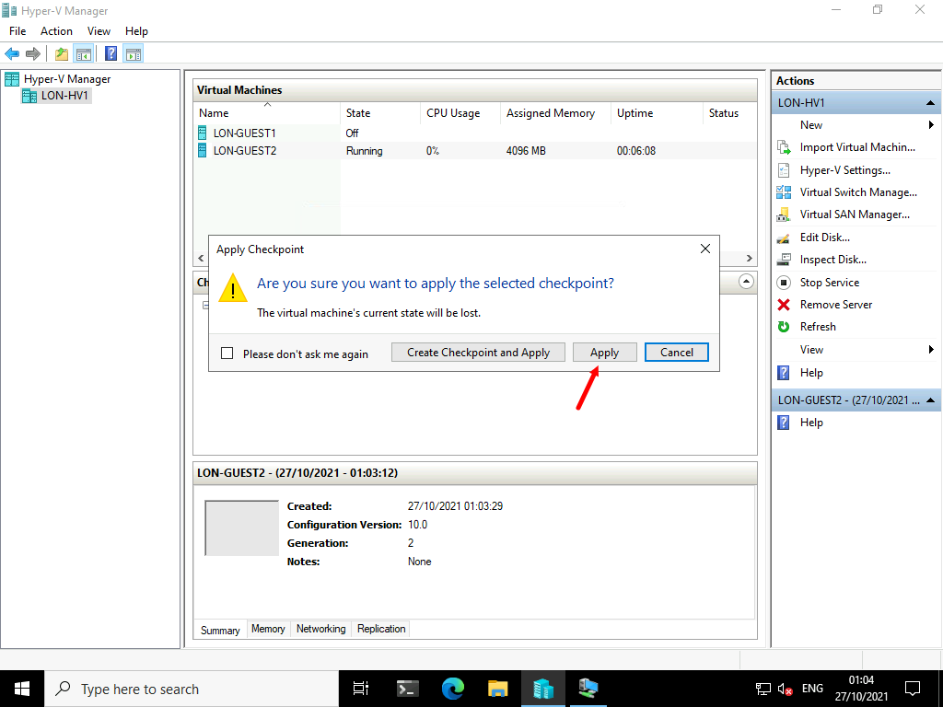

1. Verify that the **Status for LON-GUEST2** is **Off** because it was a production checkpoint.

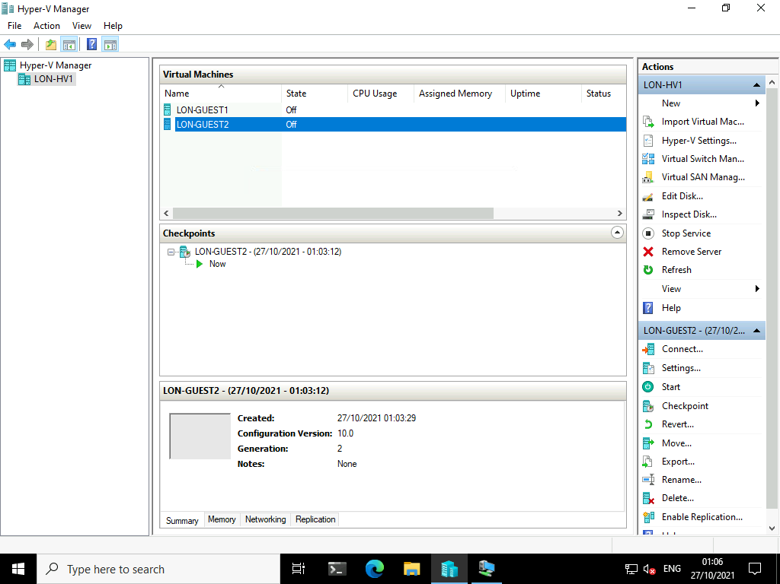

Task 5: Enable HV resource protection

1. On [**LON-HV1**](urn:gd:lg:a:select-vm), right click the **Start** button, and then click **Windows PowerShell (Admin)**.

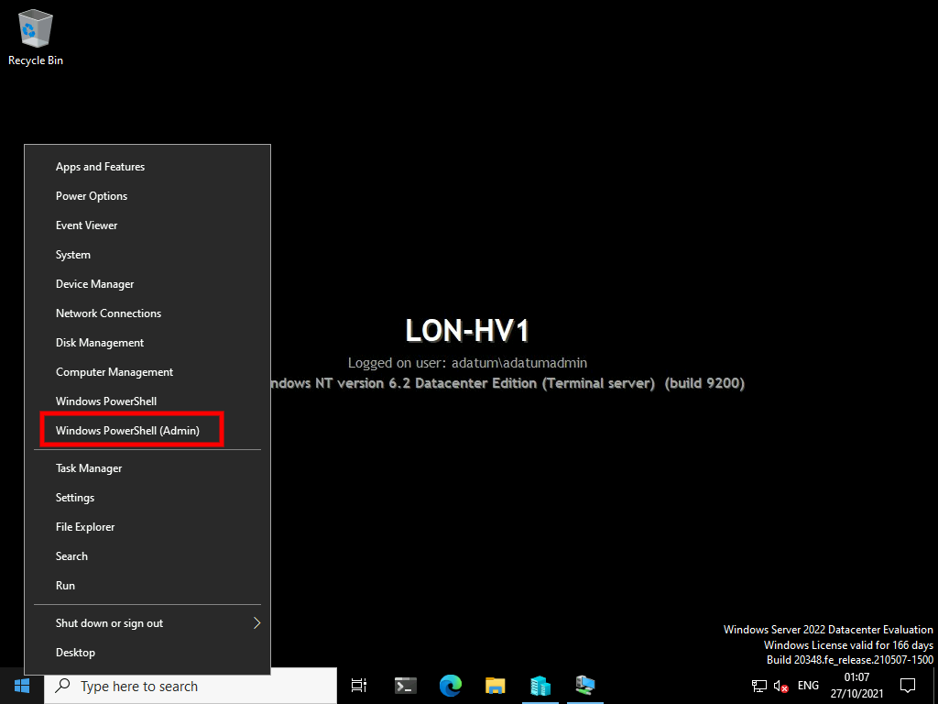

1. In **Windows PowerShell**, at the command prompt, type the following command, and then press Enter:
2. Set-VMProcessor LON-GUEST2 -EnableHostResourceProtection $true

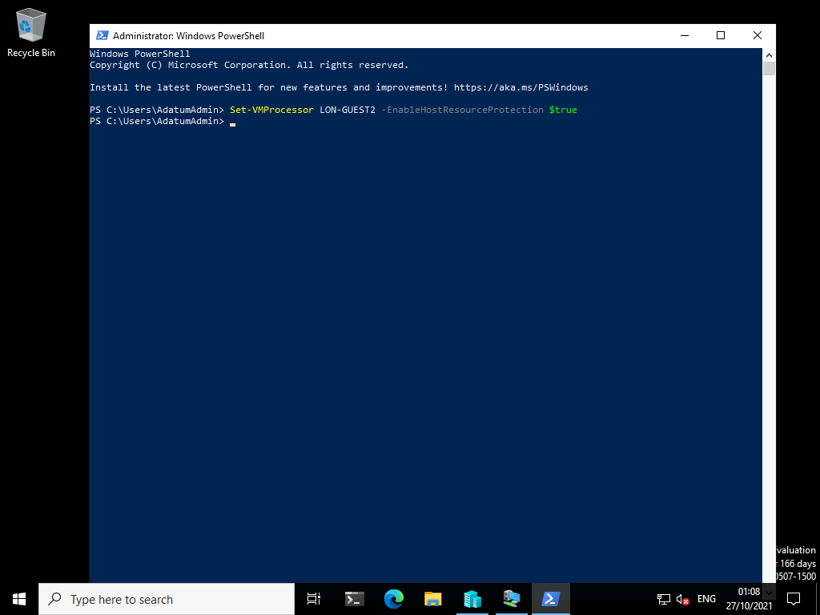

1. Close the **Windows PowerShell** window.

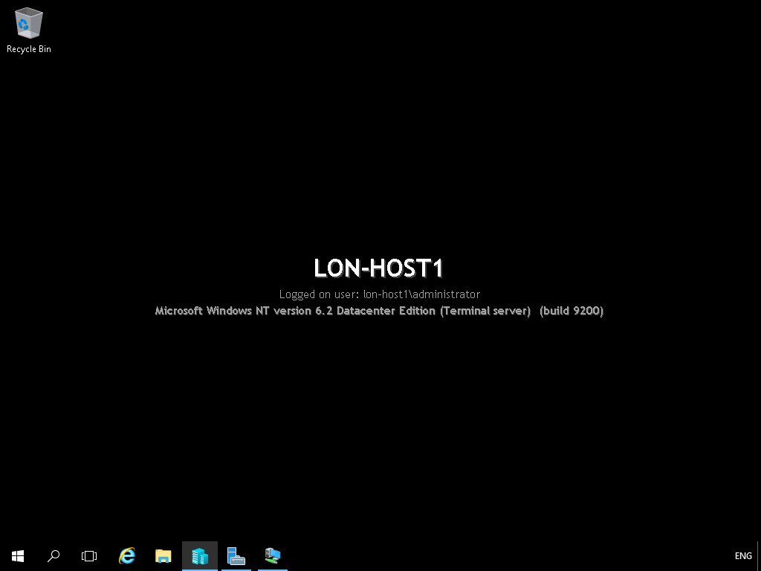

Task 6: Export a virtual machine

1. On [**LON-HV1**](urn:gd:lg:a:select-vm), in **Hyper-V Manager**, right-click **LON-GUEST2**, and then click **Export**.

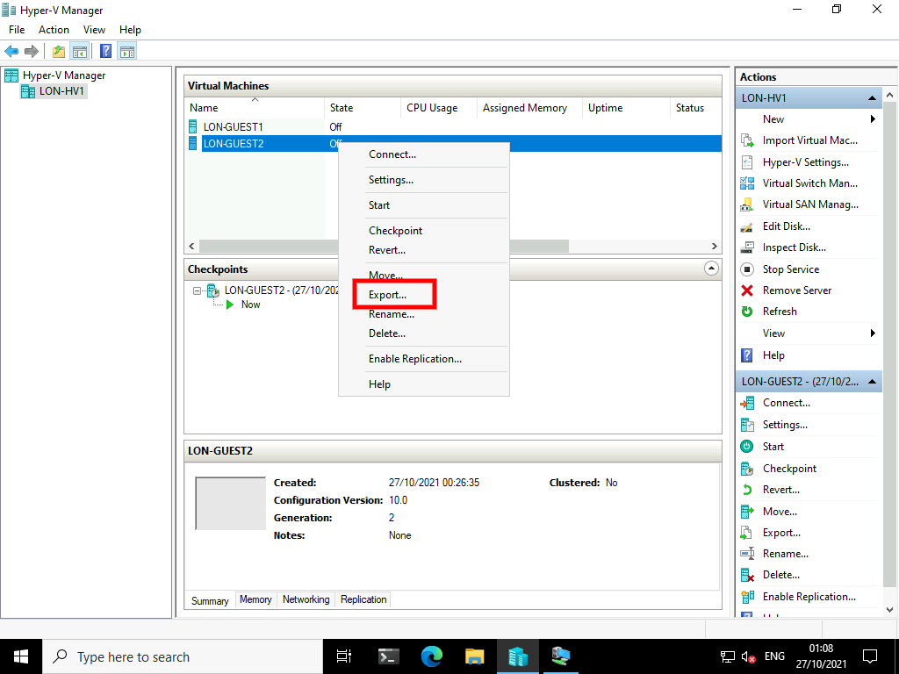

1. In the **Export Virtual Machine** dialog box, in the **Location** text box, type [**D:\VMs\Guest2-Bak**](urn:gd:lg:a:send-vm-keys), and then click **Export**.

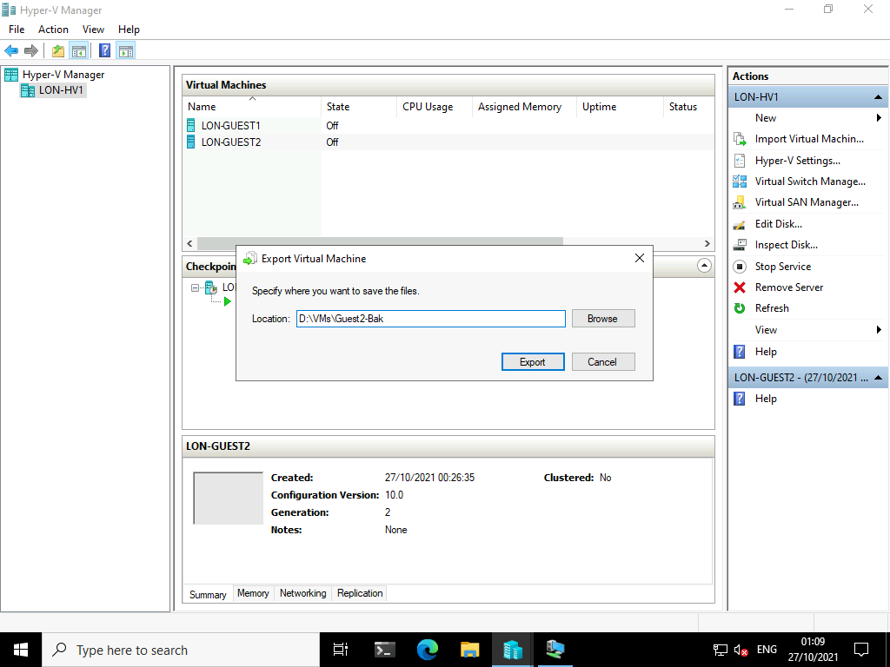

**Results**: After completing this exercise, you should have successfully created and configured both a Generation 1 virtual machine and a Generation 2 virtual machine.

Exercise 4: Enabling nested virtualization for a virtual machine

Scenario

You are considering the use of nested virtualization for your development environment where you often have a need to test applications using failover clustering. With nested virtualization, you can test many scenarios with a single physical HV.

Task 1: Create LON-NVHV

1. On [**LON-HV1**](urn:gd:lg:a:select-vm), right click the **Start** button, and then click **Windows PowerShell (Admin)**.



1. In **Windows PowerShell**, at the command prompt, type the following commands, to create a virtual hard disk and virtual machine and then press Enter:
2. New-VHD -Path D:\VMs\LON-NVHV.vhd -ParentPath D:\Server2022Base.vhd -Differencing
3. New-VM -Name LON-NVHV -MemoryStartupBytes 8192MB -VHDPath "D:\VMs\LON-NVHV.vhd" -SwitchName "Physical Network"
4. Set-VMProcessor -VMName LON-NVHV -count 4

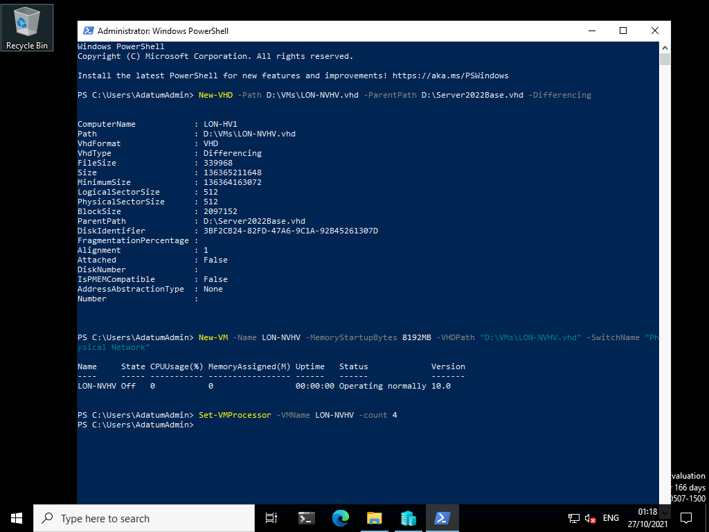

Task 2: Enable nested virtualization

1. On [**LON-HV1**](urn:gd:lg:a:select-vm), in **Hyper-V Manager**, in the **Virtual Machines** pane, verify that the **Configuration Version** for **LON-NVHV** is **10.0**.

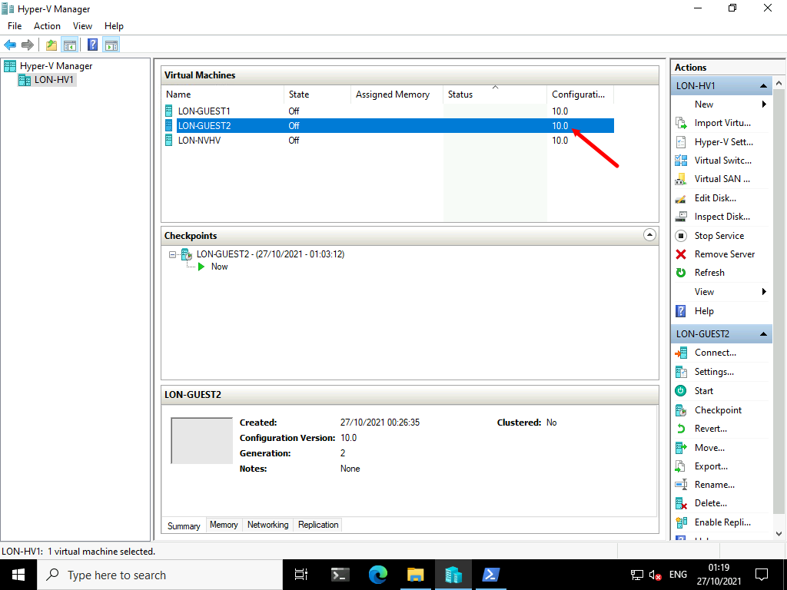

1. At the **Windows PowerShell** prompt, type the following command, and then press Enter:
2. Set-VMProcessor -VMName LON-NVHV -ExposeVirtualizationExtensions $true

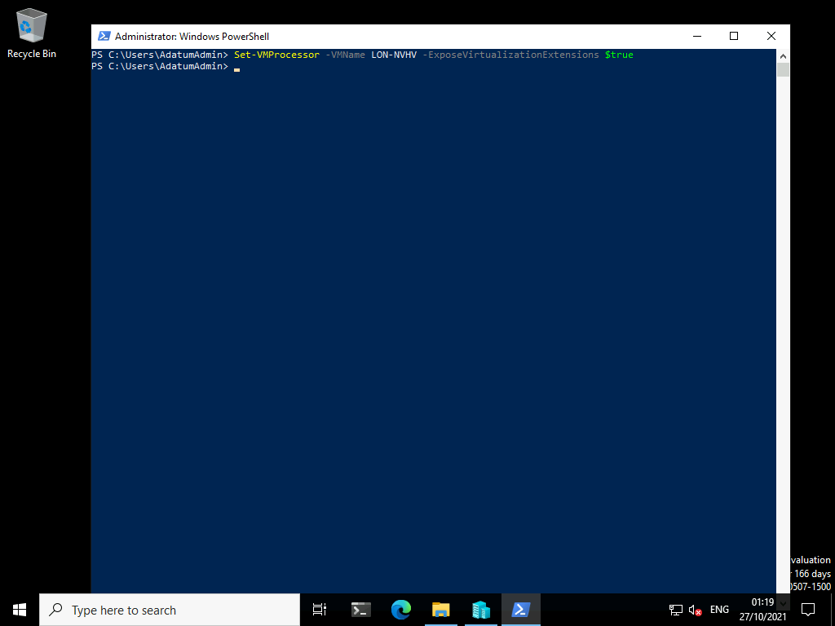

1. Type the following command, and then press **Enter**:
2. Get-VMNetworkAdapter -VMName LON-NVHV | Set-VMNetworkAdapter -MacAddressSpoofing On

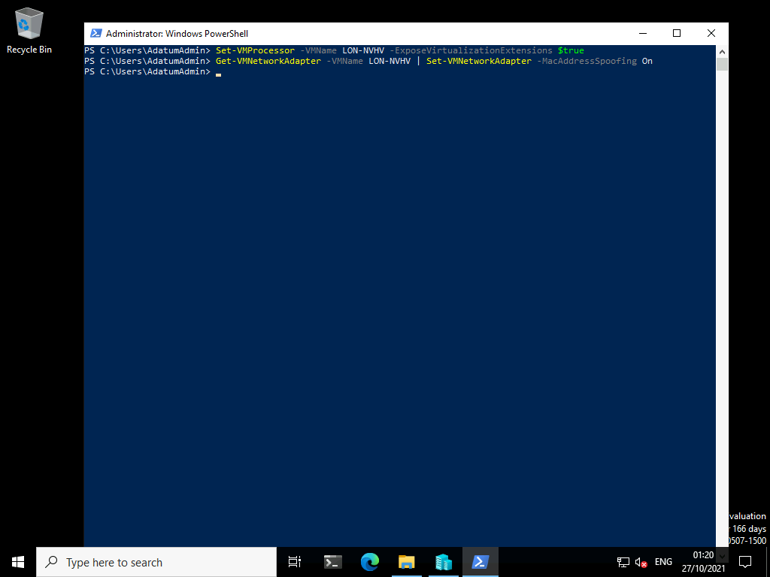

Task 3: Enable Hyper-V

1. On **LON-HV1**, at the **Windows PowerShell** prompt, type the following command, and then press **Enter**:
2. Start-VM LON-NVHV

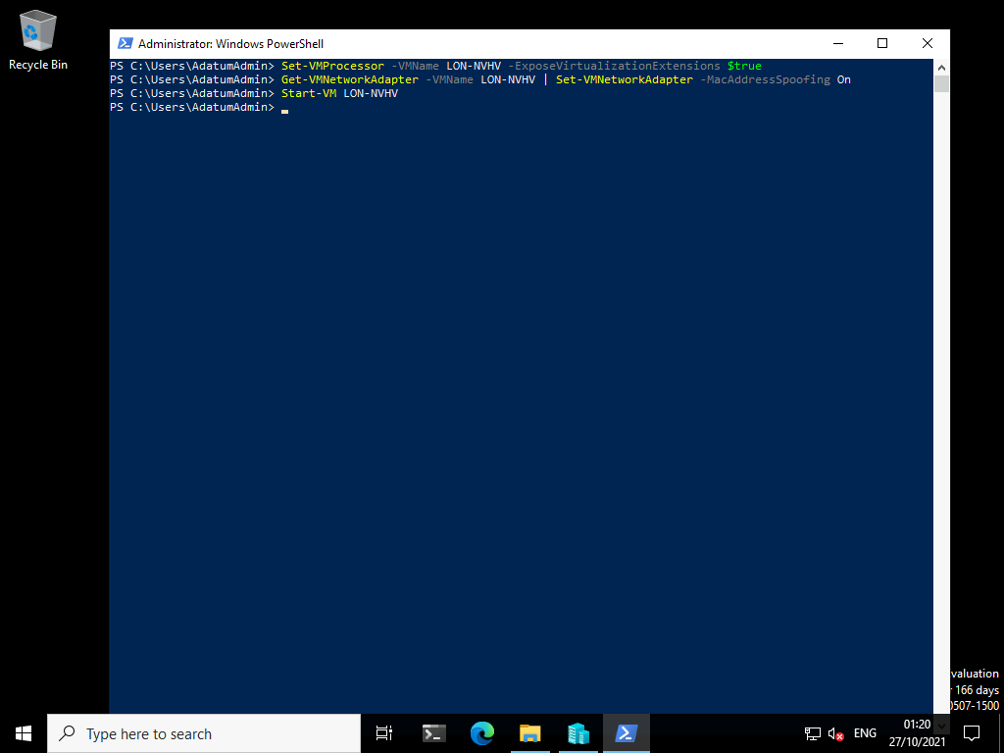

1. To view the activity on **LON-NVHV**, in **Hyper-V Manager**, right-click **LON-NVHV**, and then click **Connect**.

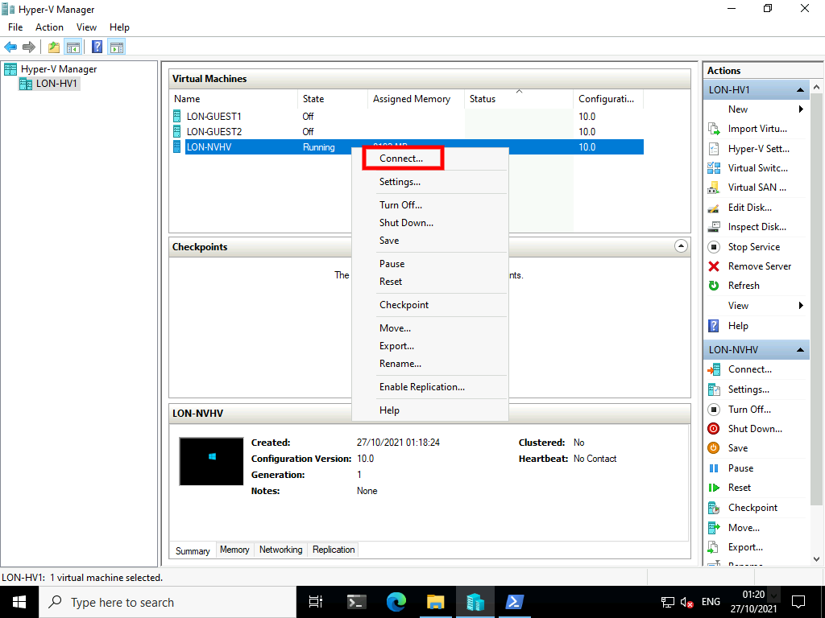

1. Once booted, on the Hi there screen click **Next**.

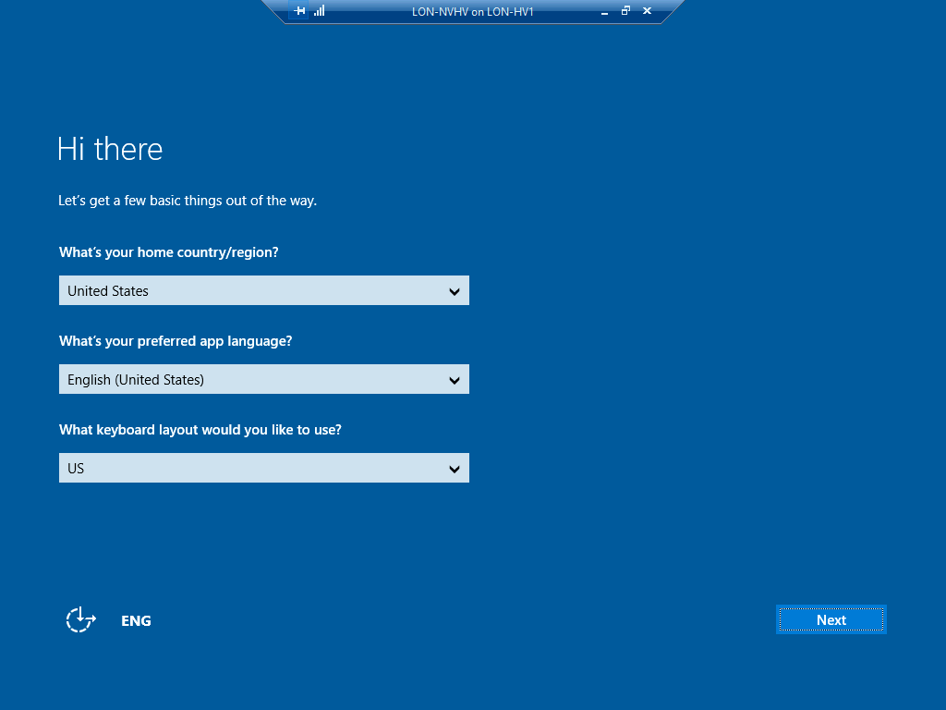

1. Accept the License terms by clicking **Accept**.

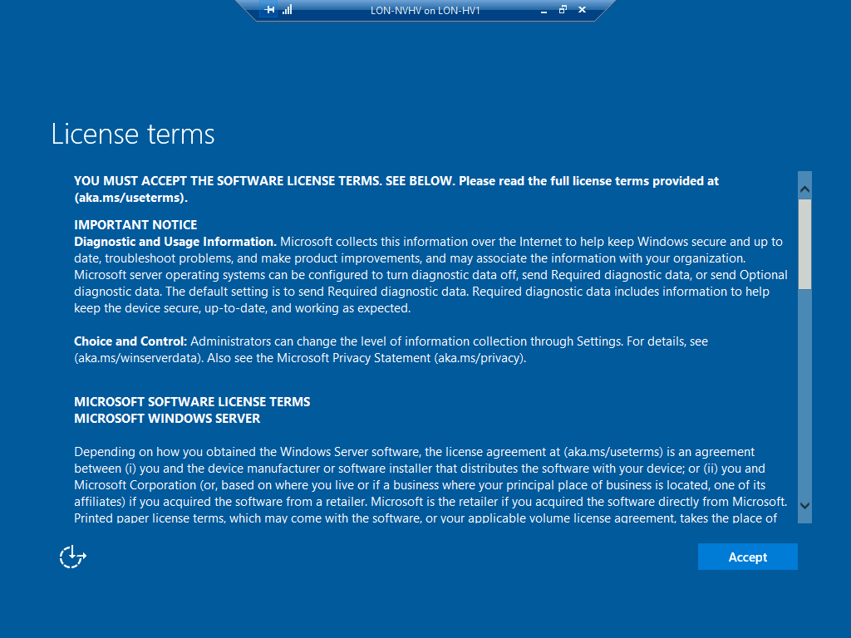

1. On the Customize settings page enter [**Pa55w.rd**](urn:gd:lg:a:send-vm-keys) as the password and reenter the password then click **Finish**.

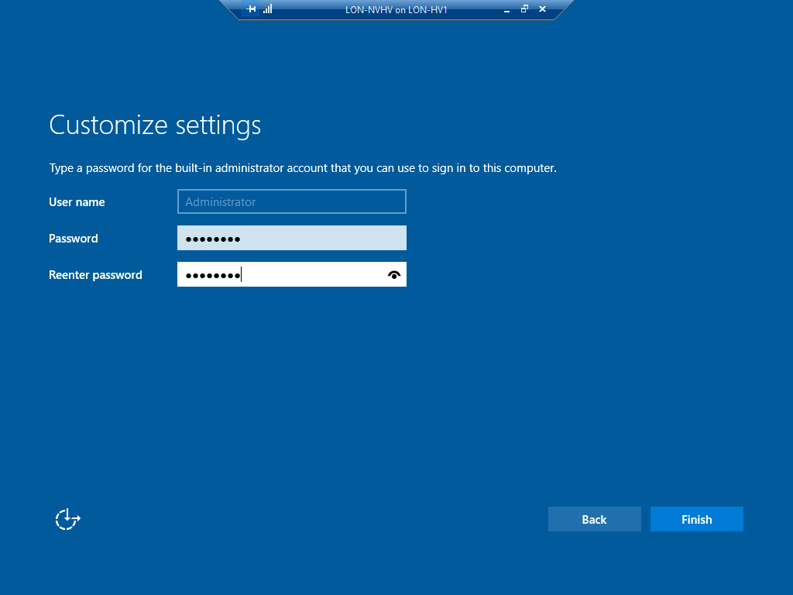

1. Minimize the LON-NVHV window.
2. On [**LON-HV1**](urn:gd:lg:a:select-vm), run the following at the Windows PowerShell prompt to connect using PowerShell direct, and then press Enter.

**Note:** This command is still on **LON-HV1** and **NOT** inside the **LON-NVHV** virtual machine!

Enter-PSSession -VMName LON-NVHV

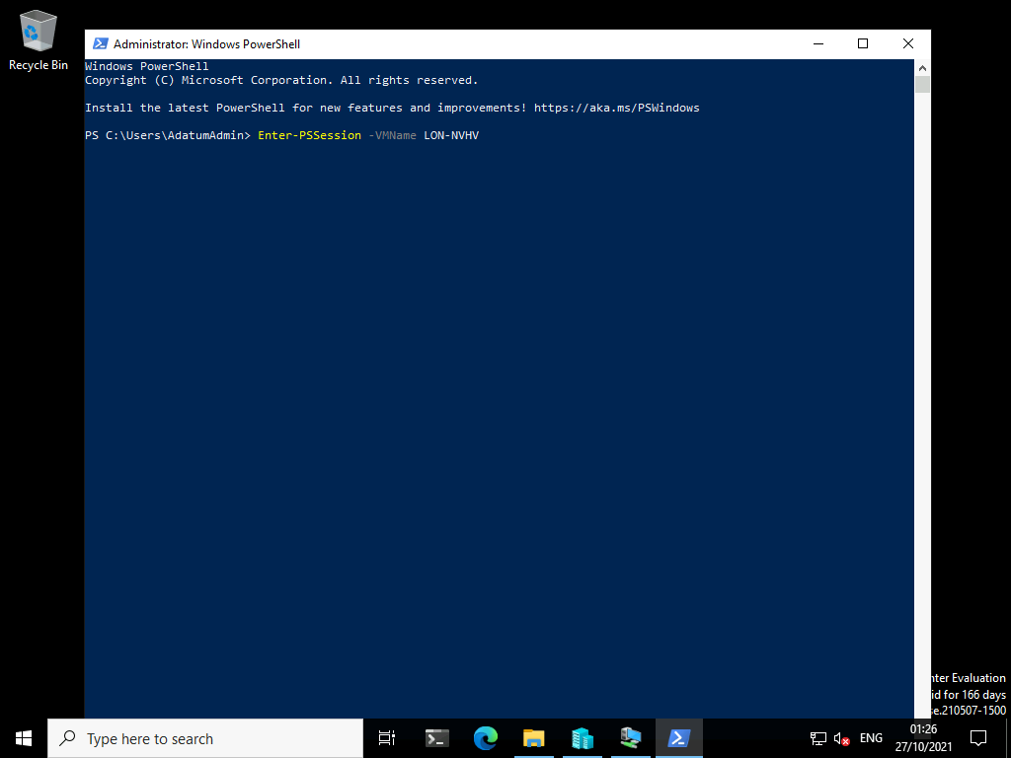

1. When you receive a prompt, sign in as [**Administrator**](urn:gd:lg:a:send-vm-keys) by using [**Pa55w.rd**](urn:gd:lg:a:send-vm-keys) as the password.

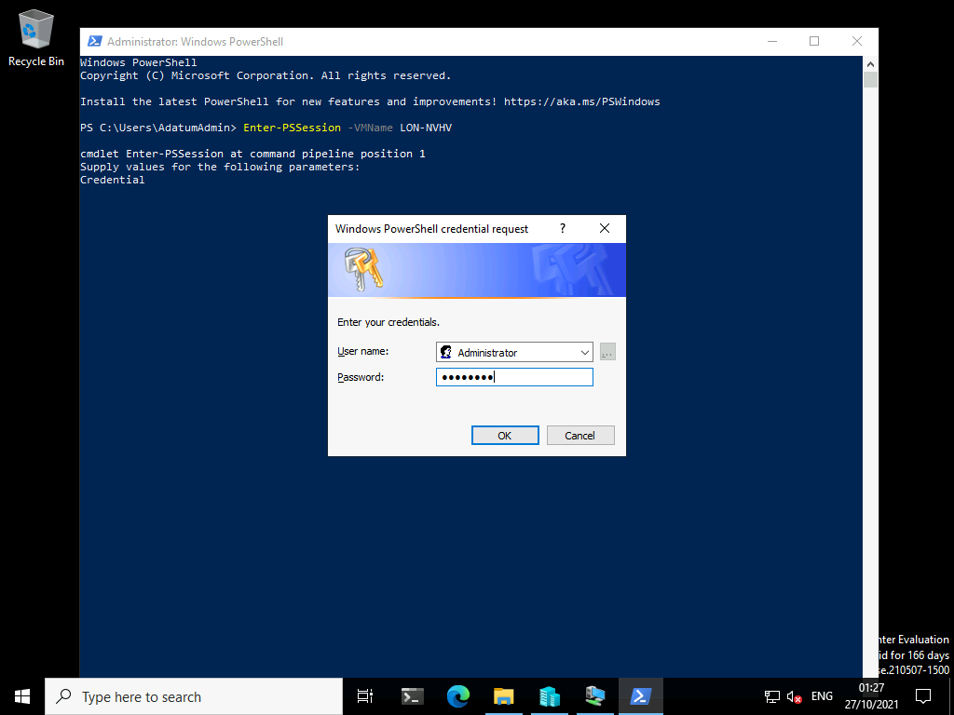

1. Type the following command, and then press Enter:
2. Install-WindowsFeature -Name Hyper-V -IncludeAllSubFeature -IncludeManagementTools -Restart

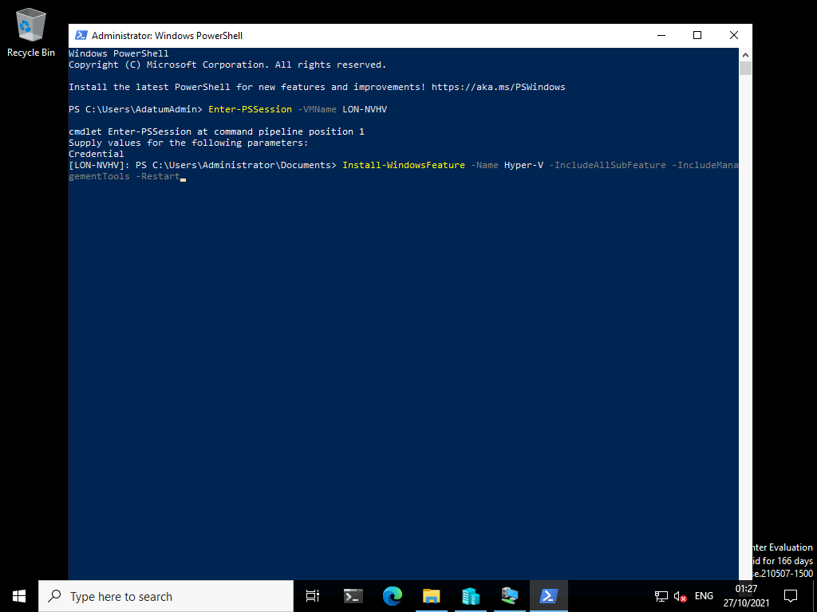

1. Wait for **LON-NVHV** to restart. The virtual machine might restart several times.
2. Switch to **LON-NVHV**.
3. Sign in to **LON-NVHV** as **Administrator** by using [**Pa55w.rd**](urn:gd:lg:a:send-vm-keys) as the password.
4. Wait for **Server Manager** to open.
5. In **Server Manager**, click **Tools**, and then click **Hyper-V Manager**.

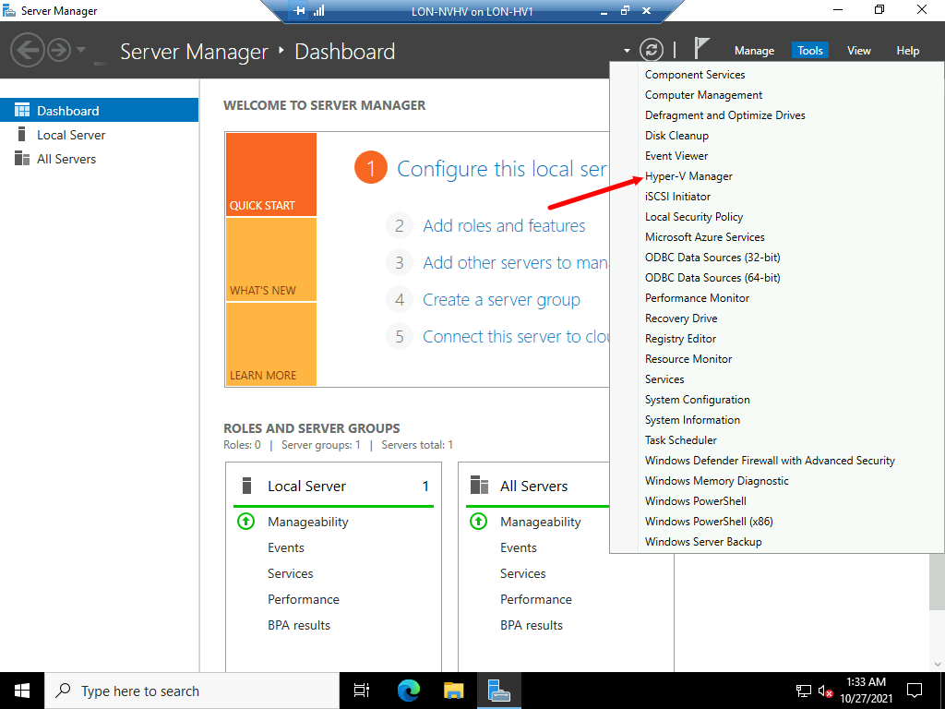

1. Verify that the server is listed in **Hyper-V Manager**, and then close **Hyper-V Manager**.

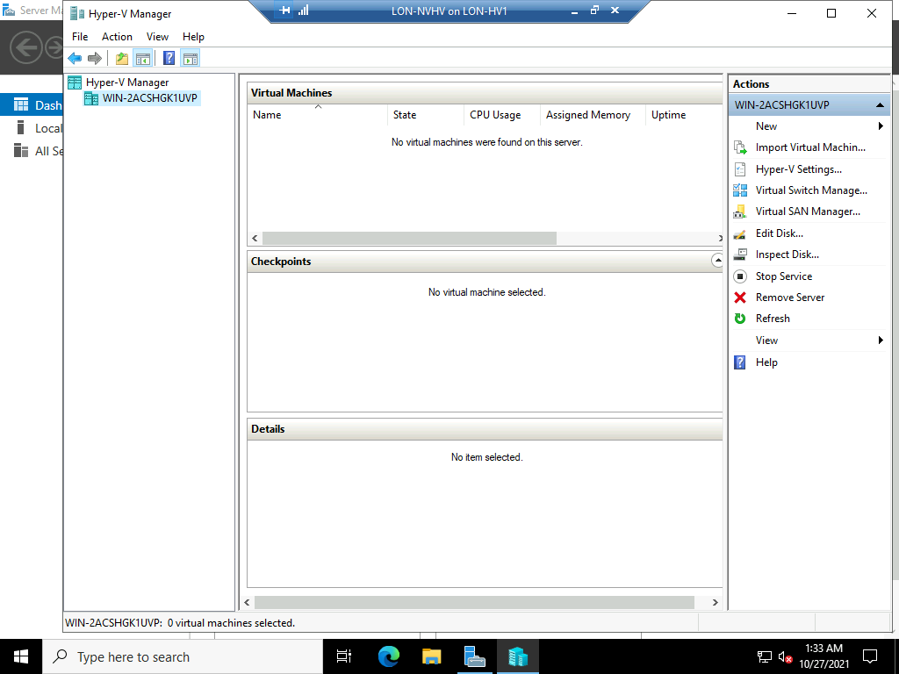

**Results**: After completing this exercise, you should have successfully configured a virtual machine for nested virtualization.

Exercise 5: Manage Microsoft Hyper-V using the Windows Admin Center.

Scenario

Having evaluated Microsoft Hyper-V you are now using the virtualization platform in production. The IT Manager would now prefer you use a more modern way to manage your virtualized infrastructure.

The main tasks for this exercise is as follows:

* Manage Hyper-V using the Windows Admin Center.

Task 1: Manage Microsoft Hyper-V using the Windows Admin Center.

1. Switch to [**LON-MGT1**](urn:gd:lg:a:select-vm)
2. Send the [**CTRL+ALT+DEL**](urn:gd:lg:a:send-vm-key-combo) command and login on as **[Adatum\AdatumAdmin](urn:gd:lg:a:send-vm-keys" \o "Paste text into VM)** with the password [**Pa55w.rd**](urn:gd:lg:a:send-vm-keys)



1. Open **Microsoft Edge** and select the **Windows Admin Center** favourite button.

**Note**: The Windows Admin Center (WAC) has been preinstalled in the lab environment. Installing the WAC is a very simple installation process.

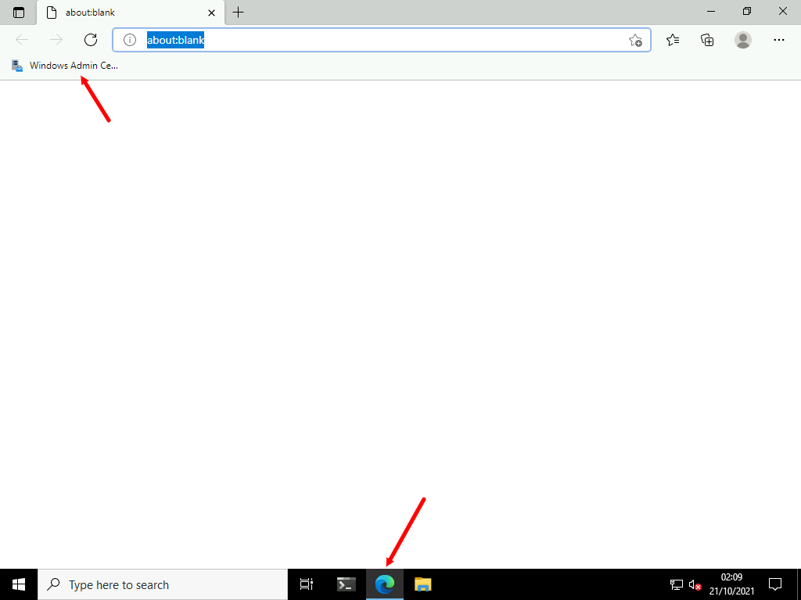

1. On the All connections window select **lon-hv2.adatum.com**.

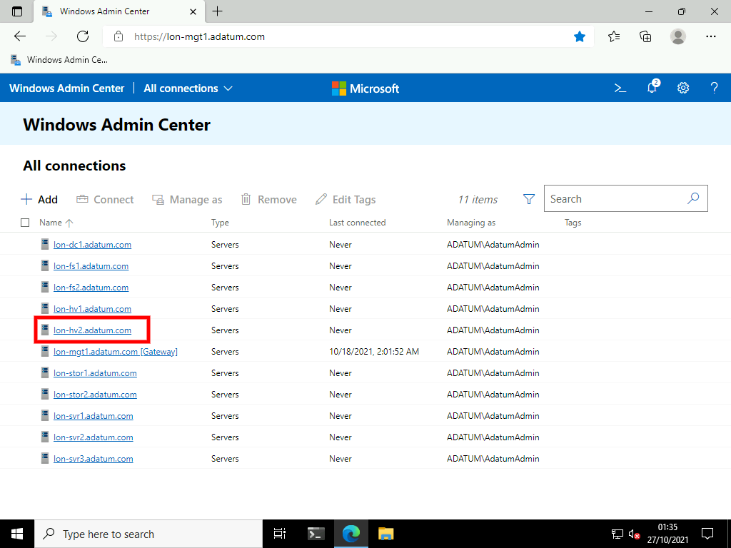

1. On the **Tools** menu select **Roles & features**.

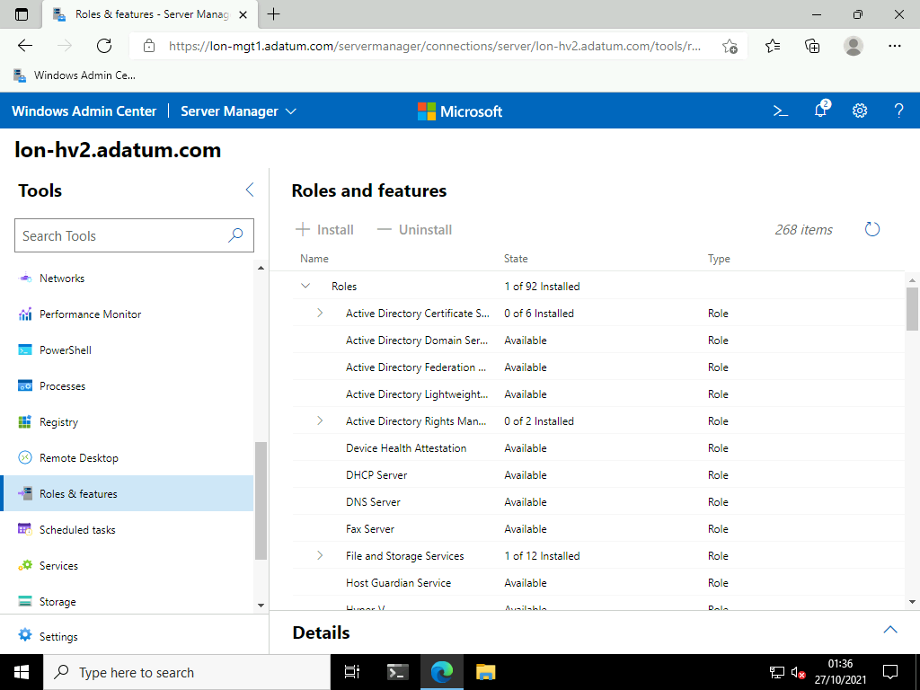

1. Select **Hyper-V** then click **+ Install**.

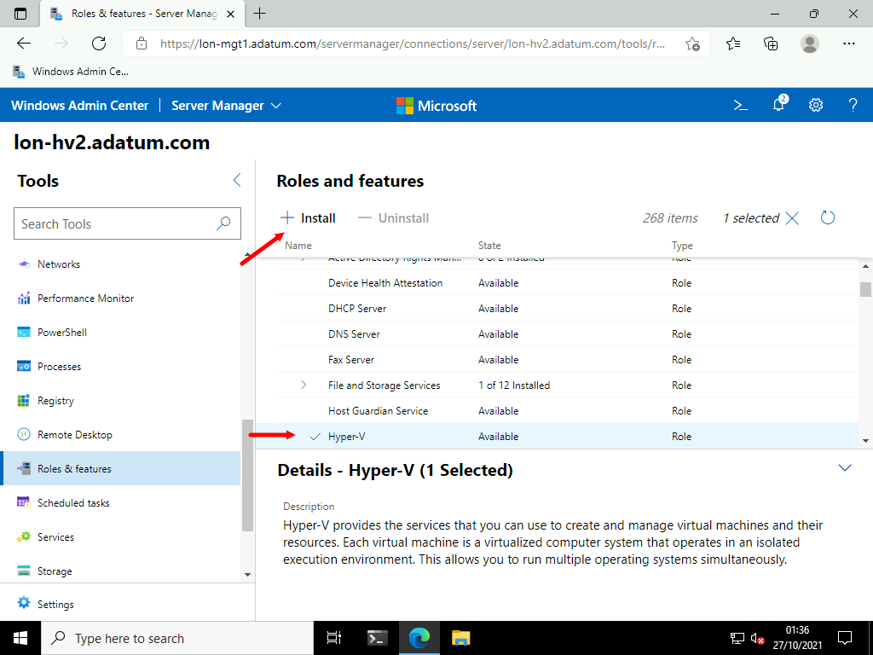

1. On the install Roles and Features blade select the **Reboot the server automatically...** check box and click **Yes**.

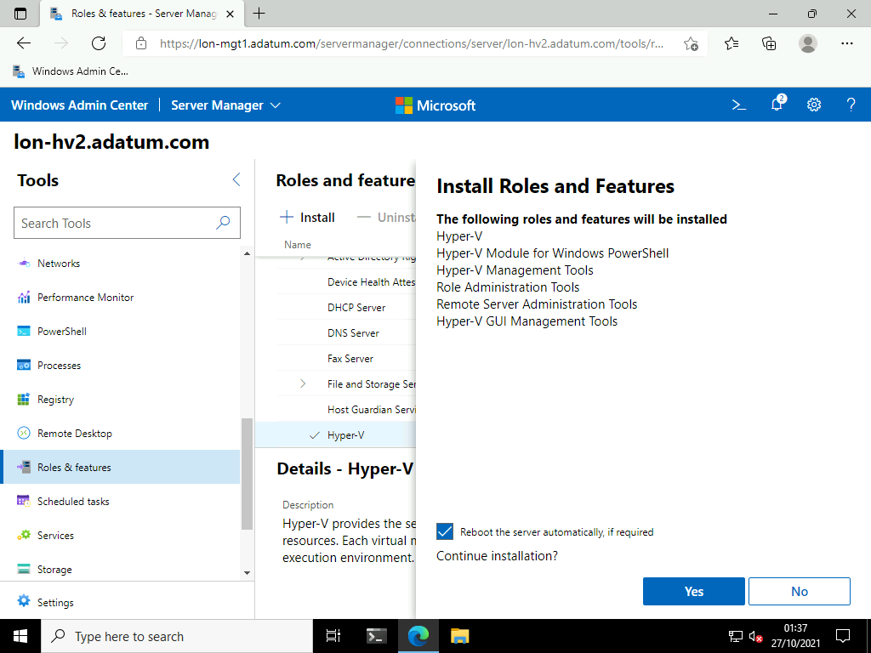

1. Click the **Notifications** icon to monitor the progress.

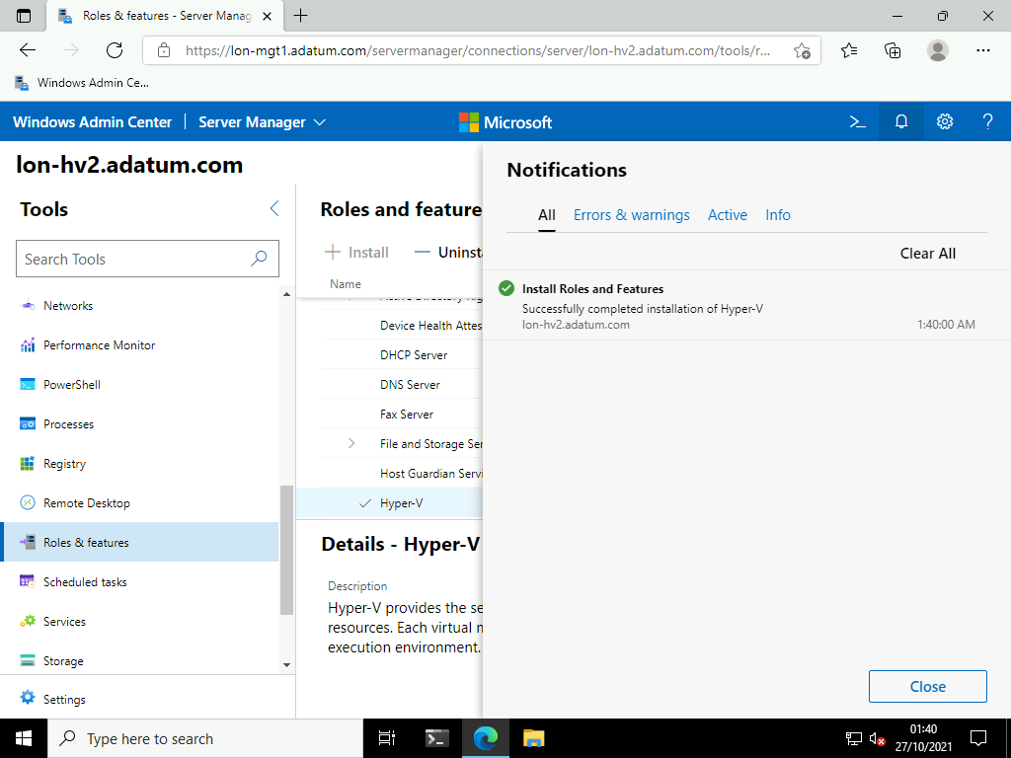

1. Switch to [**LON-HV2**](urn:gd:lg:a:select-vm) and wait for the server to reboot.

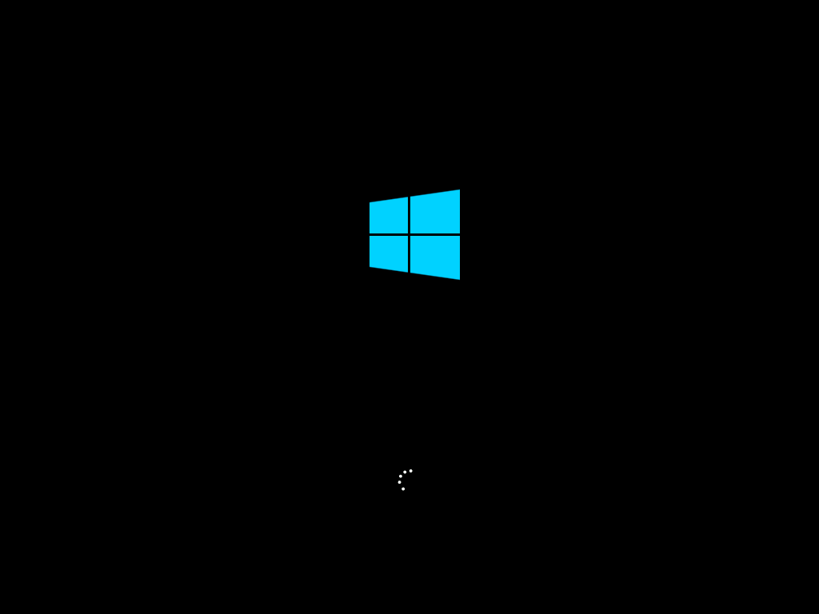

1. Return to [**LON-MGT1**](urn:gd:lg:a:select-vm).
2. **Refesh** the Windows Admin Center.
3. On the **Tools** menu scroll down and select **Virtual Switches**.

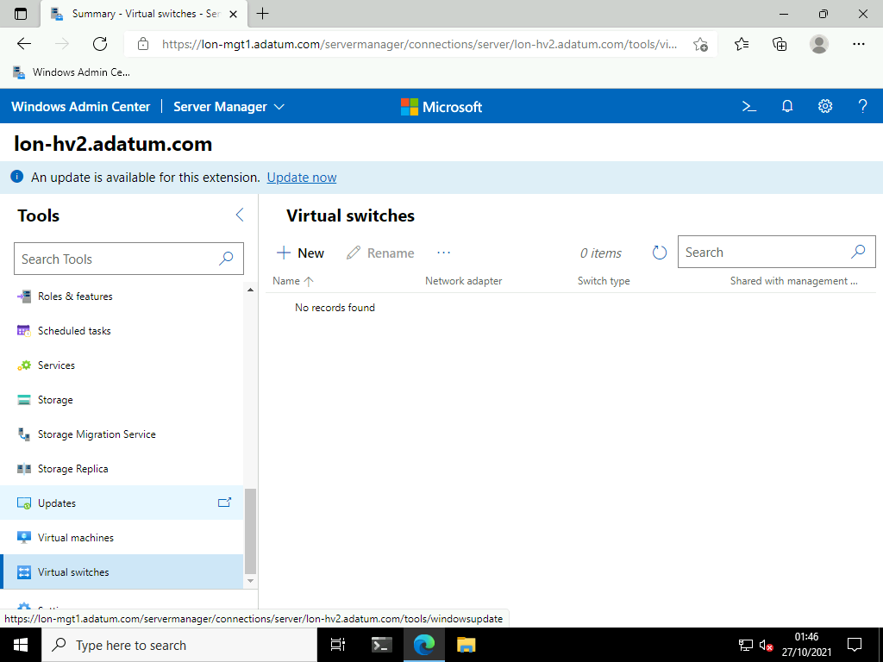

1. Select **+ New**.

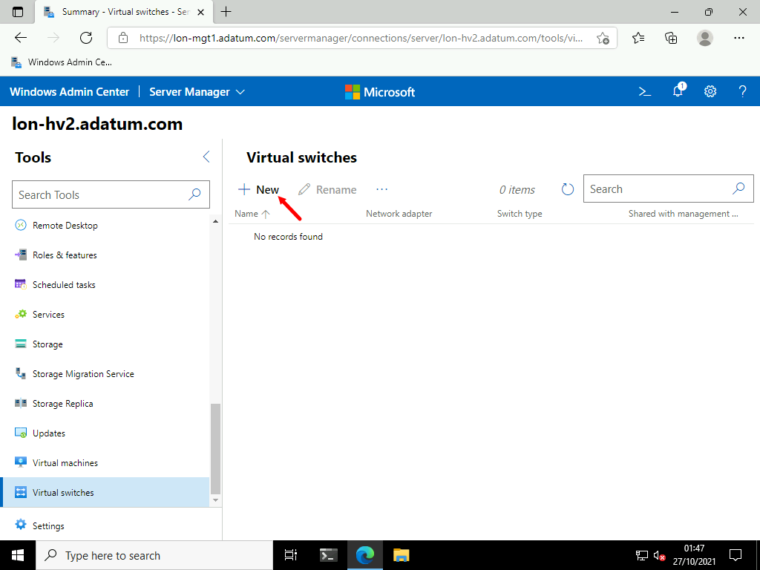

1. On the **New virtual switch** blade enter the following settings then click **Save**.
   * Switch name: [**Private Network**](urn:gd:lg:a:send-vm-keys)
   * Switch type: **Private**

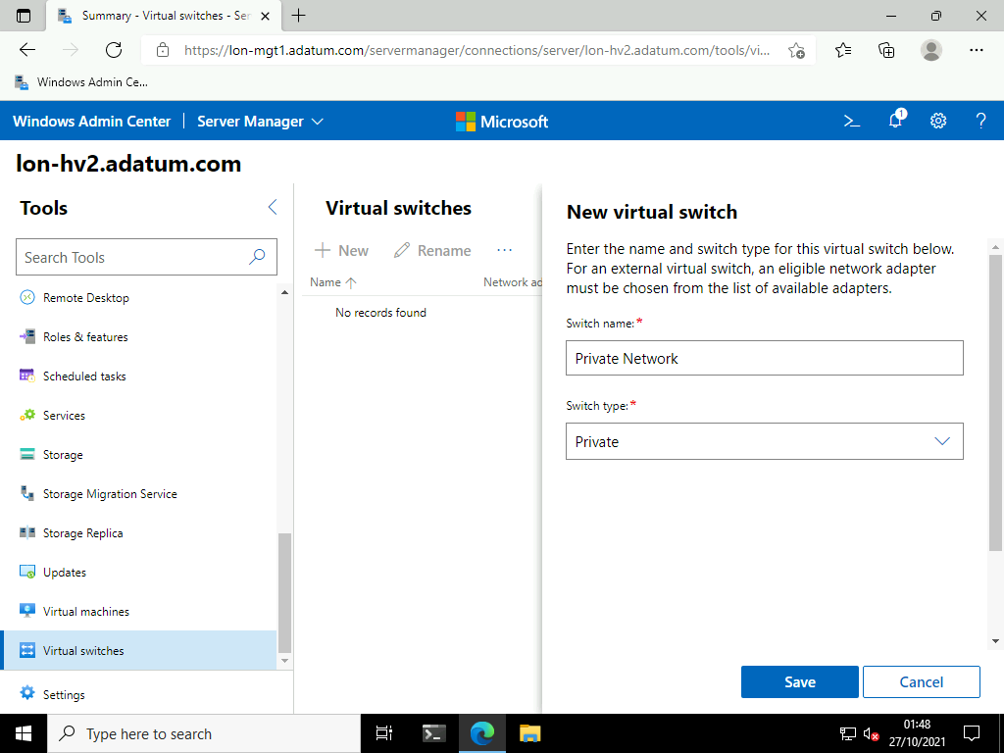

1. Repeat the sets to create another virtual switch with the following settings.
   * Switch name: [**Physical Network**](urn:gd:lg:a:send-vm-keys)
   * Switch type: **External**
   * Network adapter: **Ethernet**

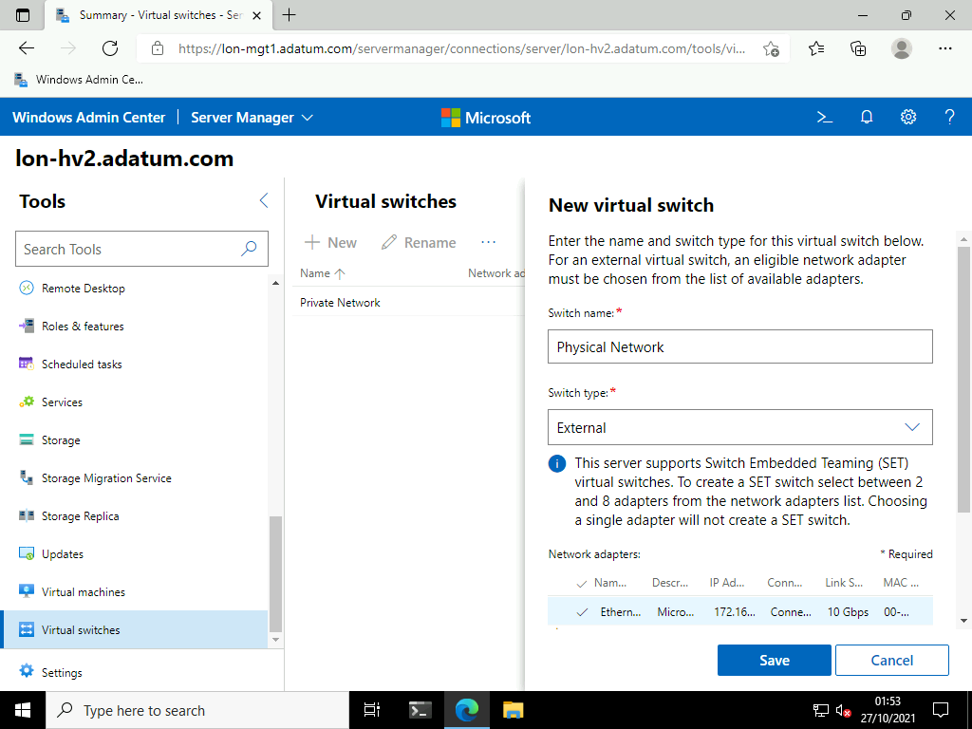

1. You may see an error stating the Virtual Switch could not be created. This is to be expected whilst the physical network card is bound to the virtual switch which causes the Windows Admin Center to disconnect.

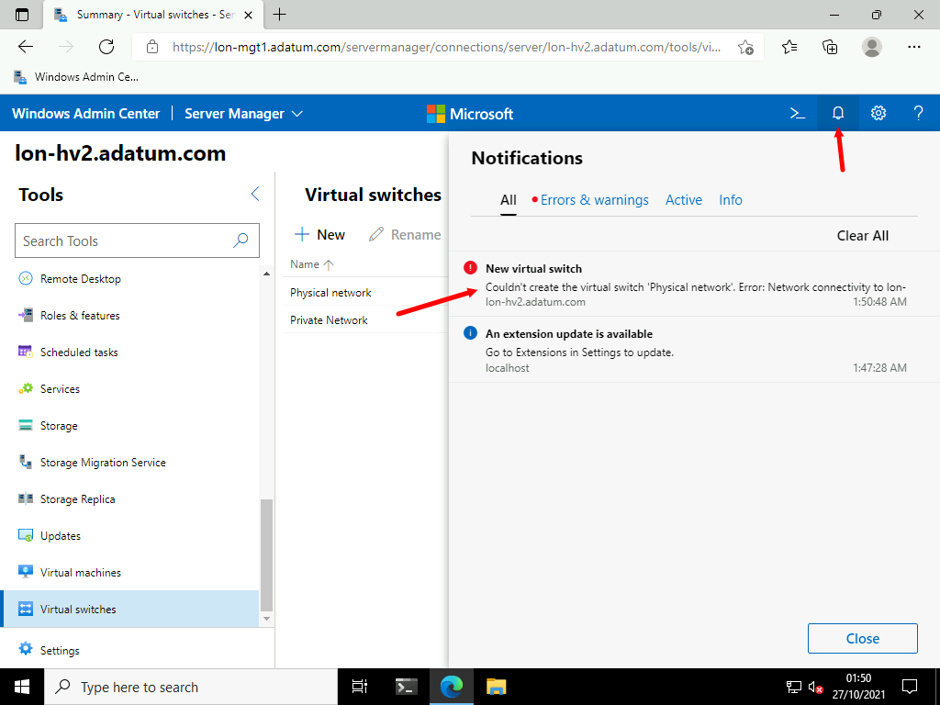

1. Once the Windows Admin Center reconnects you will see the Physical Network:

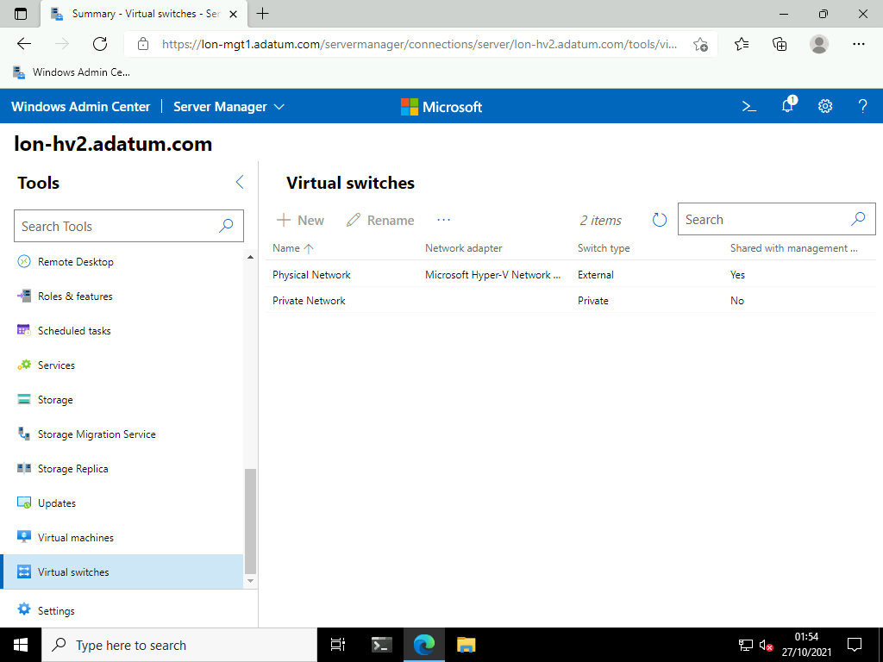

1. On the **Tools** menu select **Settings**.

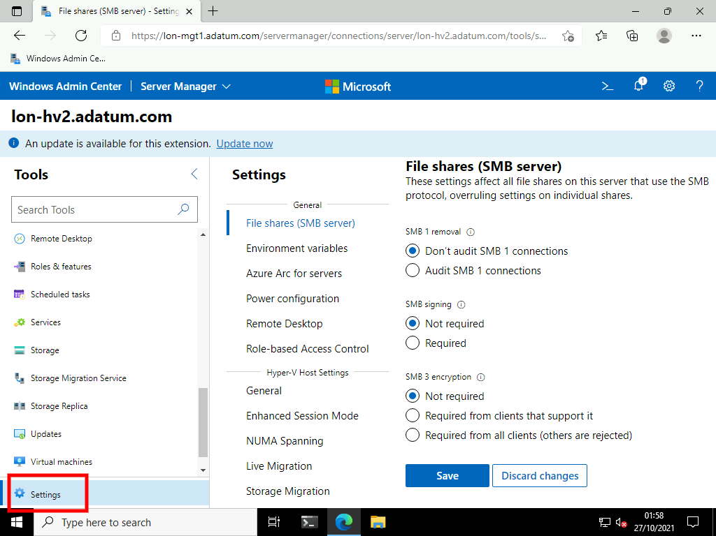

1. In the **Hyper-V Host Settings** section select **General**.

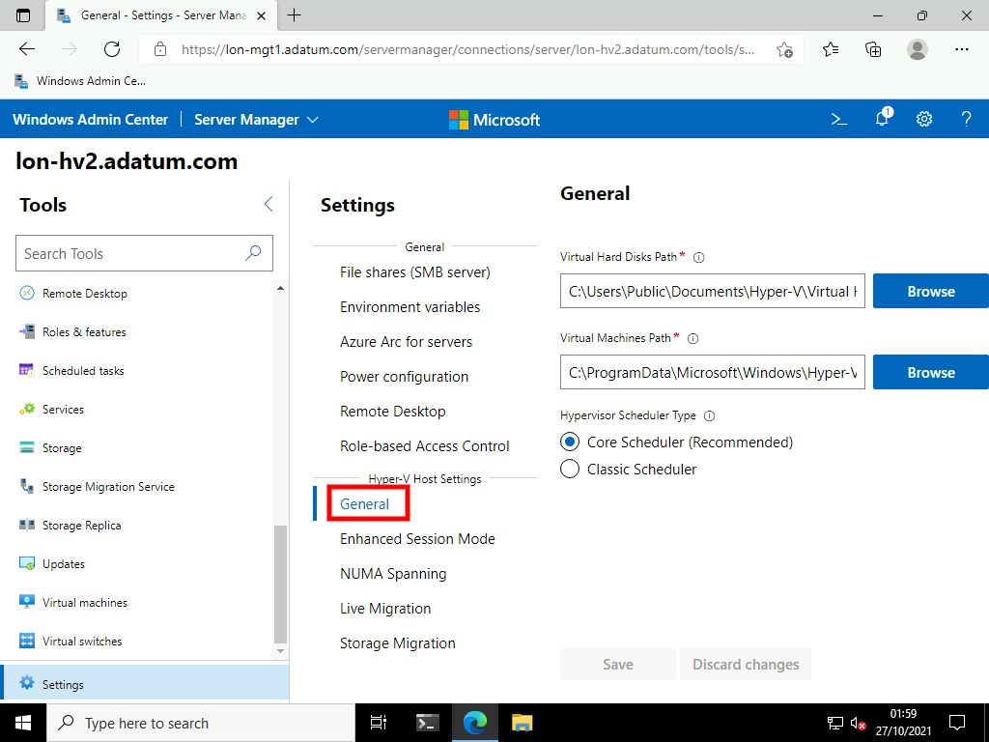

1. Change the general settings to the following then click **Save**.
   * Virtual Hard Disks Path: [**D:\VMs**](urn:gd:lg:a:send-vm-keys)
   * Virtual Machines Path: [**D:\VMs**](urn:gd:lg:a:send-vm-keys)

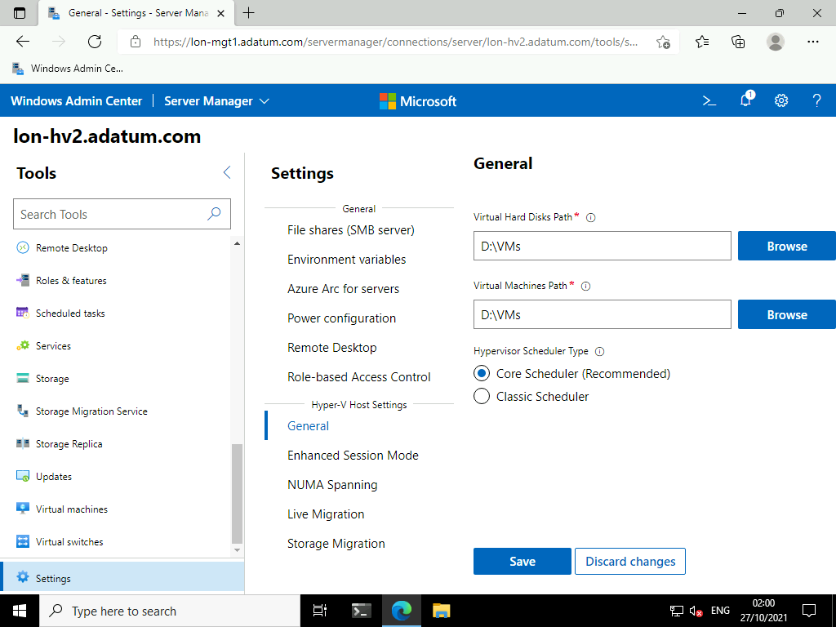

1. On the **Tools** menu select **Virtual machines**.

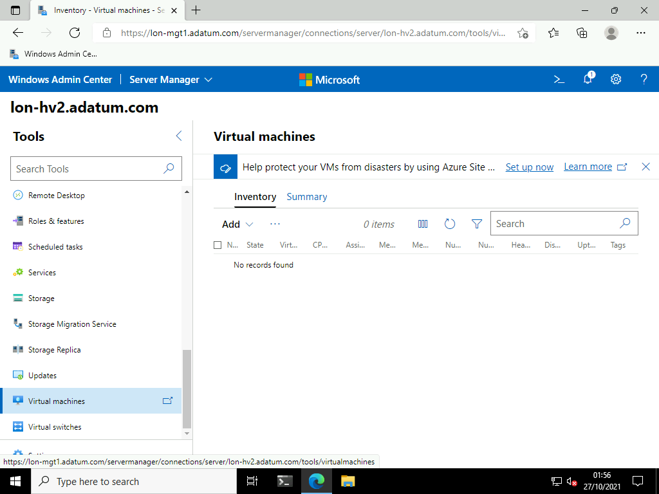

1. Click **Add** > **+ New**.

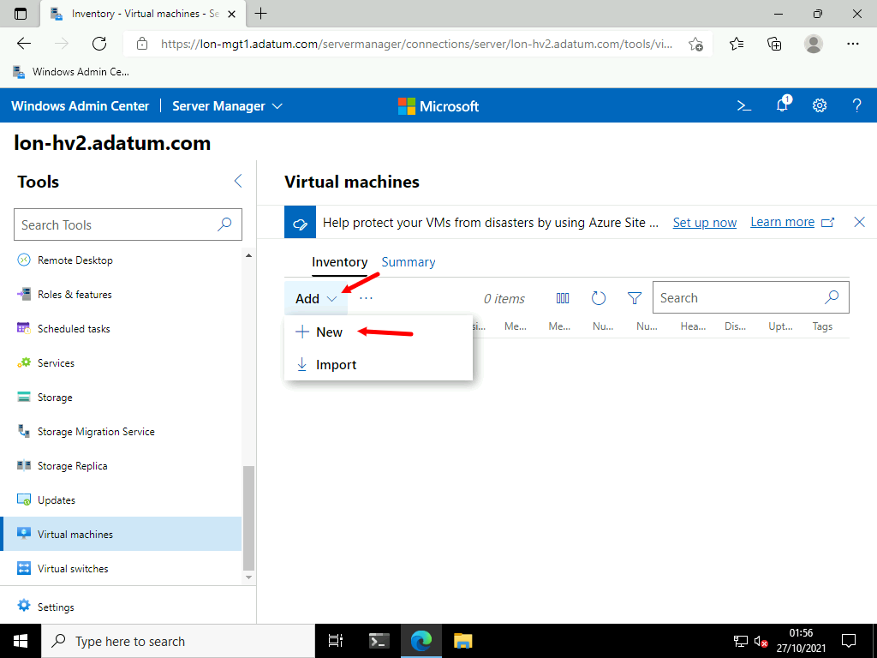

1. Create a virtual machine with the following settings then select **Create**.
   * Name: [**LON-WACVM**](urn:gd:lg:a:send-vm-keys)
   * Generation: **Generation 2 (Recommended)**
   * Path: **Leave the default path**
   * Virtual processors: [**2**](urn:gd:lg:a:send-vm-keys)
   * Memory: **2 GB**
   * Network: Virtual switch: **Physical Network**
   * Storage: Select **+ Add**

**Note** If you are unable to create the VM, you may need to update the **Virtual machines and switches** extension. To do this, select **Update now** in the banner at the top of the screen. Scroll down, select **Virtual machines and switches**, then select **Update**.

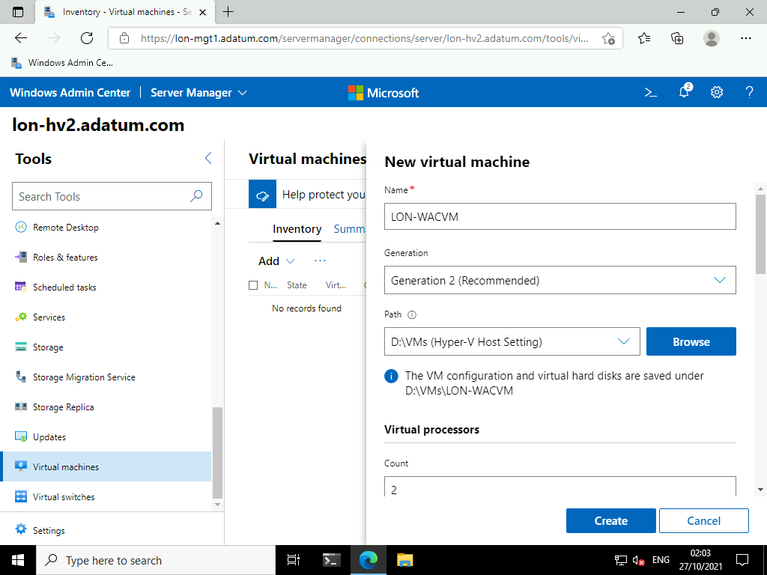

1. Once the VM has created, select **LON-WACVM** and select **Power** > **Start**.

**Note**: If you do not see the Power button you may need to click the elipsis (...)

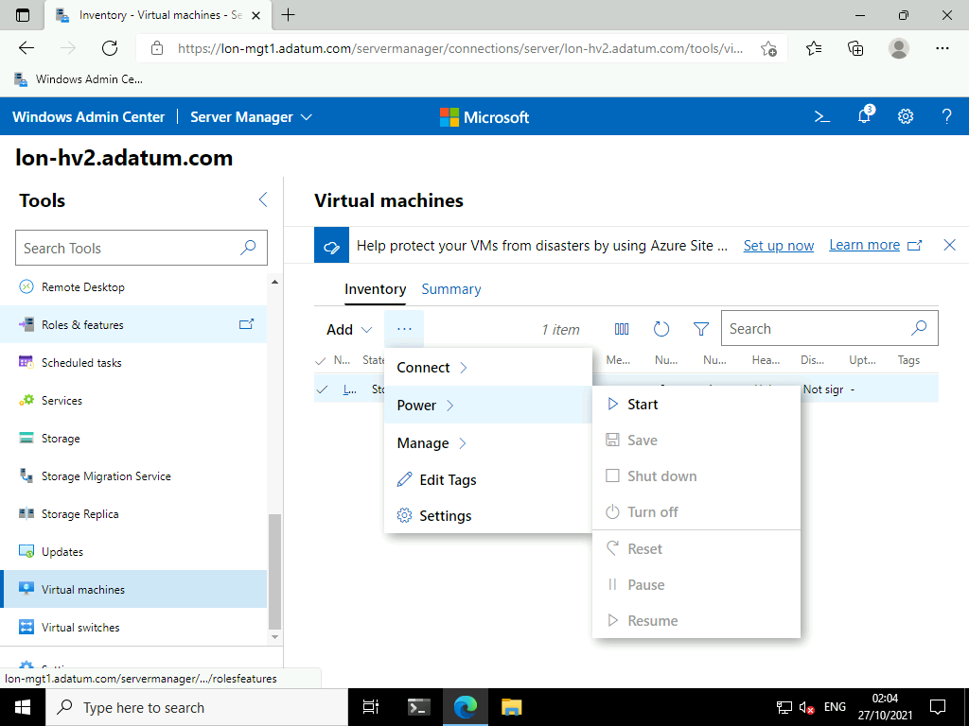

1. Click **Connect** > **Connect**.

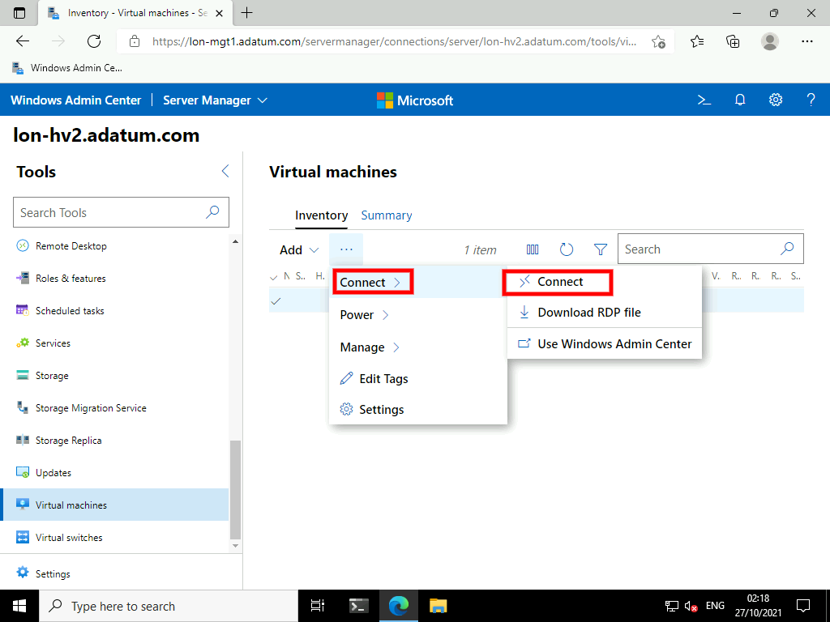

1. On the Remote Desktop blade enter the password [**Pa55w.rd**](urn:gd:lg:a:send-vm-keys) and click connect.

**Note** You may also need to update the **Remote Desktop** extension also.

**Note**: If prompted for a certificate just accept the defaults.

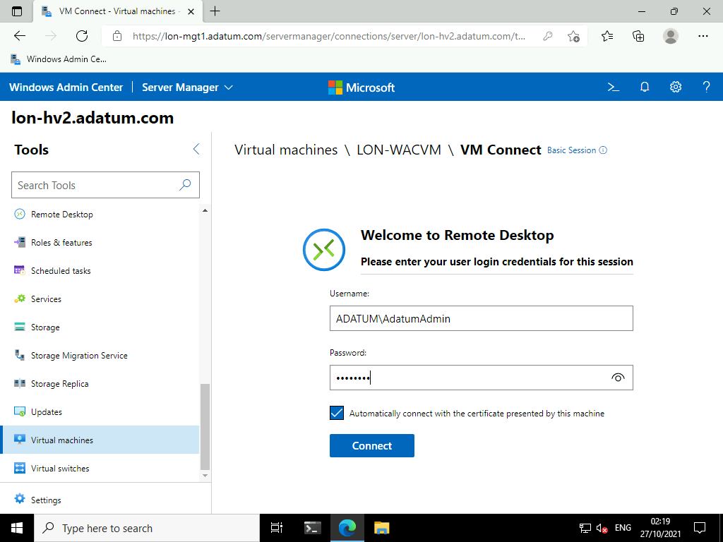

1. You are now connected to the VM. You will see the default boot screen as no Operating System has been installed on this Virtual Machine.

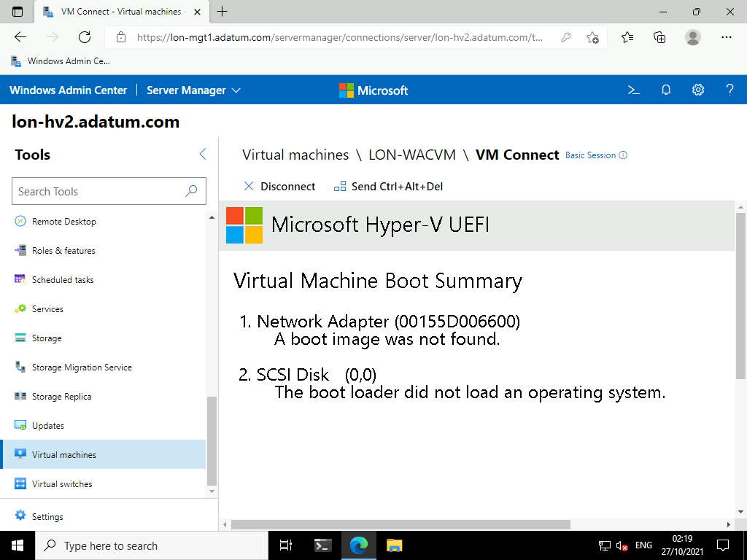

1. Select **X Disconnect**.

**Results**: After completing this exercise, you should have successfully managed Microsoft Hyper-V using the Windows Admin Center.

**Congratulations!** You have now completed this lab. To continue to the next lab click End Lab in the Tools Menu . If you wish to contiue with this lab at a later date ensure you save the lab environment rather than ending it.